Open the TI-Nspire document Magnetic_Field_of_a_Coil.tns.  In this experiment, you will investigate the proportional relationship between the magnetic flux density at the center of a long, electrically charged coil and the strength of the electrical current. Additionally, you will use experimental data to determine the numerical value of the magnetic constant. | 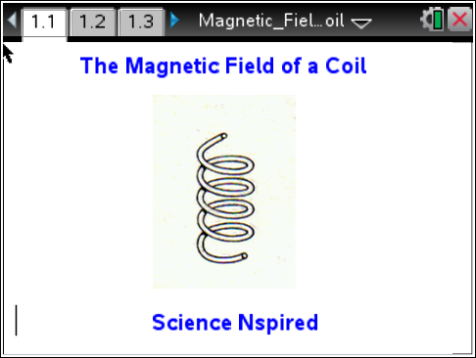

Move to pages 1.2 – 1.4. Answer questions 1 - 2 here and/or in the .tns file.
Q1. What do you predict is the relationship between the magnetic flux density inside a coil and the number of turns of the coil?

Q2. What do you predict is the relationship between amount of current through a coil and the magnetic flux density?

Move to page 1.5.

1. Connect the power supply, ammeter and coil as instructed by your teacher. Connect the Magnetic Field Sensor into the coil in an axial position.
2. Connect the sensor to the data-collection interface , such as EasyLinkTM or the Lab Cradle,. Connect the interface to the TI-Nspire handheld or computer.

Move to page 1.6.  3. The data collection has already been set up. If not, choose Menu > Experiment > Collection Mode and select Events with Entry. Enter Amps as the Name. Select OK. | 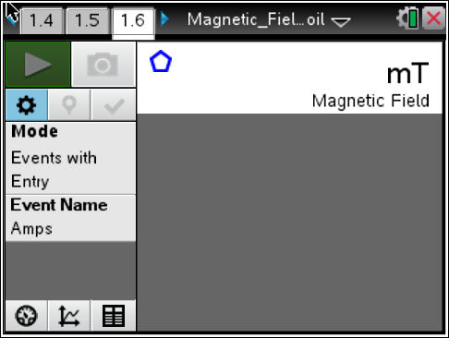
4. Turn on the power supply. Set it to 0 mA (milliamps), a unit of current.
5. Click the Start Data Collection button . When ready to record a reading, click the Keep button and type the amount of amperage. The first entry should be when the voltage is 0. Record the magnetic field reading in the data table.

6. Increase the amperage in intervals of 20 mA up to 100 mA. For each amperage, click the Keep button to record the data. Note: In the table on the next page, the last column titled “Magnetic Constant” will be calculated later.

Amps (mA) | Magnetic Field (mT) | Magnetic Constant
0
20
40
60
80
100

7. Click the Graph tab to view a graph of the results. Sketch your graph on the screenshot below.

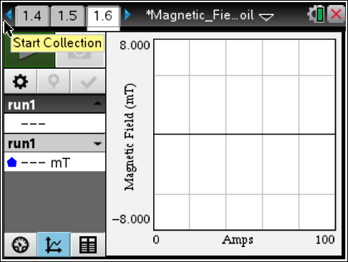

Move to pages 2.1 – 2.4. Answer questions 3 - 6 here and/or in the .tns file.
Q3. What is the relationship between the magnetic flux density and the electrical current? Explain your findings.

Q4. The equation for magnetic flux density at the inside of a coil is , where µ₀ is the magnetic constant, µ_{r} is the relative permeability, n is the number of coils, I (uppercase i) is the electrical current, and l (lowercase L) is the length of the core. Solve the equation for µ₀. Calculate the value for the magnetic constant µ₀ for each row in the table in step 6.

Q5. Calculate the average value for the magnetic constant from the values in the third column of your data table. Compare the average value to 1.26 × 10^{–6} Vs/Am.

Q6. Percent error can be found using the formula . Calculate the percent error using the experimental value (average value) and the true value, 1.26 × 10^{–6} Vs/Am.

