Open the TI-Nspire document Rate_of_Change.tns.  This activity involves the relationship between the number of songs downloaded from the internet and the corresponding time it takes for the downloads. Plotting points representing this information reveals a pattern that can help you answer questions about the situation. | 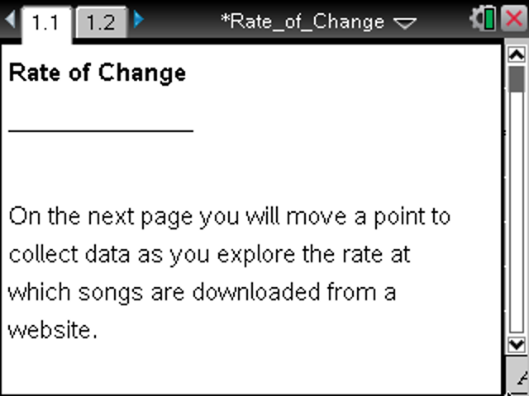

Move to page 1.2. | Press / ¢ and / ¡ to navigate through the lesson.
Problem Situation: After searching for songs online, you finally find the site you want and download your first song. You look at your watch and realize it has taken you 10 minutes to find and download only one (1) song. Now that you have found the right site, you realize that you can download three (3) songs every two (2) minutes.
1. What is the meaning of one unit along the horizontal axis? Vertical axis?

2. What does the ordered pair (10,1) represent? How does this point relate to the context of this problem?

3. Remember that the average rate at which you can download songs is 3 per every 2 minutes.
a. How many total songs will you have 2 minutes later (after the first 10 minutes)? Explain.

b. What ordered pair would you use to represent this point?

c. Move P to these coordinates, and press /^ once to mark the point.

4. Use the same average rate to plot the next three points. Describe the pattern you followed to plot these points. Record the ordered pairs below.

5. Is it possible to have the point (21, 16) on your graph if you continue with this pattern? Why or why not?

6. A rate of change is a ratio that specifies how much one quantity changes as another quantity changes.
a. Determine your rate of change for downloading songs after the site was found.

b. Look at your graph. How is the slope of the line through the points you plotted related to your answer to part a?

7. What is the total number of songs you have downloaded in each case below? Explain how you found your answer.
a. 24 minutes after you started searching.

b. An hour after you started searching.

8. Rates are often measured per single unit. For example, for speed we usually say 45 miles per hour rather than 90 miles per 2 hours.
a. Express the download rate as the number of songs per minute.

b. How long did it take you to find the site? What point on the graph would represent this time? Explain your reasoning.

9. Suppose you were able to double the number of songs you could download in two minutes after you found the site.
a. What would be the new rate of change for downloading songs?

b. How would the new graph compare to the original?

