Open the TI-Nspire document Matrix_Inverse.tns.  In the expression x * 5 = 1, the value of x must be 1/5. What would the value of x be in the equation ?  This activity will show you how to find x. | 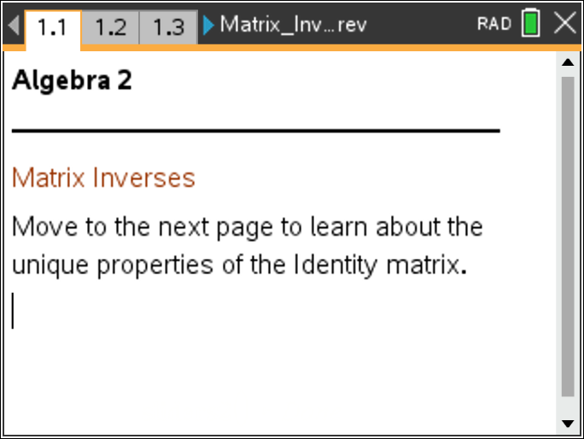

The number 1 is an incredibly powerful number in mathematics, and it can be written in many different ways. In matrix notation, the number 1 is expressed as and is called the identity matrix.
1. Multiplying 1 by any number results in no change to the number. Test this in matrix notation by multiplying by any 2 × 2 matrix.
- Open the Scratchpad.
- Enter the identity matrix by pressing t, selecting the 2 × 2 matrix template and entering.
- Now enter another 2 × 2 matrix, but choose any element values for the matrix. Press ·.
- When you finish question 1b, press d to exit the Scratchpad.
a. What is the result of the matrix multiplication?

b. Repeat this two more times using a different second matrix. What do you notice about the results? Will this always happen? Why or why not?

Move to page 1.2. | Press / ¢ and / ¡ to navigate through the lesson.
2. Attempt to change the element values in matrix B until the product [A][B] is the identity matrix . Why is it so difficult to find the correct values for matrix B?

Move to page 1.3.

3. When the product of two matrices is the identity matrix, then the second matrix is the inverse of the first matrix. The inverse matrix can be calculated using a system of equations.
a. Identify the necessary system of equations by multiplying matrices A and B. Write your result below. Confirm your result by moving the slider to yes for Show Equations.

b. Determine the correct element values for matrix B by solving the system of equations. To display the solution to this system, move the slider to yes for Show Solutions.

c. Use the Scratchpad to confirm that [A][B] results in the identity matrix. What patterns do you notice between the element values in matrix A and matrix B?

4. Using the Scratchpad, find the reciprocal of the determinant of matrix A by pressing 1pDET( and entering matrix A.

a. Knowing the value of the reciprocal of the determinant, are there other patterns that you now notice between matrix A and matrix B?

b. Would you like to change anything you wrote for question 3? Try rewriting the matrix so each element has a common denominator before answering.

Move to page 1.4.
5. Use the calculated determinant to help choose correct values for matrix B so that the product, [A][B], results in the identity matrix.

Move to page 2.1.

6. This next page is for practice. Practice finding the correct values for matrix B so that the product, [A][B], is the identity matrix. Click the arrows by the question number to get a new question.

7. Amber says that the inverse of is. Is Amber correct? Why or why not?

8. Sean says every square matrix has an inverse. Is he correct? Explain.

