Open the TI-Nspire document Tossing_Dice_Create.tns.  Suppose you toss two dice and find the sum of the faces. This activity investigates the probability of the possible sums by looking at both the theoretical sums and a simulated distribution of the sums. | 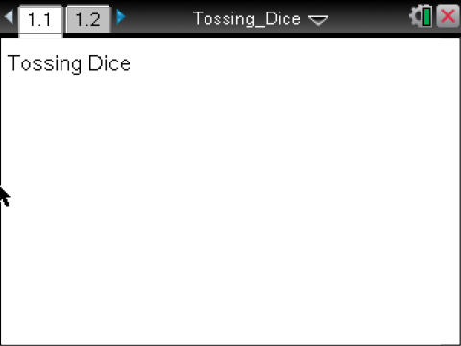

Tip: Moving the cursor over a point in a dotplot will display the horizontal-coordinate of the point.

1. Create a dotplot of a sampling distribution of the sums of the faces of two randomly-tossed fair dice using the Tossing_Dice_Create.tns file.

Move to page 1.2. | Press / ¢ and / ¡ to navigate through the lesson.
2. Generate ten sums, and observe the dotplot.
a. Which outcome seems to be most likely?

b. Which outcome seems to be least likely?

3. Generate 40 more sums to have a total of 50.
a. Describe your dotplot in terms of shape, center, and spread.

b. Compare your dotplot to your neighbor's dotplot. How are your answers to part a alike, and how they are different?

4. Use your new dotplot of 50 sums to estimate the probability of each of the following:
a. The sum of the faces is 5.

b. The sum of the faces is even.

c. The sum of the faces is greater than 8.

d. The sum of the faces is less than six.

5. a. The theoretical probability of a sum of two from the faces of two randomly-tossed fair dice is the number of ways you can obtain a two divided by the total number of possible outcomes. Explain how to find this probability.

b. Fill out the table below.
Sum of faces | 2 | 3 | 4 | 5 | 6 | 7 | 8 | 9 | 10 | 11 | 12
P(Theoretical sum) for 50 samples
P(Simulated sum) for 100 samples
P(simulated sum) for 100 samples
c. Jose announced that he did not have to find the theoretical probability of getting a sum of 11 because he knew the probability of getting a sum of 3. Explain his reasoning.

d. How do the theoretical and simulated probabilities compare?

6. The theoretical mean is 7. To find the mean of the samples you have generated, move the cursor to the dotplot, and select MENU > Analyze > Plot Value. After V1:= type mean(sum_faces), and press ·.
a. How does the mean of your simulated sampling distribution compare to the theoretical mean?

b. Continue generating sample sums, and observe the shape of the distribution and the mean of the simulated sampling distribution. Fill in the bottom row of the table in question 5b after you have generated approximately 50 more outcomes. What observation(s) can you make about the shape, center, and spread of the distribution as the number of samples increases?

c. Now that you have 100 samples, how do the theoretical and simulated probabilities compare?

7. Hy claims that, after many samples, the simulated sampling distribution of the sum of the faces of the dice will be a normal distribution. Do you agree or disagree with him? Explain your reasoning.

