Open the TI-Nspire document  Creating_and_Analyzing_Linear_Graphs.tns  See if you can complete this common phrase:  “A picture is worth ____________.”  If you answered “a dollar” or “not much” then you probably haven’t heard that phrase before! How about this: “A picture is worth a thousand words!” This is so true in science, isn’t it? Looking at a | 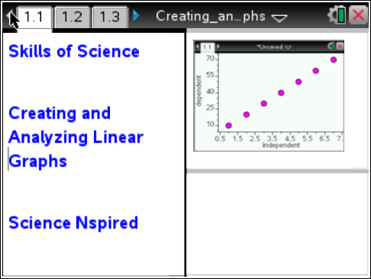
picture of something can really enhance your understand and appreciation for it. Well, science concepts are often presented in “number pictures” that we call graphs. While a well-constructed graph can do wonders for your understanding, a poor one can make science concepts more confusing. There are a few very important things to remember when making graphs. This activity will give you a chance to practice some of these things.

Problem 1: Introduction to Graphing
Move to pages 1.2 and 1.3. |  | Press / ¢ and / ¡ to navigate through the lesson.
Most graphs that you will see and work with in science show data points that include an independent variable (x) and a dependent variable (y). The independent variable appears on the horizontal axis, and the dependent variable appears on the vertical axis. The starting point and interval of the scale are also very important.  1. Read the procedure on page 1.2. Then look at the graph on page 1.3 and answer the questions below. |  | 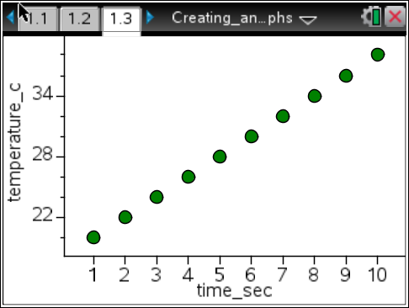
Answer questions 1-7 here.
Q1. What is the independent variable in the graph shown?

Q2. What is the dependent variable?

Q3. What do you think the units of measure are for time for this graph?

Q4. What temperature scale do you think is being used for the graph? What range of temperatures is shown on the y-axis?

Q5. If this graph represents data collected during an experiment, how long did the experiment run?

Q6. What was the minimum temperature recorded?

Q7. What was the maximum temperature recorded?

Move to pages 1.4 and 1.5.  Analyzing a Trend in a Graph  Often, it is helpful to include a best-fit line, also known as a regression line, with your graphed data set. A regression line helps you make predictions from a data set. The equation shown for the line follows the “slope-intercept” form, or y = mx + b. In this equation, m is the slope, or the rate of change, and b is the y-intercept, or the point |  | 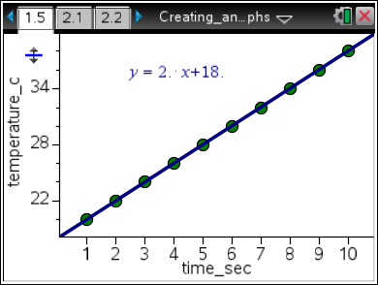
at which the independent variable would be equal to zero. The rate of change, when written, should always include the units graphed. For this graph, the unit label would be degrees C/second. Finally, make sure you pay attention to whether the rate of change is positive or negative. A positive rate indicates a steady increase, while a negative rate indicates a steady decrease.
2. Read the introduction on page 1.4. Use the graph on page 1.5 to answer the questions below.
Answer questions 8-14 here.
Q8. What is the rate of change (slope) for this data set? (Make sure you include the units!)

Q9. What is the y-intercept for this graph? (This is the temperature when time = 0 seconds. Make sure you include the units!)

Q10. Estimate what the temperature was at 7.5 seconds.

Q11. Estimate when the temperature was 25°C.

Q12. If the experiment is continued beyond the data shown, predict the time at which the temperature will be 50°C.

Q13. Predict the temperature at 12 seconds.

Q14. Predict how the graph would look if the experiment were run for 20 seconds, and draw this graph in the space to the right. Make sure you label the variables and include appropriate intervals for the scale.

Problem 2: You Try It!
Move to pages 2.1 and 2.2.  Read the introduction on page 2.1 and move to page 2.2. You will see a spreadsheet like the one shown to the right. The columns have already been named for you as “time_sec” and “temp_f”.  3. Starting in cell A1 and moving down column A, enter the following values: 2, 4, 6, 8, 10, 12, 14, 16, 18, 20.  4. Move to cell B1 and enter the following values down column B: 100, 95, 90, 85, 80, 75, 70, 65, 60, 55. Make sure you have the same number of values in each column. |  | 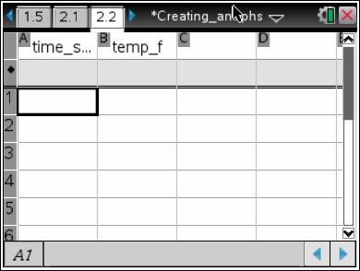
Move to page 2.3.

5. Move to page 2.3 where you will need to select the variables that you would like to graph. Move your cursor to the horizontal axis first and select time for your independent variable. Then move your cursor and select temp for your dependent variable.

Answer questions 15-21 here.
Q15. Sketch your graph in the space to the right. |  | 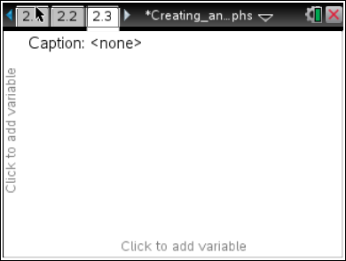
Q16. Describe the trend that you see in the data set.

Follow these steps to generate a linear regression model for the data:
6. Press menu>Analyze>Regression>Show Linear (mx+b). A regression line and corresponding equation should appear on the screen.
7. If you accidentally click and the equation disappears, you can fix it easily! Simply move your cursor to the regression line and click on it. All is well!
8. Answer the following questions after you have a graph and a regression line.
Analysis Questions
Q17. What is the rate of change of your graph?

Q18. What is the temperature when time = 0 sec?

Q19. What was the change in temperature between each value in the spreadsheet? This is also known as Δtemp (“delta” temperature).

Q20. What was the change in time between each value in the spreadsheet? This is also known as Δtime (“delta” time).

Q21. Divide Δtemp by Δtime. What is your answer? What is another name for this value, as it relates to your data?

