Open the TI-Nspire document 3x3_Linear_Systems_ of_Equations.tns.  You probably know how to find the solution to a system of two linear equations in two variables from a graph. But what happens when we add a third variable, or a third variable and a third equation? In this activity you’ll look at the graphs of linear equations in three variables, and the graphical representations of solutions to systems of linear equations with three unknowns. | 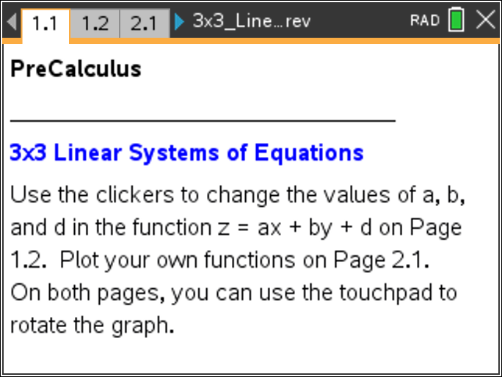

1. When solving a system of two linear equations with two variables, what do you look for graphically to indicate the solution? Explain.

2. A linear equation in three variables is an equation of the standard form ax + by + cz = d. What do you think the graph of such a function might look like? Why?

Move to page 1.2. | Press / ¢ and / ¡ to navigate through the lesson.
3. This page shows a graph of a linear function, z = ax + by + d. The graph is called a plane.
a. What is the equation in standard form of the plane shown on the page?

b. Use the clicker to change the value of a. What happens to the plane as a changes? What attribute of the plane does a affect?

c. Use the clicker to change the value of b. What happens to the plane as b changes? What attribute of the plane does b affect?

d. Use the clicker to change the value of d. What happens to the plane as d changes? What attribute of the plane does d affect?

Move to page 2.1.

4. Without graphing, how many solutions do you think the following system will have?
Explain your reasoning.

5. If any functions are plotted, clear them, and then plot the two functions from Question 4. How many solutions does the system have? How do the graphs help you see this?

6. Without graphing, how many solutions do you think the following system will have?
Can you use what you know about systems of linear equations in two variables to help you?

7. Clear the plotted functions, and plot the two functions from Question 6. How many solutions does the system have? How do the graphs help you see this?

8. Without graphing, how many solutions do you think the following system will have?
Explain your reasoning.

9. Clear the plotted functions, and plot the two functions from Question 8. How many solutions does the system have? How do the graphs help you see this?

10. Clear the plotted functions, and plot several other pairs of functions to investigate. Based on your investigations, how many solutions do you think a system of two linear equations in three variables can have? Explain your reasoning.

11. Now suppose you have three equations in three variables. Based on your work with two functions, predict how many possible solutions a system of three linear equations can have. Justify your prediction geometrically.

12. Clear the plotted functions, and plot several groups of three functions to investigate. How many solutions can a system of three linear equations in three unknowns have? How can you see these in the graphs?

