Open the TI-Nspire document Power_Function_Inverses.tns.  This activity will explore the graphs of power functions and their inverses. Throughout the lesson, pay attention to the behavior of the graphs and coordinate points on the graphs. | 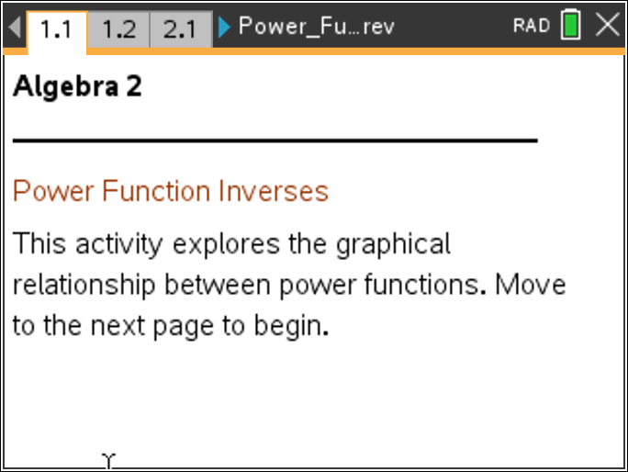

Move to page 1.2.

1. As you use the slider, the graphs of f(x) = x^{p} and are displayed on the page for odd values of p from 1 to 15. These functions are inverses of one another. What geometric relationship exists between the two graphs?

2. A trace point, A, is placed on the graph of f(x) = x^{p} and is represented by the open circle. As you drag point A along the function, the related point A' on the graph of is updated as well. What relationship exists between the coordinates of A and A'?

3. Find (f)(g)(x) and (g)(f)(x). What is the result?

Move to page 2.1.

4. As the slider is pressed, a “trail” of graphs remains as p changes in odd values.
a. The points (1, 1), (0, 0), and (–1, –1) are common to all of the graphs on this page. Using what you learned in question 2, explain why these points are common to all power functions and their inverses.

b. What do you see when p = 1? Why does this happen?

Move to page 3.1.

5. The graph of f(x) = x² is displayed on this page. A trace point, P, has been added. P', the point reflected over y = x, is also displayed. Drag the point P and watch the path of P'. Describe what you see after you drag point P over the entire graph of f(x).

6. Inverse functions must retain the properties of functions. Why does the graph resulting from the reflection of f(x) = x² over the line y = x fail to meet this condition?

Move to page 4.1.

7. The graph of f(x) = x² is displayed on this page, but this time only when x ≥ 0. Again, the trace point P is displayed, as well as P', its reflection over y = x. Drag the point P and watch the path of P'. How does restricting the domain of f(x) to x ≥ 0 allow the function to have an inverse?

8. The domain restriction x ≥ 0 allowed the graph in question 7 to have an inverse. List another possible domain restriction for f(x) that will allow there to be an inverse.

Move to page 5.1.

9. As you press the slider, the graphs of f(x) = x^{p} and are displayed for even values of p from 2 to 8. The geometric relationship observed for odd values of p no longer holds. Why does this geometric relationship fail to happen for even values of p?

10. Based on the graphs on this page, which part of a power function with an even degree is a reflection of a radical function with the same index?

11. How can you tell visually from any graph of a function whether it will have an inverse or not? Why might this be useful?

12. Jorge claims that f(x) = x² and are inverses because squaring and square roots are “opposite operations.” What has Jorge not considered in his conclusion?

