Review of Normal Curve Properties
A normal curve is a density curve that is symmetric, single-peaked, and bell-shaped. In addition, the screenshot at the right shows the percentage of data that falls within 1, 2, and 3 standard deviations of the mean.  When data fits a normal pattern, one can standardize values and compare distributions | 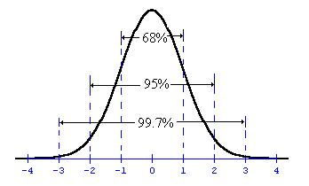
The standardized value of x is , where μ is the mean and σ is the standard deviation of the data. This value is called the z-score and it corresponds to the integers in the figure above. In other words, the z-score is the number of standard deviations a data point is above or below the mean.
The p-th percentile of a distribution is the value such that p percent of the observations fall at or below it.

Problem 1 – Given x-values, Finding Percentages
The average (mean) number of calories in a bar is 210 and has a standard deviation of 10. The number of calories per bar is approximately normally distributed.
The question we would like to know is, "What percent of candy bars contain between 200 and 220 calories?" There are two ways of determining this, graphically and using calculations.

Method 1: Graphically
Step 1: Press o and graph the probability distribution function Y1 = normpdf(x, μ, σ) replacing μ with the mean and σ with the standard deviation.  The normalpdf( is found by pressing y ½. After inputting the values into the wizard, select Paste and the normalpdf( will be pasted into Y1. | 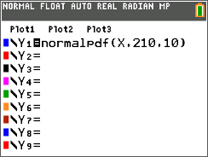
Step 2: Set the graphing window size.
1. Using the normal distribution graph from earlier, determine the two x-values where 99.7% of the data will fall between.

Press p and set the answers to Question 1 to these values as xmin and xmax.

2. The area under the curve must be 1. What is a reasonable maximum height for this curve thinking of the x-values from Question 1?
Set the answer to Question 2 as ymax.
Use these values to set your beginning graphing window. Adjust your window as needed
Press % s to see the curve.

Step 3: To find the area under the curve between 200 and 220, press y r and select command.  Select a lower and upper bound. Type 200, Í, 220, Í.  Multiply the value that appears by 100 to convert the area under the curve to a percent to answer the question. | 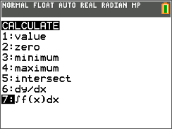
3. What percent of candy bars contain between 200 and 220 calories?
Method 2: Using Calculations
Press y ½ and select normalcdf(.  Enter the values on the screen to the right, select Paste, and press Í. | 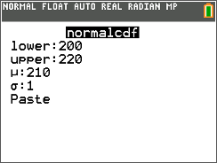
4. What percent of candy bars contain between 200 and 220 calories?

5. The length of useful life of a fluorescent tube used for indoor gardening is normally distributed. The useful life has a mean of 600 hours and a standard deviation of 40 hours. Determine the probability that
a. A tube chosen at random will last between 620 and 680 hours.

b. Such a tube will last more than 740 hours.

Problem 2 – Given Percentages, Finding x-values
While the normal curve is not a one-to-one function, if the definition of a p-th percentile is used, an
x-value that corresponds to a given percentile can be found.
6. Using the mean, μ, and the standard deviation, σ, describe the x-value that corresponds to the
a. 50th percentile.

b. 16th percentile.

c. 84th percentile.
Suppose Mike is in the 99th percentile for his height. U.S. men have an average height of 69.3 inches with a standard deviation of 2.8 inches. How can you determine how tall Mike is?
- Press ` v and select the invNorm( command.  - Enter the needed information into the wizard and select Paste. | 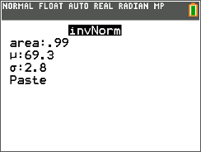
7. How tall is Mike?
8. The lifetimes of zip drives marketed by Zippers, Inc. are normally distributed, with a mean lifetime of 11 months and a standard deviation of 3 months.
Zippers, Inc. plans to offer a new warranty guaranteeing the replacement of failed zip drives during the warranty period. It can afford to replace up to 4 percent of its drives
How many months of warranty should the company offer with these drives? Round your answer to the nearest month.

9. Final grade averages are typically approximately normally distributed with a mean of 72 and a standard deviation of 12.5. Your professor says that the top 8% of the class will receive a grade of A; the next 20%, B; the next 42%, C; the next 18%, D; and the bottom 12%, F.
a. What average must you exceed to obtain an A?

b. What average must you exceed to receive a grade better than a C?

c. What average must you obtain to pass the course

Problem 3 – Given z-scores, Finding Percentiles and x-values
10. Use the diagram from the first page of the worksheet to help answer the following statements.
a. The x-value with a z-score = 0 is in the _____ percentile.
b. The x-value with a z-score = –3 is in the _____ percentile.
c. The x-value with a z-score = 2 is in the _____ percentile.

11. Using the mean, μ, and the standard deviation, σ, describe each of the following:
a. The x-value with a z-score = 0
b. The x-value with a z-score = –3
c. The x-value with a z-score = 2
Find the corresponding percentile and x-value that has a z-score = –2.3 with mean = 100 and standard deviation = 10.
Solution: Finding percentile using a standardized normal curve.
- Graph the function f1(x) = normpdf(x, 0, 1).
- Adjust the window.
- As done in Problem 1, find the area under the curve from the left to –2.3.
(The left bound is the xmin.)
- Convert the area under the curve to a percent to answer the question.
or
- Calculate normcdf(–1E99, –2.3, 0, 1).
Note: E is entered by pressing y ¢

Solution: Finding x-value.
- Calculate invNorm(percentile, 100, ), where percentile is the value you found in the first part of the solution.

12. What are the corresponding percentile and x-value that has a z-score = –2.3 with mean = 100 and standard deviation = 10?

13. In a field, the heights of sunflowers are normally distributed with a mean of 72 inches and standard deviation of 4 inches. Find the corresponding percentile and x-value for a sunflower that has a
z-score of 1.6.

14. The shoe sizes of a men’s basketball team are normally distributed with a mean of 11.5 and a standard deviation of 1.25. Find the corresponding percentile and x-value for a player that has a
z-score of –3.1.

15. A machine is programmed to fill 10-oz containers with a cleanser. However, the variability inherent in any machine causes the actual amounts of fill to vary. The distribution is normal with a standard deviation of 0.02 oz. What must the mean amount be in order for only 5% of the containers receive less than 10 oz? (You will need to use the formula for finding a z-score.)

16. The weights of ripe watermelons grown at Mr. Smith’s farm are normally distributed with a standard deviation of 2.8 lb. Find the mean weight of Mr. Smith’s ripe watermelons if only 3% weigh less than 15 lb. (You will need to use the formula for finding a z-score.)

