Open the TI-Nspire document Intermolecular_Forces.tns.

What is it about molecules that makes them stick together? It is the sticking together of molecules that causes them to form liquids and solids. In this activity you will observe the differences between polar and non-polar molecules and discover the different ways these two types of molecules stick together.

Move to pages 1.2–1.4. Answer the following questions here or in the .tns file.
Q1. The forces within a molecule, for example covalent and ionic bonds, are known as ______ forces.
A. intermolecular | B. intramolecular
Q2. Intermolecular forces are forces _____.
A. between two or more molecules | B. within a single molecule
Q3. Intermolecular forces arise from the charge clouds surrounding molecules.
A. True | B. False
Move to pages 1.5 and 1.6.  1. Read and follow the instructions on page 1.5 and observe the simulation on page 1.6. |  | 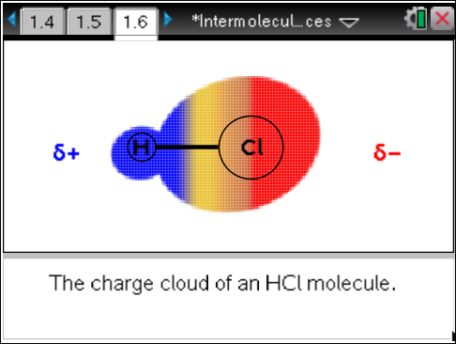
Move to page 1.7. Answer the following question here or in the .tns file.
Q4. In the charge cloud for HCl the positive charge _____.
A. remains on the left end (H) of the molecule  B. remains on the right end (Cl) of the molecule | C. oscillates regularly between the right and left ends  D. moves randomly between the right and left ends
Move to page 1.8.
2. Read the information on page 1.8.
Move to page 1.9. Answer the following question here on in the .tns file.
Q5. HCl _____. (More than one response may be correct.)
A. is a non-polar molecule  B. is a polar molecule | C. has a permanent dipole moment  D. has a temporary dipole moment
Move to pages 2.1 and 2.2.  3. Read and follow the instructions on page 2.1 and observe the simulation on page 2.2. |  | 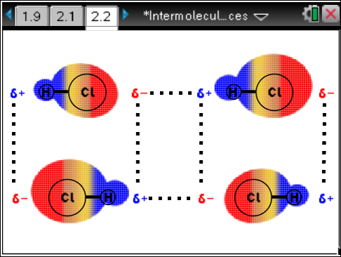
Move to pages 2.3–2.5. Answer the following questions here or in the .tns file.
Q6. The attractive forces are between the ____ end of a HCl molecule and the ____ end of another HCl molecule.
A. positive, positive  B. positive, negative | C. negative, negative  D. hydrogen, hydrogen
Q7. The lines of force between HCl molecules _____ as the charge cloud changes.
A. remain constant | C. change
Q8. The intermolecular forces between HCl molecules are _____.
A. induced dipole-induced dipole (London dispersion) forces  B. dipole-induced dipole forces | C. dipole-dipole forces  D. ionic bonds
Move to page 3.1.  4. Observe the simulation on page 3.1. |  | 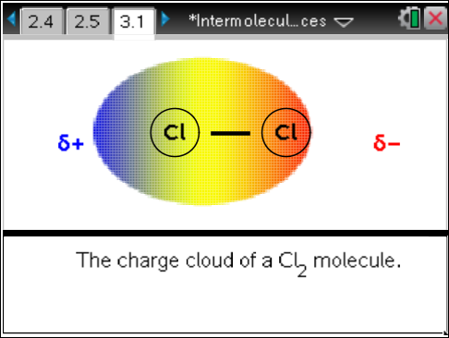
Move to pages 3.2 and 3.3. Answer the following questions here or in the .tns file.
Q9. The positive charge for Cl₂ _____.
- remains on the left end of the molecule  B. remains on the right end of the molecule | C. oscillates regularly between the right and left ends  D. moves randomly between the right and left ends
Q10. Cl₂ _____. (More than one response may be correct.)
A. is a non-polar molecule  B. is a polar molecule | C. has a permanent dipole moment  D. has a temporary dipole moment
Move to page 4.1.  5. Observe the simulation on page 4.1. |  | 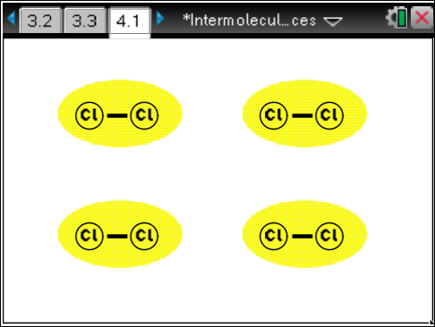
Move to pages 4.2–4.5. Answer the following questions here or in the .tns file.
Q11. The lines of force between Cl₂ molecules _____ as the charge cloud changes.
A. remain constant | B. change
Q12. The intermolecular forces between Cl₂ molecules are _____.
A. induced dipole-induced dipole (London dispersion) forces  B. dipole-induced dipole forces | C. dipole-dipole forces  D. ionic bonds
Q13. For molecules of about the same size, I would expect dipole-dipole intermolecular forces to be _____ than induced dipole-induced dipole forces.
A. stronger | B. weaker
Q14. Explain your answer to the last question.

