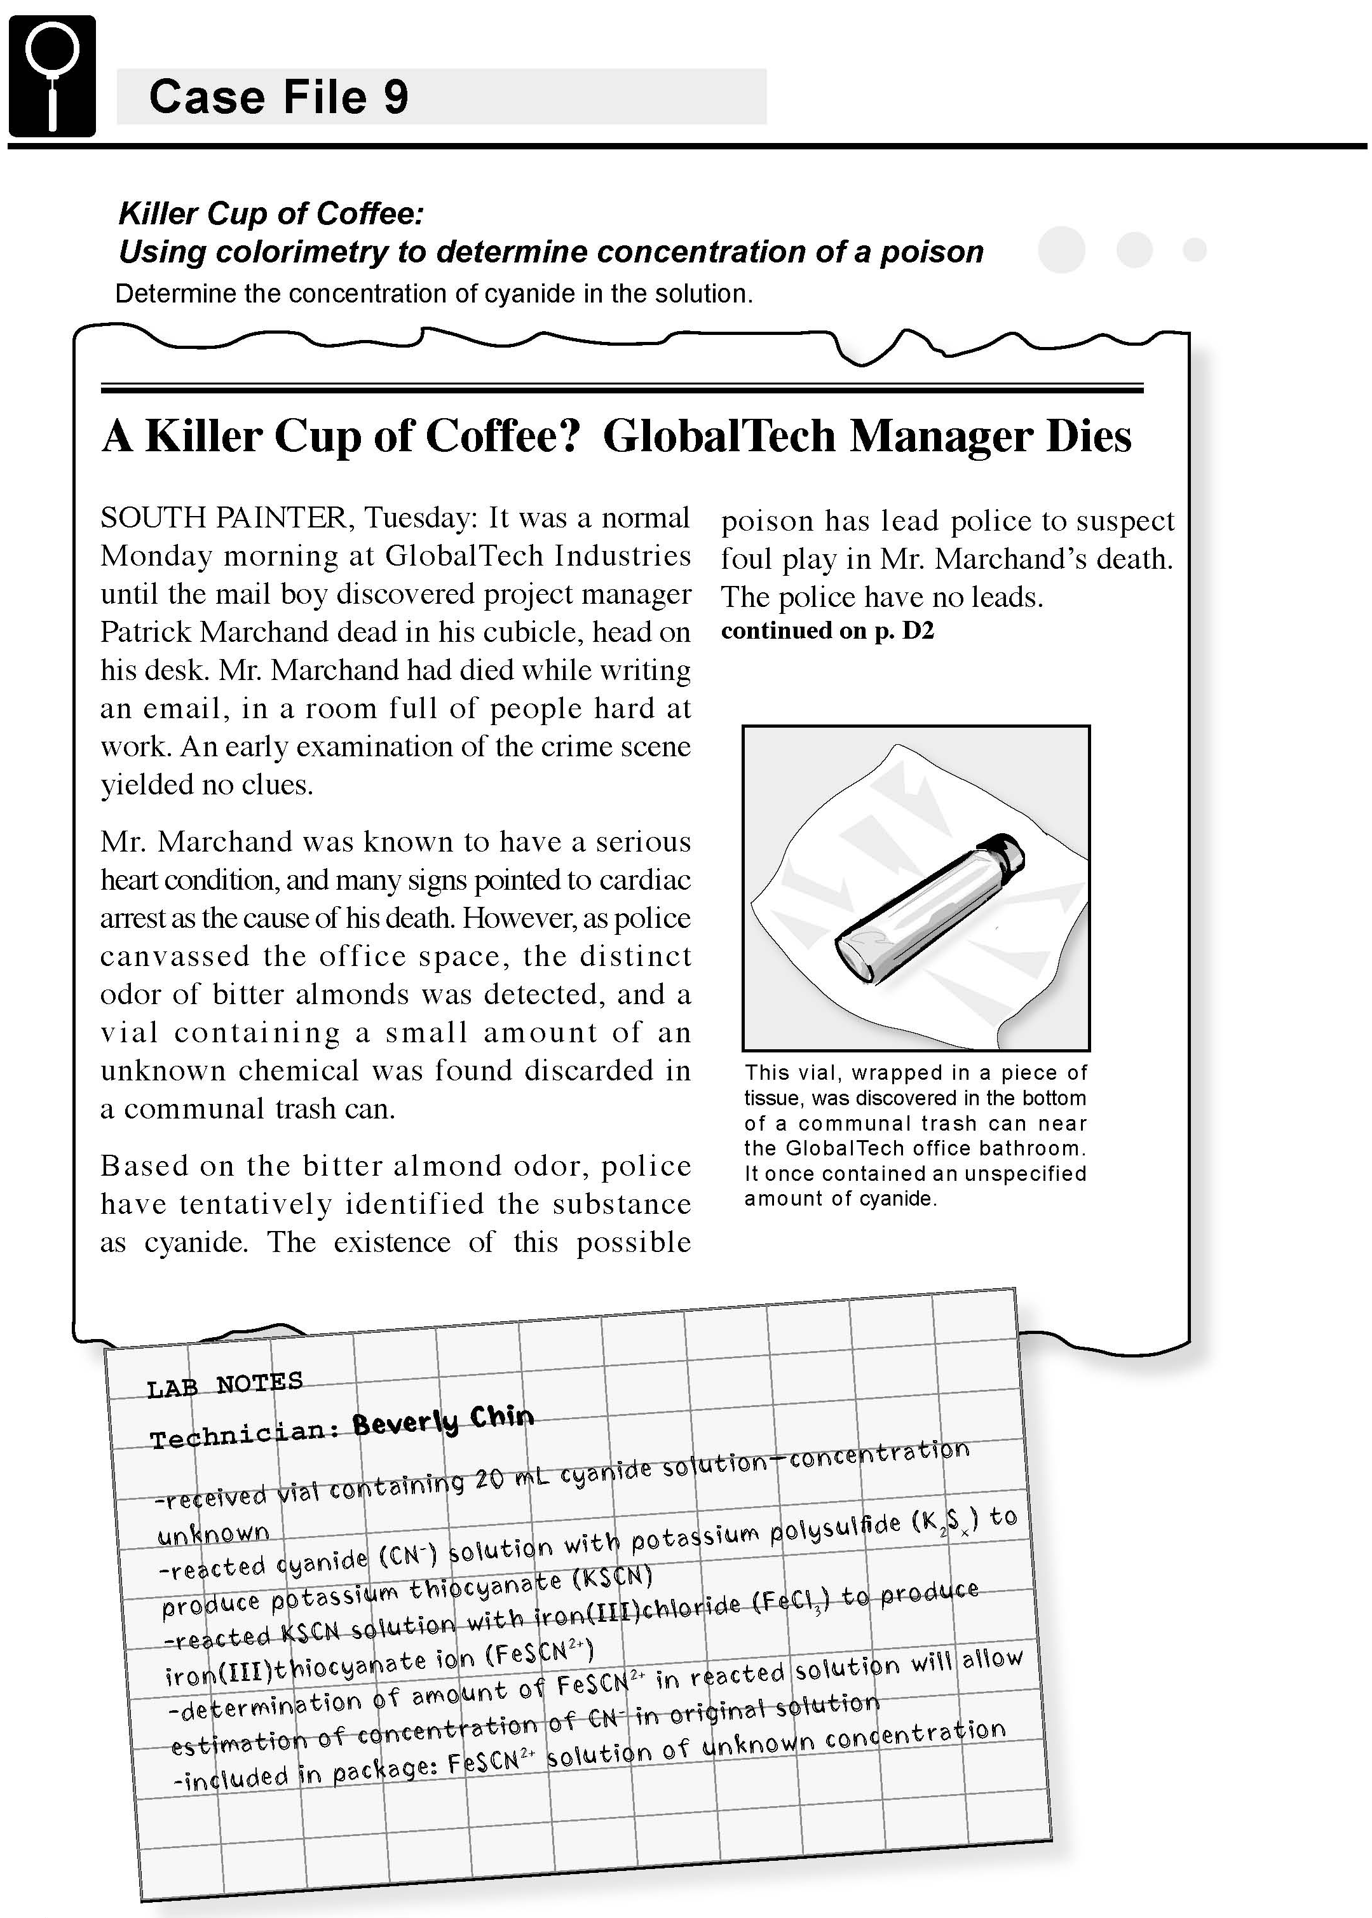

Science Objectives
- Use Beer’s law to determine the concentration of simulated iron (III) thiocyanate (FeSCN²⁺) in an unknown solution.
- Use colorimetry to determine the concentration of a colored species in a solution.
- Use a linear relationship to model the data (Beer’s law).
- Learn the importance of carefully prepared standards.

Activity Materials
- TI-Nspire™ technology  - Case 9 Killer Coffee.tns file  - Vernier EasyLink™ or TI-Nspire Lab Cradle  - Vernier Colorimeter  - 7 cuvettes  - colored wax pencil  - distilled water  - waste beaker  - two 5 mL beakers  - stirring rod  - goggles | - 5 mL of simulated FeSCN²⁺ solution of unknown concentration in the suspicious vial  - two 10 mL pipettes or graduated cylinders  - 50 mL of 0.15 M stock simulated FeSCN²⁺ solution  - 2 droppers  - 6 test tubes  - test tube rack  - lint-free tissues
Procedure
Open the TI-Nspire document Case 9 Killer Coffee.tns.  In this data-gathering activity, you will use Beer’s law to determine the concentration of iron(III)thiocyanate (FeSCN2+) in an unknown solution. |  | 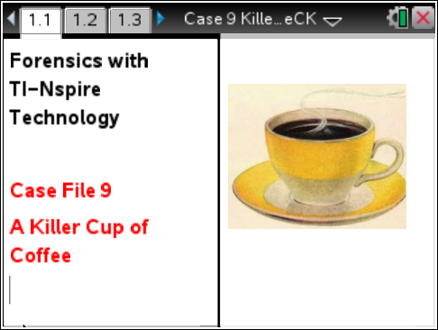
Part 1 – Preparing the Solutions
Move to pages 1.2–1.7.
CAUTION: You should obtain and wear goggles during this experiment, and be careful not to ingest any solution or spill any on their skin. Inform your teacher immediately in the event of an accident.
1. Obtain and label the following with a wax pencil:
a. Pour 50 mL of stock simulated 0.15 M FeSCN²⁺ solution into a 50 mL beaker. Label the beaker “Simulated 0.15 M FeSCN²⁺.”
b. Pour 30 mL of distilled water into a 50 mL beaker. Label the beaker “H₂O.”
2. Prepare the unknown and standard solutions.
a. Label five clean, dry test tubes with numbers 1 through 5.
b. The following table (and on page 1.5) shows how much water and stock simulated FeSCN²⁺ solution to add to each test tube. Use a pipette or a dropper and graduated cylinder to measure the correct amount of simulated FeSCN²⁺ solution into each test tube. Note: Use a separate pipette or graduated cylinder and dropper for the water and the simulated FeSCN²⁺.
c. Carefully stir the contents of each test tube with a clean stirring rod. (Clean the stirring rod with distilled water and dry it thoroughly in between each test tube.)
d. Label a sixth test tube with a “U” for unknown. Use a pipette or a dropper and graduated cylinder to measure 5 mL of simulated FeSCN²⁺ solution of unknown concentration into the test tube.
Test Tube | FeSCN²⁺ Solution  (mL) | Distilled Water  (mL) | Final Concentration of FeSCN²⁺  (mol/L)
1 | 10 | 0 | 0.15
2 | 8 | 2 | 0.12
3 | 6 | 4 | 0.09
4 | 4 | 6 | 0.06
5 | 2 | 8 | 0.03

3. Prepare the blank, the five standard solutions, and the unknown for colorimetry.
a. For each standard solution, rinse an empty cuvette twice with about 1 mL of the sample.
b. Fill each cuvette 3/4 full with the sample, and seal it with a lid.
c. Label the lid with the sample number.
d. Wipe the outside of each cuvette with a tissue.
e. Repeat Steps 3a–3d for the unknown sample. Label the lid with a “U”.
f. Repeat Steps 3a–3d using distilled water for the blank. Label the lid with a “B”.
Remember the following:
- All cuvettes should be clean and dry on the outside.
- Handle cuvettes only by the top edge or the ribbed sides.
- All solutions should be free of bubbles.

Part 2 – Collecting Data
Move to pages 2.1-2.4.  4. In your Evidence Record below, enter the volume of the suspicious vial.  5. On page 2.2, connect the Colorimeter to TI-Nspire. | 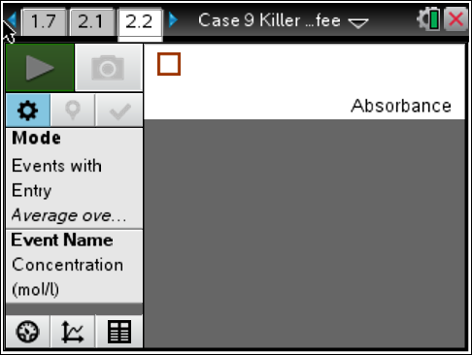
6. Calibrate the Colorimeter.
a. Open the Colorimeter lid. Place the blank cuvette containing distilled water, in the cuvette slot of the Colorimeter. Make sure that one of the transparent faces of the cuvette is pointing toward the white reference mark. Close the lid of the Colorimeter.
b. Press the < or > button on the Colorimeter to select a wavelength of 470 nm (Blue).
c. Press the CAL button until the red LED begins to flash. Then release the CAL button. When the LED stops flashing, the calibration is complete.
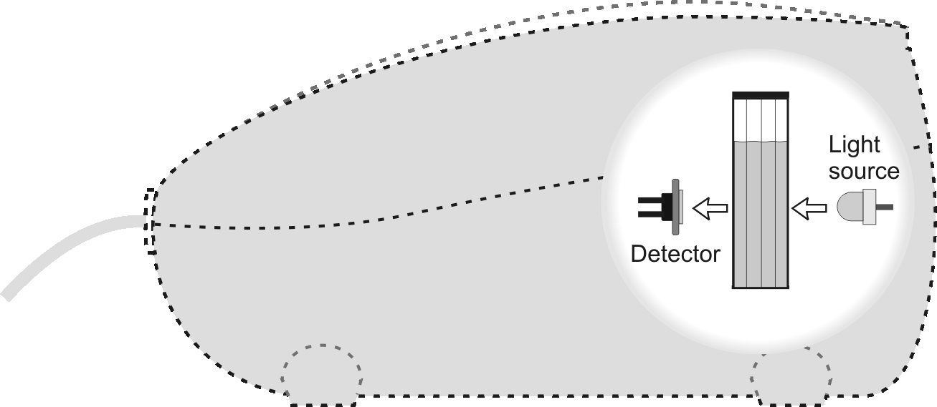
7. You are now ready to collect absorbance-concentration data at 470 nm for the solutions.
a. Start data collection .
b. Place cuvette 1 in the Colorimeter. Be sure the cuvette is clean, dry, and has a transparent face pointing toward the reference mark.
c. After closing the lid, wait for the absorbance value displayed on the monitor to stabilize, and then select Keep button.
d. Enter the concentration of the solution (from the table in Step 2) and select OK. The data pair you just collected should now be plotted on the graph.
e. Remove the cuvette from the Colorimeter.
f. Repeat this process for the remaining standards in cuvettes 2 through 5.
9. Stop data collection when you have collected data for all the samples. You will NOT have done the unknown!
10. In your Evidence Record and/or on page 3.1 (as directed by your teacher), write down the absorbance values displayed in the Data Table from page 2.2.
Part 3 – Analyzing the Data
Move to page 2.5-3.1  11. Select the Meter tab. Place the cuvette with the unknown solution in the Colorimeter. Monitor the absorbance value displayed on the screen. When this value has stabilized, round it to the nearest 0.001. | 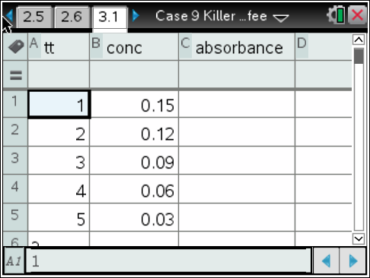
12. To determine the concentration of FeSCN²⁺ in the unknown solution, fit a straight line to the graph of absorbance vs. concentration.
a. Select the Graph tab on page 2.2 to see the graph.
b. Press the menu key and choose Analyze > Curve Fit > Linear.
c. Select Linear for the Fit Equation. A best-fit linear regression line will be shown for your five data points. This line should pass near or through the data points and the origin of the graph. The equation for a straight line is y = mx + b, where y is absorbance, x is concentration, m is the slope, and b is the y-intercept.
d. The displayed values of m and b give the best fitting line to your data points. The correlation coefficient indicates how well the data points match the linear fit. A value of 1.00 indicates a perfect fit. Record the values of m, b, and the correlation in the Evidence Record and/or on page 3.2 in the .tns file (as directed by your teacher). The linear relationship between absorbance and concentration is known as Beer’s law. Select OK.
e. Press the menu key. Choose Analyze > Interpolate. Interpolate along the regression curve to determine the concentration of the unknown solution. Tap any point on the regression curve (or use the ► or ◄ keys) to advance to the absorbance value that is closest to the absorbance reading you obtained. The corresponding concentration value is the concentration of the unknown FeSCN²⁺ solution, in mol/L. Write this value in the Evidence Record and/or on page 3.3 in the .tns file (as directed by your teacher)

Evidence Record
Volume of the suspicious vial ____________________________
Solution Number | Concentration of  Simulated FeSCN2+ in Solution  (mol/L) | Absorbance
1 | 0.15
2 | 0.12
3 | 0.09
4 | 0.06
5 | 0.03
U | Unknown

Concentration of FeSCN²⁺ in the unknown solution ________________________
y | mx + b
m
b
correlation

Case Analysis
Answer the following questions here, in the .tns file, or both.
Q1. Write the equation for the line in the form y = mx + b, using the values for m and b that you recorded in the Evidence Record. For example, if m = 3 and b = 6, then the equation for the line is y = 3x + 6.

Q2. Use the equation to calculate the concentration of FeSCN²⁺ in the unknown solution. How does the value you calculate compare with the value you read from the graph?

Q3. The volume of the cyanide solution that was found at the scene was 20 mL. Based on the calculated concentration of FeSCN²⁺ in the unknown solution, determine the concentration of potassium cyanide, KCN, in the original poison. Show all of your work. Give your answer in milligrams of KCN per milliliter of solution. Hint: One mole of KCN will produce one mole of FeSCN²⁺. Assume that all of the KCN in the poisoned solution reacted to form FeSCN²⁺. Assume that the 20 mL of original solution was not diluted during the reaction to form FeSCN²⁺ and that the sample you received was also undiluted. The molecular weight of FeSCN²⁺ is 114 g/mol. The molecular weight of KCN is 65 g/mol.

Note: Page 4.5 is a calculator page to help with this.
Q4. For most people, swallowing 300 mg of KCN is fatal. Based on the concentration of KCN in the poison that you calculated in Question 3, determine the approximate volume of poison that the victim would have to have swallowed for it to have killed him. Show all of your work.

Note: Page 4.7 is a calculator page to help with this.
Q5. Is it likely that the poison was the direct cause of death? Explain your answer. Hint: Remember that the vial was mostly empty and may, at one time, have held more than 20 mL.

Q6. Suppose you found out that the concentration of FeSCN²⁺ in the unknown was actually very different from the value you calculated in Question 2 and the value you read off of the graph. What factors could have caused this difference?

