Sound Waves and Beats
Sound waves consist of a series of air pressure variations. A Microphone diaphragm records these variations by moving in response to the pressure changes. The diaphragm motion is then converted to an electrical signal. Using a Microphone, you can explore the properties of common sounds.
The first property you will measure is the period, or the time for one complete cycle of repetition. Since period is a time measurement, it is usually written as T. The reciprocal of the period (1/T) is called the frequency, f, the number of complete cycles per second. Frequency is measured in hertz (Hz). 1 Hz = 1 s^{–1}.
A second property of sound is the amplitude. As the pressure varies, it goes above and below the average pressure in the room. The maximum variation above or below the pressure mid-point is called the amplitude. The amplitude of a sound is closely related to its loudness.
In analyzing your data, you will see how well a sine function model fits the data. The displacement of the particles in the medium carrying a periodic wave can be modeled with a sinusoidal function. Your textbook may have an expression resembling this one:
$$y=A\text{sin}\left(2pft\right)$$
In the case of sound, a longitudinal wave, the y refers to the change in air pressure that makes up the wave. A is the amplitude of the wave (a measure of loudness), and f is the frequency. Time is represented with t, and the sine function requires a factor of 2π when evaluated in radians.
When two sound waves overlap, air pressure variations will combine. For sound waves, this combination is additive. We say that sound follows the principle of linear superposition. Beats are an example of superposition. Two sounds of nearly the same frequency will create a distinctive variation of sound amplitude, which we call beats.
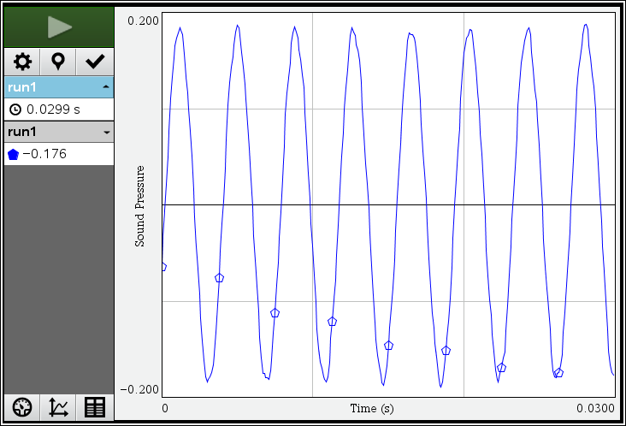
Figure 1

objectives
- Measure the frequency and period of sound waves from tuning forks or an electronic keyboard.
- Measure the amplitude of sound waves from tuning forks or an electronic keyboard
- Observe beats between the sounds of two tuning forks or two keys on an electronic keyboard.
Materials
TI-Nspire handheld or | Vernier Microphone
computer and TI-Nspire software | 2 tuning forks or an electronic keyboard
data-collection interface

Preliminary questions
1. Why are instruments tuned before being played as a group? In which ways do musicians tune their instruments?
2. Given that sound waves consist of a series of air pressure increases and decreases, what would happen if an air pressure increase from one sound wave was located at the same place and time as a pressure decrease from another of the same amplitude?

Procedure
1. Connect the Microphone to the data-collection interface. Connect the interface to the
TI-Nspire handheld or computer.
2. Be sure your handheld or computer software is set to perform angle calculations in Radians.
3. Choose New Experiment from the Experiment menu. For Part I of the experiment, the default data-collection parameters for a microphone will be used (Rate: 10,000 samples per second; Duration: 0.03 seconds).
4. To center the waveform on zero, it is necessary to zero the Microphone channel. With the room quiet, choose Set Up Sensor ► Zero from the Experiment menu. When the process is complete, the reading for the sensor should be close to zero.
Part I Simple Waveforms
5. Produce a sound with a tuning fork or keyboard, and hold it close to the Microphone. Start data collection (). When data collection is complete, a graph will be displayed.
6. The data should be sinusoidal in form, similar to the graph in Figure 1. If you are using a tuning fork, strike it against a soft object such as a rubber mallet or the rubber sole of a shoe. Striking it against a hard object can damage it. If you strike it too hard or too softly, the waveform may be rough; collect data again.
7. Print or make a sketch of your graph. Record the note you played in Tables 1, 2 and 3.
8. To examine the data pairs on the displayed graph, click any data point using the cursor . Record the times for the first and last peaks of the waveform by clicking on the data points with the cursor and then clicking the Data Marker button (). Count the number of complete cycles that occur between your first measured time and the last. Divide the difference, Δt, by the number of cycles to determine the period of the tuning fork. Record these values in Table 1.
9. Calculate the frequency of the tuning fork based on the period you calculated in Step 8. Record this value in Table 1.
10. Examine the graph again to find the maximum and minimum sound values for an adjacent peak and trough. Calculate the amplitude of the wave by taking half of the difference between the maximum and minimum y values. Record the values in Table 2.

11. To compare your data to the textbook sinusoidal model, y = Asin(2πf t), you will use the sinusoidal curve fit y = a * sin(b*x + c) + d. Comparing terms, listing the textbook model’s terms first, the amplitude A corresponds to the curve fit parameter a, f corresponds to b/2π. The curve fit parameters c and d shift the fitted function left-right and up-down, respectively and may be necessary to obtain a good fit. The time t is represented by x.
To fit your data using a sinusoidal curve fit, choose Curve Fit ► Sinusoidal from the Analyze menu. If your model does not fit the data, adjust the region used for the curve fit by moving the brackets ( [ or ] ) to make the region smaller. Record the parameter values in Table 3.
12. Calculate the frequency of the tuning for using the curve fit equation’s value for b. Record this value in Table 3.

13. Click the Store Data button () to save the first run data. Repeat Steps 5–12 for the second frequency or tuning fork.
Part II Beats
14. Two pure tones with different frequencies sounded at once will create the phenomenon known as beats. Sometimes the waves will reinforce one another and other times they will combine to a reduced intensity. This happens on a regular basis because of the fixed frequency of each tone. To listen to beats, strike your tuning forks at the same time (simultaneously) or simultaneously hold down two keys on the keyboard and listen for the combined sound. If the beats are slow enough, you should be able to hear a variation in intensity. When the beats are too rapid to be audible as intensity variations, a single rough-sounding tone is heard. At even greater frequency differences, two separate tones may be heard, as well as various difference tones.
15. To capture the beats it is necessary to collect data for a longer period of time.
- Insert a new Problem into your TI-Nspire document and add a DataQuest App to the problem. Choose New Experiment from the Experiment menu.
- Choose Collection Setup from the Experiment menu. Enter 2500 as the rate (samples/second) and 0.08 as the experiment duration in seconds. The number of points collected should be 201.
- Select OK.

16. Start the two tones sounding then start data collection (). When using tuning forks, strike them equally hard and hold them the same distance from the Microphone.
17. Note the shape of your waveform graph. You should see a time variation of the sound amplitude. The pattern will be complex, with a slower variation of amplitude on top of a more rapid variation. Ignoring the more rapid variation and concentrating in the overall pattern, count the number of amplitude maxima after the first maximum and record it in Table 4.
18. Record the times for the first and last amplitude maxima. To do this, click any data point by using the cursor . Divide the difference, Δt, by the number of cycles to determine the period of beats (in s). Calculate the beat frequency in Hz from the beat period. Record these values in Table 4.
Data
Part I Simple Waveforms
Table 1
Tuning fork or note | Number of cycles | Time of first max (s) | Time of last max (s) | Δt  (s) | Period  (s) | Calculated frequency (Hz)

Table 2
Tuning fork or note | Peak | Trough | Amplitude

Table 3
Tuning fork or note | Parameter a | Parameter b  (s^{–1}) | Parameter c | Parameter d | Calculated frequency (Hz)

Part II Beats
Table 4
Number of cycles | Time of first max  (s) | Time of last max  (s) | Δt  (s) | Beat  (s) | Calculated beat frequency  (Hz)

Questions
Part I Simple Waveforms
1. Did your curve fit match the waveform well? In what ways was the curve fit similar to the data and in what ways was it different?
2. Compare the curve fit frequency calculated in Step 12 to the frequency calculated in Step 9. Which would you expect to be more accurate? Why?
3. Calculate the percent error between the curve fit frequency and the frequency of the tuning fork or keyboard note for both of the notes played.
4. Compare the parameter a to the amplitude of the waveform.
Part II Beats
5. Is there any way the two individual frequencies can be combined to give the beat frequency you measured earlier? Compare your conclusion with information given in your textbook.
Extensions
1. There are commercial products available called active noise cancellers, which consist of a set of headphones, microphones, and some electronics. Intended for wearing in noisy environments where the user must still be able to hear (for example, radio communications), the headphones reduce noise far beyond the simple acoustic isolation of the headphones. How does such a product work?
2. The trigonometric identity
$\text{sin}x+\text{sin}y=2\text{sin}\left(\frac{x+y}{2}\right)⋅\text{cos}\left(\frac{x−y}{2}\right)$
is useful in modeling beats. Show how the beat frequency you measured above can be predicted using two sinusoidal waves of frequency f₁ and f₂, whose pressure variations are described by sin(2π f₁ t) and sin(2π f₂ t).
3. Most of the attention in beats is paid to the overall intensity pattern that we hear. Use the analysis tools to determine the frequency of the variation that lies inside the pattern (the one inside the envelope). How is this frequency related to the individual frequencies that generated the beats?
4. Examine the pattern you get when you play two adjacent notes on a keyboard. How does this change as the two notes played get further and further apart? How does it stay the same?

