Open the TI-Nspire document Needs_of_Living_Things.tns.  Move to pages 1.2 – 1.3.  1. Read through pages 1.2 and 1.3 in the .tns file as well as the background information stated below. Page 1.3 will also give instructions on how to complete the simulation on page 1.4. |  | 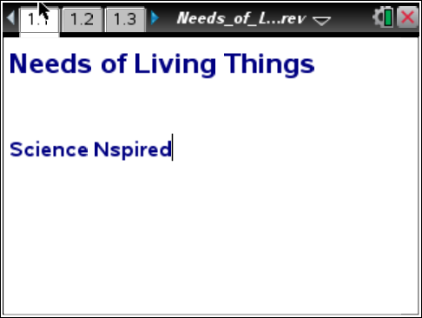
Living things are dependent upon several factors which include the use of energy, nutrients, water availability, predators and their environment. These factors are known as limiting factors, which include anything that would put a “limit” on an animal’s ability to thrive in an ecosystem. There is a direct relationship between a healthy and stable ecosystem and an organism’s ability to thrive. Each organism has a different set of requirements for survival.
In this simulation, you will manipulate the requirements first for a set of plants and finally for an array of animals, to see what will happen when they are placed in a specific ecosystem.
Move to page 1.4.
2. On this page, you will see four buttons— Plant, Temperature, Moisture, and Reset.  - Each time you select the Plant button, a different plant will appear.  - The same thing goes for Temperature and Moisture.  - Once you have selected all three variables, a new button will appear, Show Population. |  | 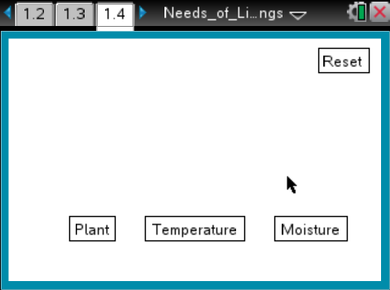
- When you select Show Population, a graph will appear showing the change in population of that specific plant over a period of time.
- Select the correct conditions and the plant population will increase; select the wrong conditions and the plant population will decrease.
Try different combinations to see which plant is best suited to which environment. Once you feel comfortable with the different scenarios, move on to the next page.
 | Tech Tip: You can also modify the variables by selecting  , the desired variable, and then the desired option. You may need to back-out to the main Tools Menu to see the desired menu option.
Move to page 1.5.
3. Before moving onto the questions, read the background information on page 1.5 about biomes.

After going through this simulation, you should notice that different plants need different environmental conditions to survive. These different environments are called biomes, also known as large distinctive regions of plant and animal communities maintained by a specific climate. In the previous simulation, you looked at plant life in four different biomes including boreal forest, temperate forest, tropical rainforest and desert. These are just a few of the major biomes that make up the Earth.
Move to pages 1.6 – 1.9. Answer questions 1-4 below and/or in the .tns file.
Q1. Of the four different kinds of plants, which plant is most capable of adapting to a variety of living conditions?

- Evergreen Tree
- Willow Tree
- Palm Tree
- Hedgehog Cactus

Q2. In which biome would you most likely find a willow tree?

- Tropical Rainforest
- Boreal Forest
- Temperate Forest
- Desert

Q3. Palm trees are typically found in a sub-tropical or tropical climate. Which conditions most accurately describe a tropical climate?

- hot and dry
- hot and wet
- cool and dry
- cool and wet

Q4. Name three “limiting factors” in a Hedgehog Cactus’ environment.

Move to page 2.1.
4. Read through page 2.1. It explains how to complete the simulation.
On page 2.3, you will see four different buttons, similar to the ones you saw in the previous simulation. This time, the four buttons are Feeding Type, Biome, Living Space, and Reset. You will be able to manipulate the limiting factors in this simulation.
- Once you have selected the buttons and selected your three variables, another button will come up indicating Show Animal.
- This time, you manipulate the environment and an animal that is adapted to those living conditions will be displayed on the screen.
- Explore the different conditions before you move on.
Move to page 2.2.
5. Read through page 2.2. It reviews key vocabulary you will need to know in order to fully understand the simulation.
- A carnivore is a meat eater that receives most of its energy and nutrient requirements from a diet consisting of animal tissue.
- A herbivore is an organism that primarily eats autotrophs (producers), also known as plants, algae, and certain types of bacteria.
- An autotroph is an organism that is capable of self-nourishment by processes such as photosynthesis as a source of nutrients and energy.
6. On Page 2.3, you can manipulate the three major categories including Feeding Type, Biome, and Living Space to show a specific animal that lives in that particular region.  - Feeding type is broken down into three options including carnivore, herbivore, and autotroph.  - Biome is broken down into three options including desert, lake, and swamp.  - Living space is broken down into two options including minimal area and large area.  Note: Once you have made a selection in all three categories a new button will appear in the middle of the screen displaying Show Animal. Select Show Animal to display the animal that best fits with the limiting factor choices you made.  - You can restart the simulation by selecting the Reset button on the top right corner of the screen. |  | 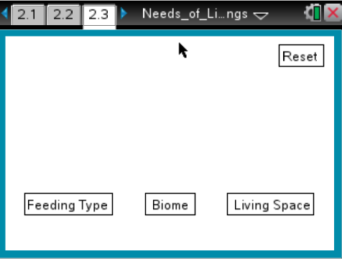  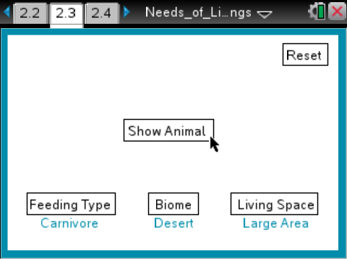
Move to pages 2.4 – 2.11. Answer questions 5-12 below and/or in the .tns file.
Q5. Which of the following animals is NOT an example of a carnivore?

- oscar
- heron
- macaw
- anaconda

Q6. Which term best describes an organism that is capable of producing its own food through photosynthesis?

- carnivore
- herbivore
- autotroph
Q7. Which of the following organisms would most likely be found in a desert?

- lizard
- anaconda
- snail
- heron

Q8. According to the simulation, which environment best fits a coyote’s needs?

- swamp, large area
- desert, large area
- lake, large area
- swamp, minimal area

Q9. Which organism in this simulation is most acclimated to a variety of living conditions?

- beaver
- rattlesnake
- snail
- grass

Q10. Pick an animal and list at least three things it needs in order to survive. Place both parts of your answer below.

Q11. Using what you have learned from both simulations on pages 1.4 and 2.3, what would most likely happen to an organism if it was removed from its natural environment? Why?

Q12. Living organisms have a direct relationship with the environment they live in. How have humans affected the natural environments of other organisms?

