Before beginning the activity, clear out any functions from the □ screen, turn off all Stat Plots, and make sure that the calculator is in Radian mode.  You are also going to utilize the Transformation Graphing App. To start this app, press the  and select Transfrm from the list. Press  twice to activate the application. |  | 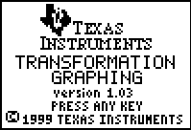
Problem 1 – Amplitude
In this problem, you will explore the amplitude of a function of the form f(x) = a sin(x).
Press  to access the Program menu and select the PHSESHFT program.  You will see the menu options to the right. Choose 1:Amplitude. |  | 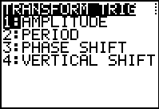
The program will graph the parent function y = sin(x) and enter Y1 = a sin(x) into the □ screen.  You will see A=1 with the equals sign highlighted. Enter in values from –3.5 to 3.5 and press  to see the effect the values have on the graph. |  | 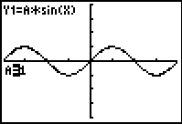
- Describe how the different values of a affect the shape of the graph.

- What happens if a is negative?

- Complete the following statement:
For a ≠ 0, the graph of Y1 = a sin(x) has an amplitude of ___________.
Problem 2 – Period
In this problem, you will explore the period of a function of the form f(x) = sin(bx).
Choose the PHSESHFT program again from the Program menu. Choose 2:Period.  The program will graph the parent function y = sin(x) and enter Y1 = sin(bx) into the □ screen.  Enter the following values for B to see the effect the on the graph: 0.125, 0.25, 0.5, 0.75, 1, 2, 4, 8. |  | 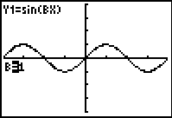
- Describe how the value of b affects the shape of the graph.

- What happens to the period when 0 < b < 1?

- What happens to the period when b > 1?

- Complete the following statement:
For b > 0, the graph of Y1 = sin (bx) has a period of _________.
Problem 3 – A Simple Phase Shift
In this problem, you will explore the phase shift of a function of the form f(x) = sin(x + c)
Choose the PHSESHFT program and select 3:Phase Shift. The program will graph the parent function y = sin(x) and enter Y1 = sin(x + c) into the □ screen.  Enter the following values for C to see the effect the on the graph: –2π, , –π, , , , , π, , 2π |  | 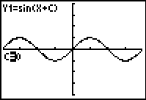
- Describe how the value of c affects the shape of the graph.

Problem 4 – Vertical Shift
In this problem, you will review the vertical shift of a function of the form f(x) = sin(x) + d.
Choose the PHSESHFT program and select 3:Vertical Shift. The program will graph the parent function y = sin(x) and enter Y1 = sin(x) + d into the □ screen.  Enter the following values for D to see the effect the on the graph: –3 to 3 in 0.5 increments. |  | 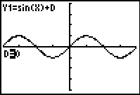
- Describe how the value of d affects the shape of the graph.

- Complete the following statement:
The graph of Y1 = a sin(x) + d has a vertical shift of ___________.

Problem 5 – Combining Transformations
In this problem, you will see which parameters impact the phase shift of the parent function, y = sin(x). You are to enter in various values for a, b, c, and d, and observe what happens. Try to write an equation that defines the phase shift in terms of the parameters that affect it.
Select the TRIGCOMB program from the Program menu. Choose 1:Phase Shift from the menu options.  Enter values to change a, b, c, and d in the function Y1 = a sin(bx + c) + d. |  | 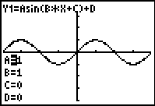
- Which of the four parameters result in a phase shift of the graph?

- Complete the following statement:
For a ≠ 0 and b > 0, the graph of Y₁ = a sin(bx + c) + d has a phase shift of

Problem 6 – Bringing It All Together
- For functions of the form f(x) = a sin(bx + c) + d, with a ≠ 0 and b > 0, the graph has:
- amplitude = _________  - period = _________ | - phase shift = _________  - vertical shift = _________
The same characteristics hold true for functions of the form g(x)=a cos(bx + c) + d.
To verify this, press □ and arrow up to Plot1 and press  to turn off the stat plot. Then, change the sine equation to a cosine equation.  Press  and repeat Problems 1–4 with the cosine function. |  | 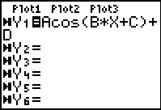
Finally, you will apply what they have learned about vertical and phase shifts. You are given the equations and graphs of two sine functions and asked to find equations of cosine functions that coincide.
First, you first have to quit the Transformation Graphing APP. To do this, press the  and select Transfrm from the list. Choose 1:Uninstall. |  | 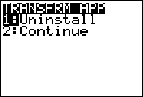
Select the TRIGCOMB program from the Program menu. Choose 2:Sine To Cosine and select 1:EQN 1. |  | 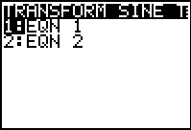
You will see the graph of the following function:  Y₁(x) = –1.5 sin + 4. Press □ and enter the cosine function into Y₂ that matches the sine function.  What is the equation that matches? |  | 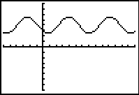
Clear out your function in Y2.  Do the same process with the second equation. Choose the TRIGCOMB program and select 2:Sine To Cosine. Choose 2:EQN 2 for the function: Y1 = 3 sin(2x) – 5.  What is the equation that matches? |  | 