Open the TI-Nspire document The_Mailbox.  Mathematical modeling can be an open-ended exploration. In this activity, you will examine the image of a mailbox and determine a mathematical question that you can explore and answer. | 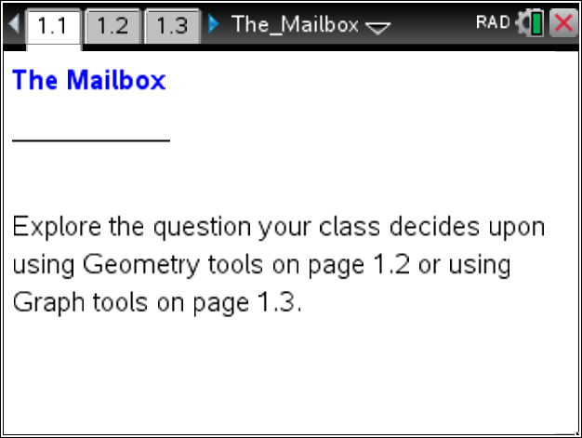  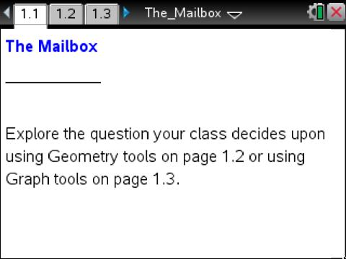

Move to page 1.2.
1. Look at the image of the mailbox. What mathematical questions could you explore?

2. What is the least amount of information you will need to know in order to calculate and answer your questions?

The scale given in the top right of page 1.2 is not correct for the actual size of the mailbox. It can be selected and modified.
3. What information do you need to correct the scale? How can you use that information to do so?

- What answer did you get to the question you were solving? The images below are provided to help you explain your method.

