Open the TI-Nspire document Law_of_Sines.tns.  You might know how to find unknown side lengths or angles when you have a right triangle, but what do you do when you can’t use the Pythagorean Theorem? In this activity, you will learn the Law of Sines, a relationship that you can sometimes use to find unknown side lengths or angles in non-right triangles.  . | 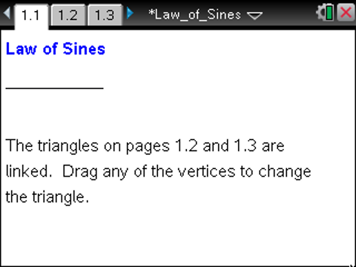

Move to page 1.2. | Press / ¢ and / ¡ to navigate through the lesson.
1. This page shows triangle ABC, with angles A, B, and C, and corresponding sides opposite those angles whose lengths are a, b, and c, respectively. You can drag any of the vertices to change the triangle.
a. Drag the vertices to change the shape of the triangle. How does the size of the angle relate to the length of the side opposite the angle? Explain.

b. Below the triangle, you will see ratios. What is each ratio comparing?

c. Drag the vertices, and observe the values of the ratios. What do you observe?

2. Adjust the triangle so that sin B = 1.
a. What is the measure of angle B? How do you know? What kind of triangle is triangle ABC?

b. Use trigonometric ratios to write sin A as a ratio of sides a and b.

c. Use the fact that sin B = 1 to show that, in this case, 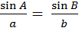 .

d. Use a similar argument to show that, in this case, 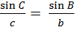.

e. Why must it be true, in this case, that 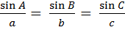 ?

Move to page 1.3.

3. The equality you just showed in question 2 is called the Law of Sines. It is true for all triangles, not just right triangles. Investigate why the Law of Sines is true on Page 1.3.
a. Move vertex B so that angle C is obtuse. When C is obtuse, the segment h appears within the triangle. The segment h is called an altitude of the triangle, and it is perpendicular to the side it intersects. Explain why the statement at the top of the screen, is true.

b. Using the fact that , explain why the Law of Sines is true for your triangle.

c. What if C is a different obtuse angle? Will this change your results in the previous parts of this problem?

4. a. Move vertex B until angle C is a right angle. How can you be certain C is a right angle?

b. Does the relationship between h, a, and b still hold when C is a right angle? Explain.

c. What does this tell you about the Law of Sines when C is a right angle? Explain.

5. The Law of Sines can be used to find unknown side lengths and angle measures in a triangle, including many triangles that are not right triangles. In order to use the Law of Sines to find unknown side lengths and angle measures in a triangle, what is the minimum information you would need to know about the triangle? Explain.

Move to page 1.5.

6. For each part below, set the side lengths and angle on your handheld as specified. How many triangles can you build with each of the specifications? Why is that true?
a. c = 3.5, a = 5.8, A = 60°

b. c = 3, a = 7, A = 25°

c. c = 5, a = 3.8, A = 40°

d. c = 6, a = 3.5, A = 30°

e. c = 6, a = 2, A = 30°

7. Fix c = 4 and t = 30°. Change the value of a, and observe the number of triangles that can be made. What is the relationship between side a, side c, and segment h (the perpendicular from vertex B to side b) when you can build 0, 1, or 2 triangles?

8. What do your results in question 7 tell you about when you can use the Law of Sines to solve for the unknown quantities in a triangle? Forming two triangles is called the Ambiguous Case. Under what circumstances will the Ambiguous Case occur? What quantities should you check before applying the Law of Sines? Explain.

Move to page 1.6.

9. Determine if there are 0, 1, or 2 triangles possible, and use the Law of Sines, if possible, to solve for the missing side lengths and angles in each of the following triangles. If no triangles are possible, explain why not.
a. a = 1.2, b = 1. B = 42º

b. a = 25, B = 39º, C = 112º

c. a = 2, b = 7, A = 41º

d. a = 10, c = 12, A = 50º

