Open the TI-Nspire document SD_Measure_of_Spread.tns.  Some data are close to the mean and some are not. In this activity, you will explore the meaning of standard deviation. | 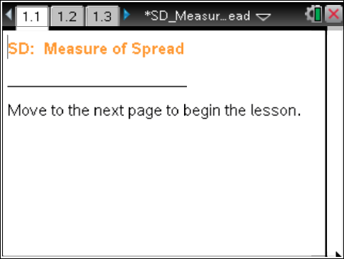

Move to page 1.3. | Press / ¢ and / ¡ to navigate through the lesson.
1. The graphs on page 1.3 display a distribution of hypothetical total rainfall to the nearest inch for a given month in a given year for the 15 states in the region of the United States classified as the South. The mean of the data set is indicated by the vertical line segment and the standard deviation by the horizontal line segment.
- Describe the information the mean provides about the amount of rainfall in the South for that month.

- Find the range, and describe the information it provides.

- Estimate the numerical value of the "standard deviation," and describe the information it could provide.

2. The arrow on the lower graph can be used to generate other possible distributions of rainfall amounts for that month in those 15 states that might, for example, have come from different years. Investigate how the distributions and associated summary measures change.
- What measure(s) remains constant? Explain why. What would this indicate about the amount of rainfall in those states for the different years?

- What measure(s) changes? Explain the relationship between the measure(s) and the distribution.

- Of the distributions you examined, why does the initial distribution have the smallest standard deviation?

- Describe a distribution with the largest possible standard deviation for 15 data values that have a mean of 5, a minimum of 0, and a maximum of 10. Explain your reasoning.

Move to page 2.2.

Tech Tip: To deselect a point, move the cursor to a white space on the screen and click. If you do not deselect a point you have moved, it will move again along with the next point you choose. Clicking on the vertical lines reveals the associated plot values.

3. The dot plot shows a possible distribution of the hypothetical total amount of rainfall for a given month in inches in a given year for the same 15 Southern states. You can move the points to change the possible distributions and investigate how the mean and the standard deviation change. The arrow resets the dot plot.
a. Sketch what you think a distribution with a standard deviation of approximately 0 inches would look like. Then create such a distribution by dragging the points. How well did it match your conjecture?

- Describe the distribution, and interpret it in the context of the rainfall.

4. a. How will the standard deviations compare if 1) distribution A has 14 data points with a value of 10 inches and one data point with a value of 0 inches, and 2) distribution B has 14 data points with a value of 7 inches and one data point at 0 inches? Explain your reasoning. Drag the points to verify your prediction.

b. In question 2d, you described a distribution with the largest possible standard deviation for 15 possible data values that have a mean of 5, a minimum of 0, and a maximum of 10. Verify your response to 2d by dragging points on the dot plot. Were you surprised? Why or why not?

c. If you allow the mean to vary between 0 and 10, do you think you can get a standard deviation larger than the one you found in your answer to question 4b? Explain your reasoning, and then test your conjecture by dragging the points.

5. Work with a partner to determine whether it is possible to have two different distributions with the same mean and standard deviation. If so, describe a strategy that worked. If not, explain.

6. What do you think is the biggest difference between a distribution with a small standard deviation and one with a large standard deviation?

This page intentionally left blank.

