Open the TI-Nspire document Comparing_Linear_and_Exponential_Functions.tns.  In this activity, you will explore the values of the expressions 3x and 3^{x} as x changes from 0 to 5. You will compare the two expressions by investigating patterns in how their values change both in a table and graphically. | 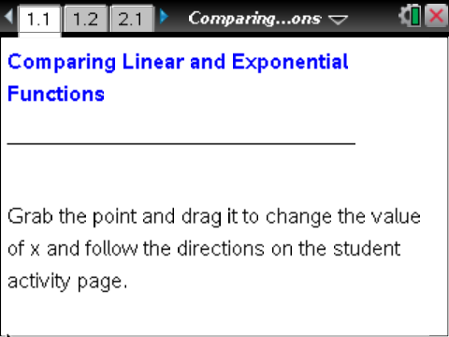

Move to page 1.2. | Press / ¢ and / ¡ to navigate through the lesson.
1. Grab and drag the point to change the value of x. Complete the table below. Which column is growing faster?

x | 3x | 3^{x}
0
1
2
3
4
5

2. a. As x increases from 2 to 3, how does the value of 3x change?

b. As x increases by 1, describe the pattern in the numbers in the 3x column of the table.

c. As x increases from 2 to 3, how does the value of 3^{x} change?

d. As x increases from 3 to 4, how does the value of 3^{x} change?

e. As x increases by 1, describe the pattern in the numbers in the 3^{x} column of the table.

3. On page 1.2 you can only look at values of x from 0 to 5. If x = 6, what would be the values of 3x and 3^{x}? How did you determine the values for 3x and 3^{x}?

4. Why are the values for 3^{x} increasing faster than the values for 3x?

5. The function f(x) = 3^{x} is called an exponential function, while the function f(x) = 3x is a linear function. Describe the differences in the two functions.

Move to page 2.1.

6. Drag the point to the right to produce two graphs—one solid, one dashed. Use the information from the table in question 1 to identify which graph represents an exponential function and which graph represents a linear function. Justify your answer.

7. How do the graphs of f(x) = 3x and f(x) = 3^{x} support your response to question 4?

8. Aaron says that the values of f(x) = 5^{x} will increase faster than the values of the linear function f(x) = 5x. Do you agree or disagree? Justify your answer.

