Open the TI-Nspire document Multiplying_Inequalities_by_Negative_Numbers.tns.  Note that 1 < 5, but –1 > –5. This activity lets you explore how pairs of numbers are ordered on a number line. You will also learn about the resulting effects of multiplying both numbers by positive or negative numbers. | 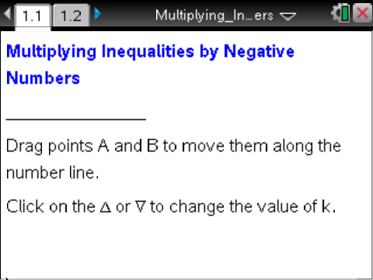

Move to page 1.2. | Press / ¢ and / ¡ to navigate through the lesson.
1. a. How is the inequality between A and B related to the inequality between A' and B'

b. How is A' related to A on the number lines?

2. By clicking on the up or down symbol on the screen (Δ or∇), change the multiplier k to 3.
a. What is the relationship between A and B related to the inequality between A' and B'?

b. How is A related to A' and B to B'?

3. a. Move point A from –5 to 5, and describe the changes that occur

b. Move point B to 5, and describe the changes that occur

4. Vary the value of the multiplier k between −4 and 4. Identify all values for k in the following.
a. A' = B'

b. A' = A, B' = B

c. A' and B' are in the same order as A and B

d. A' and B' are in a different order than A and B

5. Sara multiplied both sides of the inequality 1 < 5 by –1. Her answer was –1 < –5. Is she correct? Explain.

6. Complete the table below. For each description, state the inequality in column 2. Then describe how each value of k affects the relation on the right. The first row is partly done for you.

Description | Inequality | k = 3 | k = 0 | k = 2 | k = –4
Point A is left of point B | 1 < 5 | 3 < 15
Point A is right of point B and point B is less than 0
Point A is negative and point B is positive
Both points A and B are negative

7. In general, what value(s) of k will result in:
- The relationship in both inequalities being the same?

- The inequality symbol on the left becoming an equals sign on the right?

- The relationship in the inequalities being reversed?

8. Write an inequality comparing the two given numbers. Then complete the table using what you have learned about working with inequalities.
Numbers | Inequality | Multiply both sides by –3 | Multiply both sides by 4 | Add 2 to both sides | Subtract 3 from both sides | Divide both sides by –1
–1 , –10 | –10 < –1
2 , –10
–4 , –8

9. Tell whether the statement is always true, sometimes true, or never true. Give a reason for your thinking. (It might help to choose values for a, b, and c and test them with or without the .tns file.)
  - If a < b, then ac > bc.
b. If a ≥ b, then b ≤ a.

