Open the TI-Nspire™ document Linear_Inequalities_in_Two_Variables.tns.  The solution set for an inequality in two variables is the set of ordered pairs that satisfy that inequality. This activity gives you a visual way of thinking about the solution set to an inequality in two variables. | 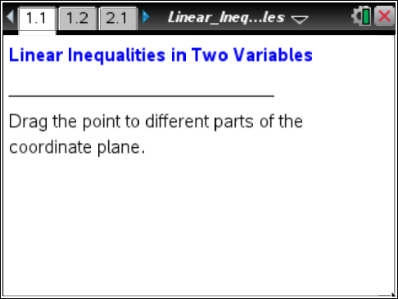

Move to page 1.2.
1. Move point P. Describe the changes that occur as you move the point. What stays the same?

2. Why do you think the line y = x + 1 is called a boundary line?

3. Complete the table below by moving the point to three locations: above the boundary line, on the boundary line, and below the boundary line.
 | Above the  Boundary Line | On the  Boundary Line | Below the  Boundary Line
Coordinates (x, y) of the Point
Equation or Inequality
on Screen
Verify by substituting
the coordinates into the equation or inequality.
Move to page 2.1.
4. The words true or false appears depending on where the point is located. What does true or false refer to in this context?

5. a. Select < for the inequality symbol by using the up or down arrows on the screen so that the inequality reads y < –x + 1. Now move the point to a location where this inequality is true. Show work to verify that the coordinates of the point you choose make the inequality a true statement. We say that such a point satisfies the inequality.

b. Explain why every point directly below this point must also satisfy the same inequality.

c. Explain why every point directly to the left of this point must also satisfy the same inequality.

6. a. Select > for the inequality symbol by using the up or down arrows on the screen so that the inequality reads y > –x + 1. Now move the point to a location where this inequality is true. Verify that the coordinates of the point you chose satisfy the inequality.

b. Explain why every point directly above this point must also satisfy the same inequality.

c. Explain why every point directly to the right of this point must also satisfy the same inequality.

7. The solution set for an inequality in two variables (x, y) is the set of all points in the plane that satisfy that inequality.
a. Use the up or down arrows on the screen to change the inequality symbol to < and then to >. Which points satisfy these new inequalities that did not satisfy the inequalities in Questions 5 or 6?

b. Explain in your own words how to graph the solution set to an inequality.

8. Write the linear inequality that is represented by these graphs. Check your solution on a TI-Nspire Graph page. Press . after f1(x) = to remove the equal sign and choose an inequality.

a. ______________ b. ______________
