Open the TI-Nspire document Proofs_of_Identities.tns.  An identity is an equation that is true for all values of the variables for which both sides of the equation are defined. In this activity, you will discover some trigonometric identities by manipulating the graphs of trigonometric functions. You will then use your algebraic skills and your knowledge of trigonometric representations to prove these identities. | 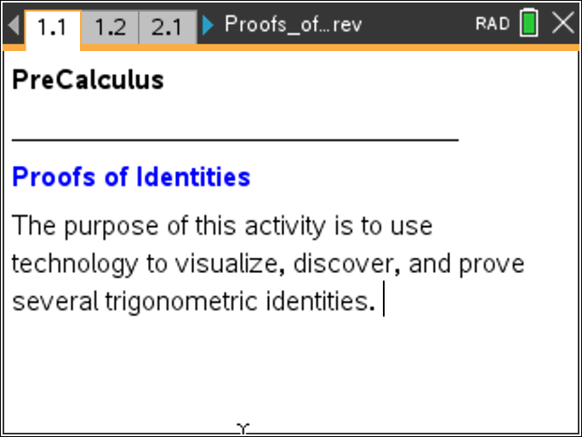
Move to page 1.2.
This page shows the graphs of two identical functions: f1(x) = 1 and f2(x) = 1. Throughout this activity, the graph of f1(x) is shown as a thin, solid line and the graph of f2(x) is shown as a thicker dashed line.

1. Press /G to access the function entry line. Press the up arrow (£) to access the equation for f1(x) and change it to csc(x). Change the equation for f2(x) to
What do you notice about the two graphs? Why is your conclusion true?

2. Complete the information for the other "Reciprocal Identities". To do so, you might want to change the equations for f1(x) and f2(x) to help you visualize the identities.
a.

b.

c.

d.

e.

3. Why are these statements called Reciprocal Identities?

Move to page 2.1.

Click on the slider to transform into
4. How does changing the parameter, a, affect the graph of

5. Write the equation for with a specific value for a such that

6. Using the information above, fill in the blank:
_____

Move to page 2.2.

This page shows the unit circle and the definitions for three basic trigonometric functions in terms of x, y, and r. The segment labeled r has been reflected over the x-axis. Drag point P, and observe how the coordinates of point and its image point change.
7. Consider the relationship between the coordinates of and the coordinates of Write the coordinates of and the image point, in terms of x and y.

8. Using the coordinates of the image point and the definitions of the basic trigonometric functions shown on the screen, write an expression for sin(–) in terms of sin().

Move to page 2.3.

Click on the slider to transform into
9. How does changing the parameter, a, affect the graph of

10. Follow the directions in questions 5 and 6, using the cosine function instead of the sine function. Write the equation for in the space below.

Move back to page 2.2.

11. Using the coordinates of the image point and the definitions of the basic trigonometric functions shown on the screen, write an expression for cos(–) in terms of cos().

Move to page 2.4.

Click on the slider to transform into
12. Follow the directions in questions 5 and 6, using the tangent function instead of the sine function. Write the equation for in the space below.

13. Use the information you obtained about and in questions 8 and 11 to write an expression for tan(–) in terms of tan().

14. Use the information from above to fill in the information below for the "Negative Angle Identities."
a.

b.

c.

Move to page 3.1.

Click on the slider to transform into
15. How does changing the parameter, a, affect the graph of

16. Use the equation for to fill in the blank:
_______________.

Move to page 3.2.

This page shows a right triangle with acute angles and labeled. Press the arrow (£) to see the image of the triangle after a copy of the right triangle is placed so that the two triangles form a rectangle. Press the arrow (£) again to see the measures of two additional angles labeled as and
17. Why are the two angles in the image labeled as they are?

18. What is the relationship between and Explain your answer.

Move to page 3.3.

19. a. Click and drag vertex A and vertex B. What do you notice about and Write an equation to express in terms of

b. Substitute for to re-write the equation above in terms of

20. We see from questions 17 - 19 that the sine of an acute angle is equal to the cosine of its complement. The sine and cosine functions are called cofunctions. The tangent and cotangent functions are also cofunctions. Use this information to fill in the blanks below for the "Cofunction Identities."

a. ( _____________ )

b. ( _____________ )

c. ___________________

Move to pages 3.4 and 3.5.

Use these pages to support the identities you wrote in question 20.

Move to page 4.2.

Move the sliders to change the values of the two parameters in to transform the graph of into
21. Write the equation for with specific values for a and b such that

Move to page 4.3.

This page shows a right triangle and the definitions of three basic trigonometric functions in terms of the lengths of the sides.
22. Divide both sides of the Pythagorean Formula by a² as shown, and simplify the result. Substitute the appropriate trigonometric functions for the ratios and , and rewrite the equation below.

23. Repeat the process, dividing by b² and then by c² to yield two additional identities. Fill in the information below for the "Pythagorean Identities."

a. _____________ = sec²(x)

b. _________+ cot²(x) = __________

c. sin²(x) + ________= _________

Move to page 4.4.

Use this page to visually support the identities you derived in question 23. Press / G to access the function entry line. Press the up arrow (£) to access f3(x). Enter the left half of the equation from #23b as f3(x) and the right half of the equation as f4(x). Repeat the process for the equation for #23c.

24. a. Using the Pythagorean Identity, divide all three terms by and simplify the fractions to write another Pythagorean Identity.

b. Use the identity to divide all three terms by , and simplify the fractions to write another Pythagorean Identity.

