Part 1 – Warm Up
1. When is y = e^{x} increasing and when is it decreasing? Sketch the graph.

2. For what values of x greater than 2 is y = e^{x} greater than y = x³? Sketch y = x³ on the same graph.
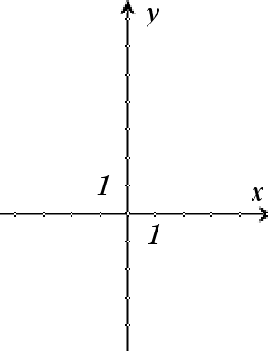
3. Fill in the blank: e^{x} is greater than x⁴ when x > _______.

4. Exponential growth occurs for y = e^{ax} when a is ________. If y = b^{x}, exponential growth occurs for what values of b?

5. Exponential decay occurs for y = e^{ax} when a is ________. If y = b^{x}, exponential decay occurs for what values of b?

6. Let y(x) = 3e^{kx}. Solve for k when y(4) = 9. Show your work.

Part 2 – Infestation (Exponential Growth)
The rate of increase of bugs is proportional to the number of bugs in a certain area. When t = 0, there are 2 bugs and they are increasing at a rate of 3 bugs/day.
1. If b is the number of bugs, express the first sentence as a differential equation.

2. The first step to solve this DE is to separate the variables. Do this step.

3. Next, integrate both sides of the equation.

4. Why do you not need to put a “+ C” on both sides of the equation after integrating?

5. Find the particular equation for the number of bugs as a function of time by applying the initial conditions. Show work to solve for b. Also, repeat the steps given on page 3.7.
6. How many bugs are there on the beginning of the 2nd day? At the beginning of day 3?

7. When will there be approximately 1,200 bugs? Show the equation and what you substituted.

Part 3 – Extermination (Exponential Decay)
1. Mr. Exterminator arrives to save the day when there are 1,600 bugs. He applies some poison which produces an exponential decay such that the rate of decrease is proportional to the number of bugs. At the start of day 2 of bug elimination, t = 2, you estimate 600 bugs. Find the particular solution for the number of not-dead-yet bugs as a function of time, d(t). Show all of the steps to solving this separable differential equation.

2. Mr. Exterminator says the poison lasts for 10 days. Use the Graph Trace tool to determine how many bugs are still alive when t = 10.
d(10) = _____________

3. Should you have him come back for a second application? Explain.

4. About how many days until there is only one bug left? Show work or explain your method.

