About the Lesson  - This lesson is aligning with the curriculum of IB Mathematics Applications and Interpretations SL/HL and IB Mathematics Approaches and Analysis SL/HL  - This falls under the IB Mathematics Core Content Topic 5 Calculus:  5.2 Increasing and decreasing functions, and the graphical interpretations of the first derivative of a function.  5.6 (AI) Local maximum and minimum points.  5.7 (AA) Graphical behavior of functions between f, f’, and f”.  As a result, students will:  - Realize information about a graph based on the first and second derivatives.  - Learn that a function’s derivative is positive when the function increases and negative when the function decreases.  - Learn that the second derivative is positive when the graph is concave upward and negative when the graph is concave downward.  Vocabulary  - derivatives  - concavity  - relative/local maximum  - relative/local minimum  Teacher Preparation and Notes  - Students can complete this activity independently but may benefit from the discussion that occurs when working in a small group.  - Students should be able to understand how the first derivative provides information about where the function is increasing or decreasing and how the second derivative provides information about the concavity of the graph.  - Many students can understand that when a function is increasing, the derivative is positive, but they cannot correctly interpret what that means on a graph. Instead of understanding that this means the graph is always above the x-axis, some students may think that the derivative is increasing.  - Have the students begin with a graph such as y = cos(x). Have students examine the derivative or slope of the function at each point as they move through an interval where the function is increasing. Ask students what a graph of those derivatives at each point would look like.  TI-Nspire™ Navigator™ System  - Send out the Derivatives and their Graphing Relationships.tns file if you want the students to answer questions on the Nspire.  - Monitor student progress using Class Capture.  - Use Live Presenter to spotlight student answers.  Activity Materials  Compatible TI Technologies:  TI-Nspire™ CX Handhelds,   TI-Nspire™ Apps for iPad®,  TI-Nspire™ Software | 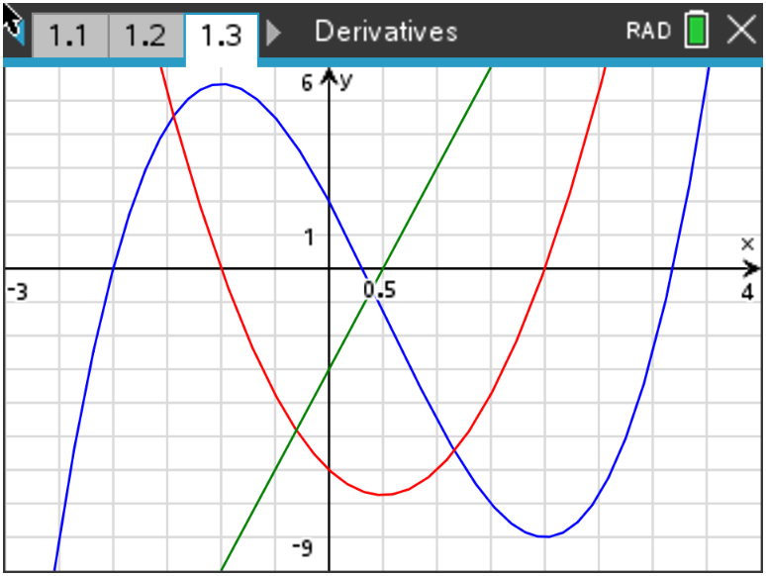  Tech Tips:  - This activity includes screen captures taken from the TI-Nspire CX II handheld. It is also appropriate for use with the TI-Nspire family of products including TI-Nspire software and TI-Nspire App. Slight variations to these directions may be required if using other technologies besides the handheld.  - Watch for additional Tech Tips throughout the activity for the specific technology you are using.  - Access free tutorials at http://education.ti.com/  calculators/pd/US/Online-Learning/Tutorials  Associated Materials:  - Derivatives and their Graphing Relationships_Student.pdf  - Derivatives and their Graphing Relationships_Student.doc  - Derivatives and their Graphing Relationships.tns

Teacher Tip: This might be a good time to refresh student memories about the difference between Radian and Degree modes on the handheld. You can also show them how to change the Settings so all answers are rounded to the nearest hundredth.
The first and second derivative of a function can provide a great deal of information about the function itself. In this activity, you will examine the graphs of functions along with their derivatives and look for relationships that exist.

Throughout this activity, make sure your handheld is in Radian mode and round your answers to the nearest hundredth.

Problem 1 –
1. Input the equation into a graphs page. Set the viewing window as shown and graph on your handheld.
Answer:
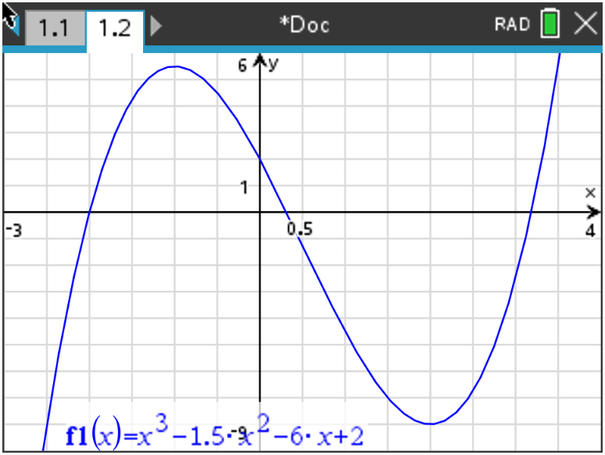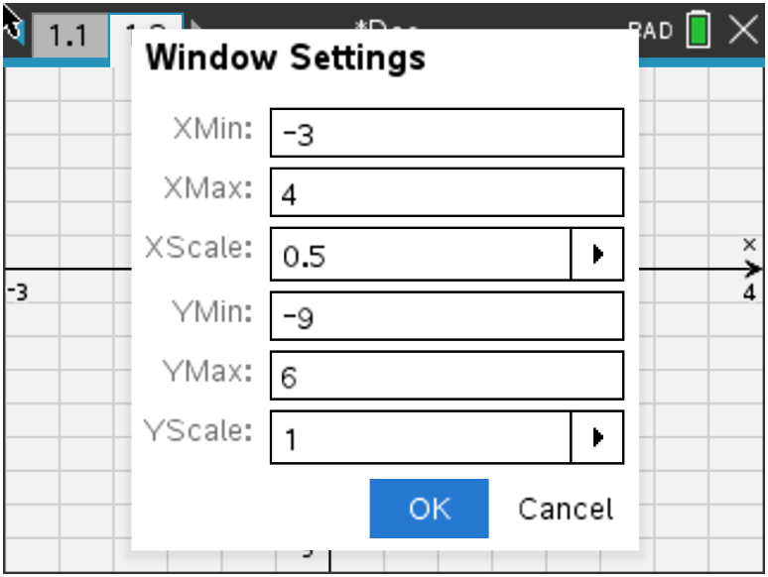

2. Find the x-values at which the relative maximum and relative minimum values of the
function occur. Press Menu > 6 Analyze Graph.
Answer: The relative maximum occurs at x = -1, and the relative minimum occurs at x = 2.

3. Find the intervals of x over which the function increases.

Answer: The function increases over (-∞, -1) and (2, ∞).

4. Find the intervals of x over which the function decreases.

Answer: The function decreases over (-1, 2).

Teacher Tip: A discussion might be needed to review different notations students can use when describing intervals of increase or decrease, as well as concave up or concave down. This document uses interval notation, as seen in number 4, (-1, 2), can also be written as -1 < x < 2.

5. State the kind of values the derivative should have over an interval where the function increases.
Explain.

Answer: The derivative should have positive values. The derivative is the rate of change or slope
at a point, and an increasing portion of a graph has a positive rate of change.

6. Graph the derivative of the function. Press Tab > Math Templates Key > . You will need
to fill in the spaces provided from this derivative command. It should look like this: .
You can find by pressing var, or you can just type .

Answer:
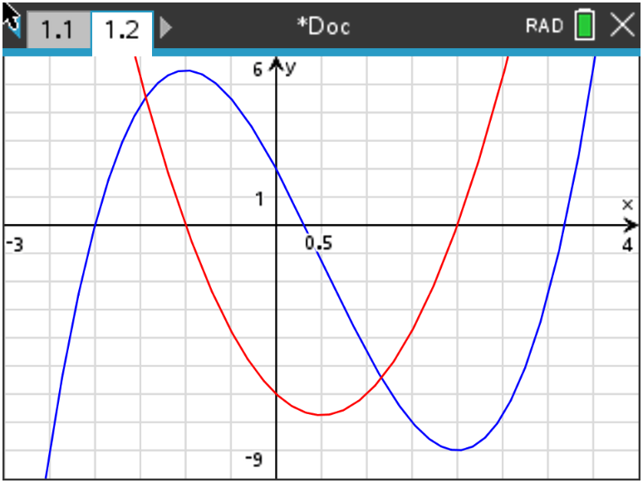

7. Find the x-values of the derivative where a relative maximum or minimum of the original function
occurs.
Answer: The derivative at each relative maximum or minimum is equal to zero.

8. State if the derivative is positive or negative over the intervals where the function increases.

Answer: The derivative is positive where the function increases.

9. State if the derivative is positive or negative over the intervals where the function decreases.

Answer: The derivative is negative where the function decreases.

10. When the derivative crosses the x-axis from positive to negative, describe what happens to the graph
of the function.

Answer: When the derivative crosses the x-axis from positive to negative, the function has a relative
maximum.

11. When the derivative crosses the x-axis from negative to positive, describe what happens to the
graph of the function.

Answer: When the derivative crosses the x-axis from negative to positive, the function has a relative
minimum.

12. State over what intervals of x the derivative increases.

Answer: The derivative increases from (0.5, ∞).

13. State over what intervals of x the derivative decreases.

Answer: The derivative decreases from (-∞, 0.5).

14. If the first derivative is increasing, state if the second derivative is positive or negative.

Answer: If y ‘ is increasing, y ‘’ is positive because y ‘’ is the derivative of y ‘.

15. If the first derivative is decreasing, state if the second derivative is positive or negative.

Answer: If y ‘ is decreasing, y ‘’ is negative because y ‘’ is the derivative of y ‘.

16. Graph the second derivative into . Use the same commands you used to find the first
derivative, the only difference is instead of using you will be using Examine it
where the first derivative is increasing and decreasing. State if it matches your predictions.
Explain any differences, and state any additional observations.

Answer:
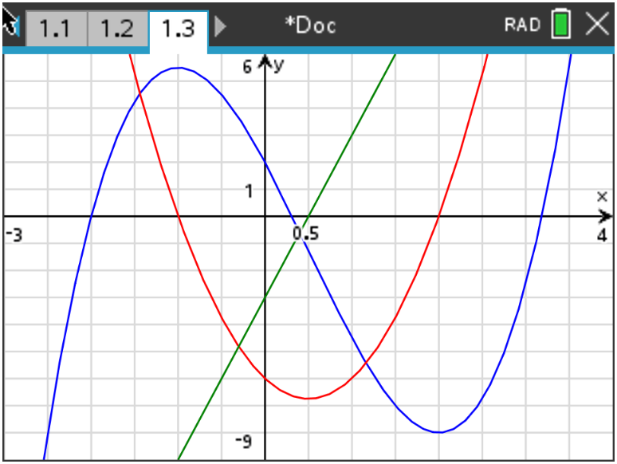

17. The graph of a function is concave upward when the graph of the first derivative is increasing. Sketch
a portion of the graph that is concave upward. State what is true about the graph of
where the graph of is concave upward.

Answer: Check students’ sketches. The second derivative is positive.

18. The graph of a function is concave downward when the graph of the first derivative is decreasing.
Sketch a portion of the graph that is concave downward. State what is true about the graph
of where the graph of is concave downward.

Answer: Check students’ sketches. The second derivative is negative.

Problem 2 -

19. Graph the equation over the interval [-5, 5] on your handheld
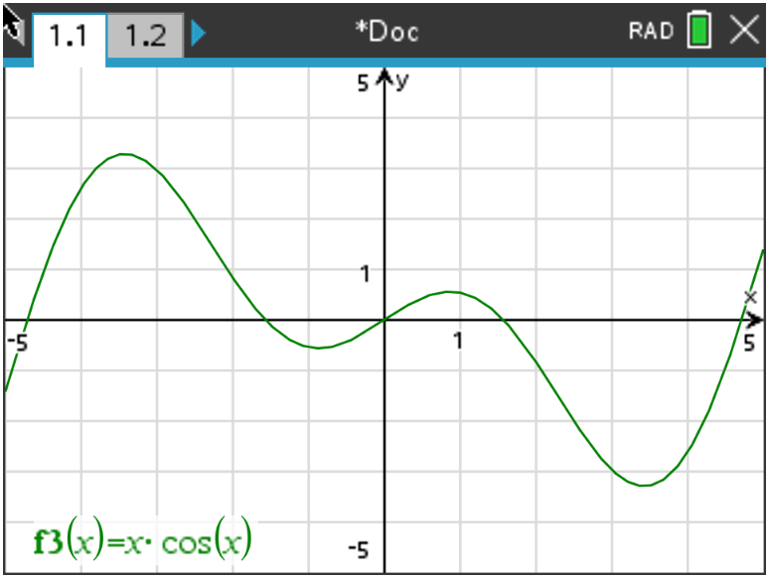

a. State the interval(s) of x-values where the function is increasing.

Answer: The function is increasing from (-5, -3.43), (-0.86, 0.86), and (3.43, 5) within the viewing
window.

b. State the interval(s) of x-values where the function is decreasing.

Answer: The function is decreasing from (-3.43, -0.86) and (0.86, 3.43).

c. State the interval(s) of x-values where the function is concave upward.

Answer: The graph of the function is concave upward from (-2.29, 0) and (2.29, 5).

d. State the interval(s) of x-values where the function is concave downward.

Answer: The graph of the function is concave downward from (-5, -2.29) and (0, 2.29).

Teacher Tip: In problem 3 you may have to answer some questions as the students will be graphing the first derivative and not the original function. Let them explore and discover before giving assistance.

Problem 3 –

20. Suppose that you have only an equation for the derivative of a function. The derivative of f(x) is:

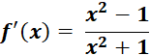

Graph this into and then change the window to the dimensions seen here. Using your handheld
as a guide, sketch the graph below.
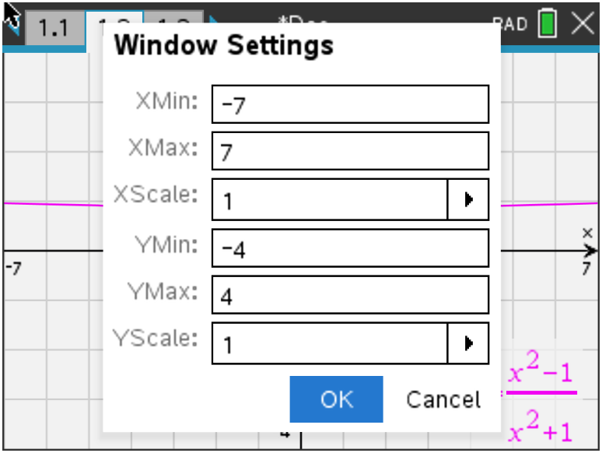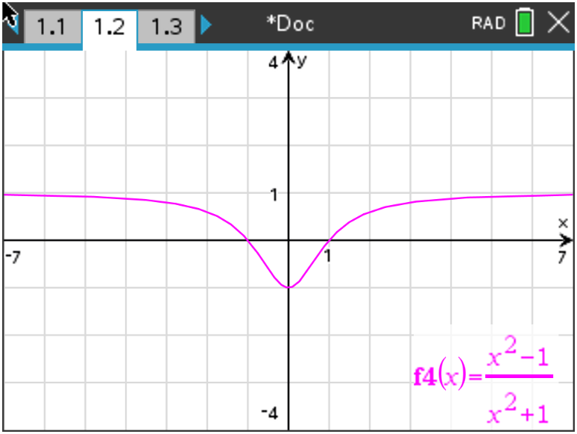

a. State the interval(s) of x-values where the function y = f(x) increases. Explain.

Answer: The function increases where the derivative is positive. These intervals are (-∞, -1) and
(1, ∞).

b. State the interval(s) of x-values where the function y = f(x) decreases. Explain.

Answer: The function decreases where the derivative is negative. The interval is (-1, 1).

c. State the interval(s) of x-values where the function y = f(x) is concave upward. Explain.

Answer: The graph of the function is concave upward when the first derivative is increasing. This
interval is (0, ∞).

d. State the interval(s) of x-values where the function y = f(x) is concave downward. Explain.

Answer: The graph of the function is concave downward when the first derivative is decreasing. This
interval is (-∞, 0).

Ticket Out the Door -

21. Summarize at least three main concepts that you explored in this activity.

Answer: Answer will vary, but should include the following:
The derivative is positive when the graph of the function is increasing and negative when the
function is decreasing.

The graph of the function is concave upward when the derivative is increasing or second
derivative is positive.

The graph of the function is concave downward when the first derivative is decreasing or the
second derivative is negative.

**Note: This activity has been developed independently by Texas Instruments and aligned with the IB Mathematics curriculum, but is not endorsed by IB™. IB is a registered trademark owned by the International Baccalaureate Organization.

