Overview

The purpose of the .tns file described in this document is to utilize parametric equations to enable students to see the graph of an object’s height as a function of time, in addition to seeing the actual path of the object.

Materials

• TI-Nspire™ handheld or Computer Software

Step 1—Preparing the document  1. Open a new document on the handheld by pressing c > New Document. Open a new document in the Teacher Software by clicking File > New TI-Nspire Document.  2. Select Add Notes.  3. Create a title page for the activity. | 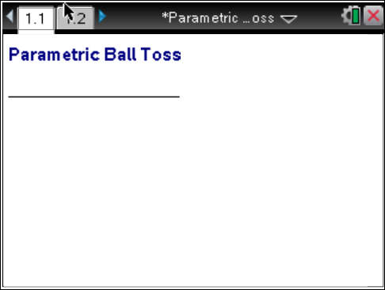
From this point on, directions for the Computer Software and the Handheld will be notated separately where appropriate.
4. Handheld: Add another Notes page by selecting /~ > Add Notes (or /I > Add Notes).
Computer Software: Add another Notes page by clicking Insert > Notes.
5. Handheld: Select MENU > Insert > Math Box (or press / M) to add a Math Box.
Computer Software: Select Document Tools > Insert > Math Box (or press Ctrl+M).

6. Add separate Math Boxes for each of the following parametric function definitions and press · after each function:  - x1(t) := t (On the handheld, you can press / t to obtain Ï.)  - y1(t) := -16t^2+32t+48  Note: If you do not want to see the > Done message at the end of each entry, select / MENU > Math Box Attributes, and change the Input & Output to Hide Output. | 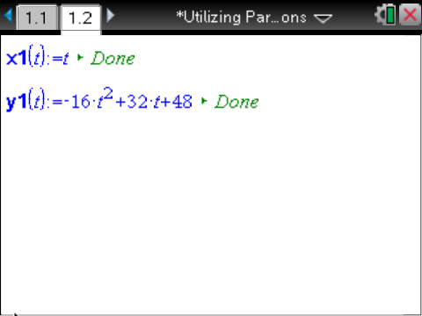
7. Handheld: Select ~ > Page Layout > Select Layout, and select the option to split the whole page in half vertically, with the left side also split in half horizontally (resulting in three work areas).
Computer Software: Select Edit > Page Layout > Select Layout, and choose the appropriate icon to split the page in half vertically, with the left side also split in half horizontally (resulting in three work areas).
8. Add a Notes page to the lower left work area, and add a Graphs page to the right work area. The upper left work area is the Notes page you have already created and modified. | 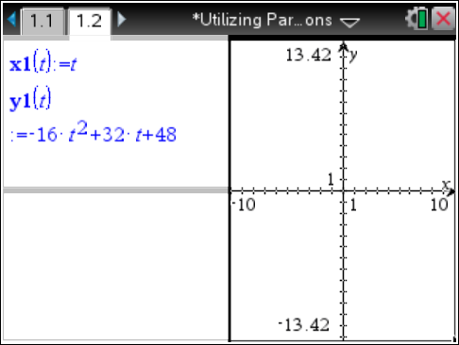
9. In the Graphs work area, change the window settings to [-1.5,3,5] x [-5,75] by selecting MENU > Window/Zoom > Window Settings.
Computer Software: Select Document Tools > Window/Zoom > Window Settings.
10. If necessary,
Handheld: To hide the function entry line, press / G or click on the chevron, .
Computer Software: To hide the function entry line, click on the chevron, .

Step 2—Add a Slider  11. Handheld: While still in the graphing work area, select MENU > Actions > Insert Slider. Position the slider in the left portion of the graph screen. Rename the slider variable n.  Computer Software: Select Document Tools > Actions > Insert Slider.  12. Handheld: Select / > MENU > Settings, change the slider settings as indicated in the screens to the right, and click OK.  Computer Software: Right-click in the slider box, select Settings, change the slider settings as indicated in the screens to the right, and click OK | 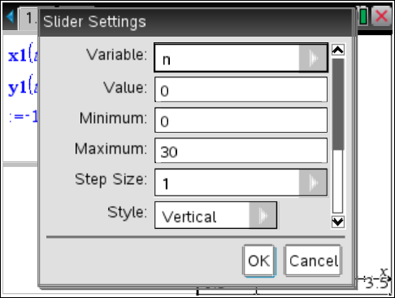  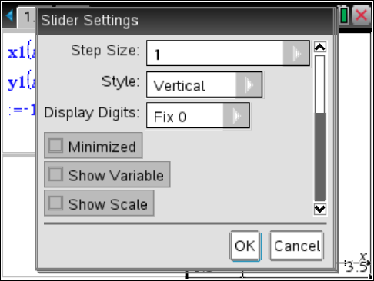
The figure to the right shows the slider created with the settings  given above. | 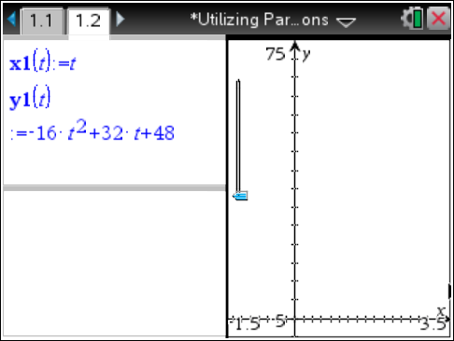

Step 3—Setting up the Other Notes Pane
13. In the bottom Notes work area, insert the following Math Boxes. (Remember to press · after each one.)
- To make it easier to change functions, add:
  - tstep := 0.1
  - tmin := 0

- For the parametric plot, add:
  - x1plot := seq(x1(t*tstep),t,tmin,n)
  - y1plot := seq(y1(t*tstep),t,tmin,n)

- To see the path of the ball, add:
  - x2plot := {-1,x1(n*tstep)}
  - y2plot := {y1(n*tstep),y1(n*tstep)}

- (Optional) Change Math Box Attribute: Hide output.
The figure to the right shows the set-up of the bottom Notes work area.  Note: If you change the parametric function definitions, x1(t) and y1(t), it might be necessary to adjust the graph window, slider range, tstep, and tmin. | 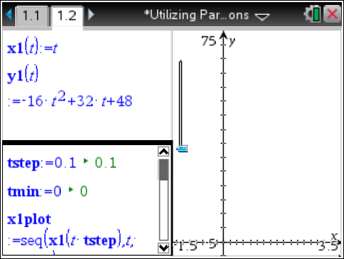
Step 4— Complete the Set-Up of the Graphs Work Area  14. Handheld: In the Graph work area, select MENU > Graph Entry/Edit > Scatter Plot. For scatter plot s1, press h, select x1plot for the x-value and y1plot for the y-value, and press ·.  Computer Software: Select Document Tools > Graph Entry/Edit > Scatter Plot. For scatter plot s1, click on the round “var” button at the top of the screen, select x1plot for the x-value and y1plot for the y-value, and press Enter. | 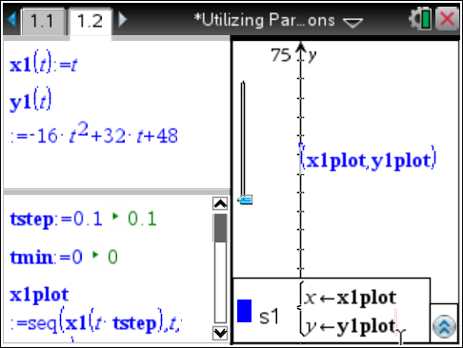
15. Handheld: Press / G to re-open the entry line. Move up using the arrows to s1(x, y), and select / MENU > Attributes.  Computer Software: Right-click on s1(x, y), and select Attributes. | 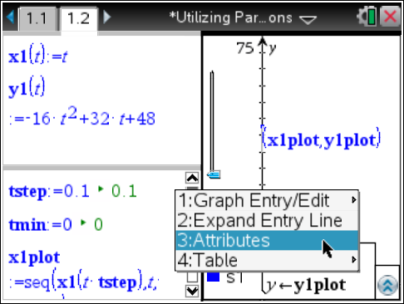
16. Choose the thin point and the connected graph from the Attributes menu. | 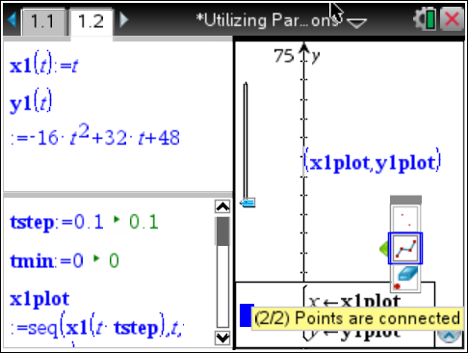
17. The following is a list of the coordinates and attributes for the three scatter plots:
- Scatter plot s1: (x1plot,y1plot); Attributes: thin point, connected graph.
- Scatter plot s2: (x2plot,y2plot); Attributes: large solid point, connected graph.

18. Handheld: To join the two points with a dotted segment, select MENU > Geometry > Points and Lines > Segment, and click on each of the two plotted points to form the line segment.
Computer Software: Select Document Tools > Geometry > Points and Lines > Segment, and click on each of the endpoints to make a line segment.
19. Handheld: Move your cursor over the line segment, select / > MENU > Attributes, and choose thin line and dotted.  Computer Software: Right-click on the line segment, select Attributes, and choose thin line and dotted. | 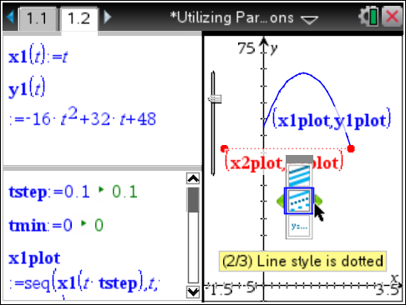
20. Handheld: Hide the endpoints of the line segment by moving your cursor over each of the two endpoints and selecting / > MENU > Hide.
Computer Software: Hide the two endpoints by right-clicking on each of them and selecting Hide.
21. Handheld: Hide the labels of the scatterplots by moving your cursor over each label and selecting / > MENU > Hide.  Computer Software: Hide the labels of the scatterplots by right-clicking on each label and selecting Hide. | 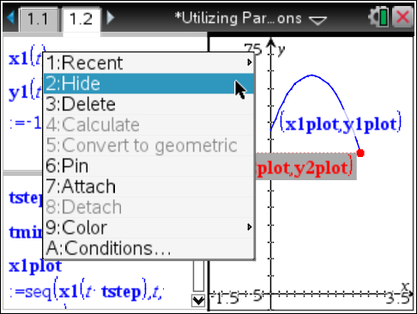
Note: You might want to adjust your screen so the graph on the right is larger.
Handheld: Select ~ > Page Layout > Custom Split. You will see a wheel in the center of the page; press the arrows ( ¡ ¢ ) to move the column to the desired location and press · to set the column in place.
Computer Software: Position your cursor on the vertical line separating the two vertical panes. When you see the double-sided arrow, click and move the column to the desired location and release to set the column in place.
Note: You might also want to slide the lower left quarter pane out of sight completely.  Handheld: Select ~ > Page Layout > Custom Split. You will see a wheel in the center of the page; press the arrows ( £¤) to move the pane to the desired location and press · to slide the pane out of sight.  Computer Software: Position your cursor on the horizontal line separating the two horizontal panes. When you see the double-sided arrow, click to slide the pane out of site and release.  As you move your slider, your screen should look like the one to the right. | 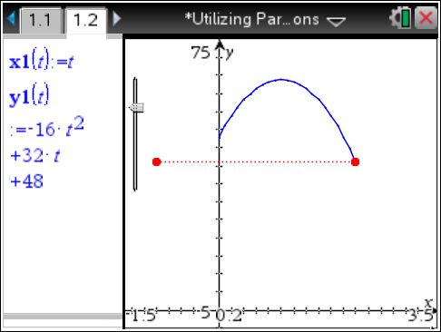
Note: Handheld: To eliminate the need to grab and drag the slider, you can animate it. To do so, click on the slider, and select / MENU > Animate. To stop the animation, press / MENU > Stop Animate.
Computer Software: Right-click on the slider, and select Animate. To stop the animation, right-click on the slider, and select Stop Animate.

