Open the TI-Nspire document Focus_Directrix_Definition_ of_Conics.tns.  Any conic can be defined by the relationship between two important features, its focus and its directrix. In this activity, you will explore those relationships for different types of conic functions. | 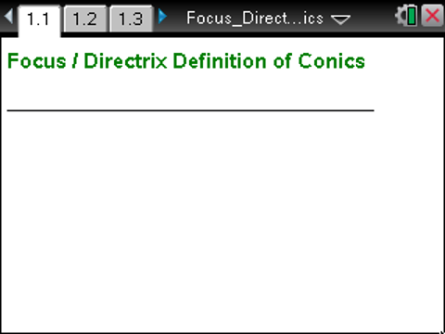

Move to page 1.3. | Press / ¢ and / ¡ to navigate through the lesson.
1. The point F is called the focus of the parabola pictured, and the horizontal line is called the directrix.
a. As you drag the point F, what do you notice about the distance between F and the x-axis and the distance between the directrix and the x-axis?

b. Suppose you set the focus to (0, 18). What would the equation of the directrix be? How do you know?

2. Point P is an arbitrary point on the parabola.
a. What do the segments and represent?

b. As you drag point P along the parabola, what do you observe about the distance between P and the focus and the distance between P and the directrix?

c. If you change the location of the focus, what happens to the relationship you observed in part b? Explain.

3. Based on your observations in Questions 1 and 2, what is the relationship between any point on the parabola and the focus and directrix? Explain.

4. Use your response to Question 3 to define a parabola in words based on its focus and directrix.

Move to page 2.2.

5. Point F is the focus of the ellipse and the vertical line is the directrix.
a. Drag point F along the positive x-axis. Does the directrix change with the focus as in the case of the parabola? What relationship do you observe between the focus and the directrix?

b. Set the focus to the point (3, 0). What happens to the shape of the ellipse as you drag point d to change the location of the directrix? What is the relationship between the focus and the directrix and the shape of the ellipse?

6. Set the focus to point (3, 0) and d to (6, 0). Point P is an arbitrary point on the ellipse.
a. What do the segments and represent?

b. As you drag point P along the ellipse, what do you observe about the relationship between PF and PQ?

c. Relocate the focus and/or the directrix, and drag point P along the new ellipse. What happens to the relationship between PF and PQ?

7. Based on your observations in Questions 5 and 6, what must be the relationship between any point on an ellipse and the focus and directrix of the ellipse.

8. Use your response to Question 8 to define an ellipse in words by its focus and its directrix.

Move to page 3.2.

9. Point F is the focus of the hyperbola and the vertical line is the directrix.
a. Drag point F along the positive x-axis. Does the directrix change with the focus as in the case of the parabola? What relationship do you observe between the focus and the directrix?

b. Set the focus to the point (6, 0). What happens to the shape of the hyperbola as you drag point d to change the location of the directrix? What is the relationship between the focus and the directrix and the shape of the hyperbola?

10. Set the focus to the point (6, 0) and d to (3, 0). Point P is an arbitrary point on the hyperbola, and point P’ is the corresponding point on the other branch of the hyperbola.
a. What do the segments , , , and represent?

b. As you drag point P along the hyperbola, what do you observe about the relationship between PF and PQ? Between P’F and P’Q?

c. Relocate the focus and/or directrix and move P along the hyperbola. What effect does this have on the relationships you observed in part b?

11. Based on your observations in Questions 9 and 10, what must be the relationship between any point on the hyperbola (include both branches) and the focus and the directrix of the hyperbola?

12. Use your response to Question 11 to define a hyperbola in words based on its focus and directrix.

13. Revisit your definitions in Questions 4, 8, and 12. Are your definitions for the three conics sufficiently distinct that, given a definition you could say with certainty which conic you are describing? If so, explain why. If not, modify your definitions to make them sufficiently distinct.

