Open the TI-Nspire document Introduction_to_Conics.tns.  Is there a relationship between the locus definition and the vertex form of a parabola? In this activity, you will explore conic sections and the parabola. | 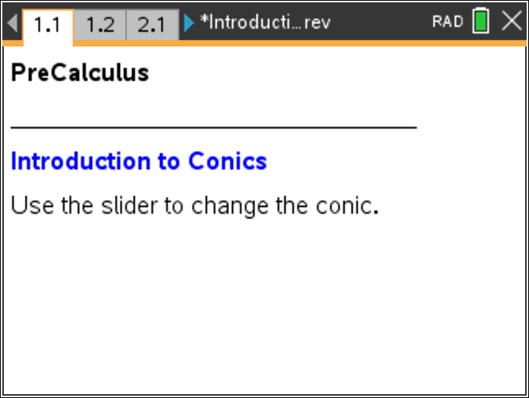

Move to page 1.2.

1. Use £ and ¤ to scroll through the different conic sections. Briefly describe how each of the conic sections is formed. Complete the table below.
Conic Section | Description
Circle
Ellipse
Parabola
Hyperbola
Move to page 2.1.

2. Point F is called the focus of the parabola. What is the line through point F perpendicular to the directrix called?

3. Line d is called the directrix. What is the relationship between line d and the dashed line through point F?

4. Drag point P along the curve. What property seems to be true for all points along the parabola?

5. Drag point F around the screen. Does the property observed in Question 4 remain true? Explain your answer.

Move to page 2.2.

6. The vertex form of the equation for a parabola, y = a(x – h)² + k, is shown.
Use £ and ¤ to change the value of a. Describe how the value of a affects the graph.

7. Use £ and ¤ to change the value of h. Describe how the value of h affects the graph.

8. Use £ and ¤ to change the value of k. Describe how the value of k affects the graph.

Move to page 3.1.

9. Given focus (m, n), directrix y = d, and point (x, y) on a parabola, use the distance formula to derive the equation for any parabola function.
a. Find the distance between the focus and point P.

b. Find the distance between point P and the directrix.

c. Set the two distances you found in Questions 9a and 9b equal to each other and solve for y.

10. Use the vertex form of the equation for a parabola, y = a(x – h)² + k, and the derived equation from Question 9 to answer the following questions.
a. Explain the relationship among the focus, the directrix, and the value of a.

b. Explain the relationship between the focus and the value of h.

c. Explain the relationship among the focus, the directrix, and the value of k.

