Open the TI-Nspire document Histograms.tns.  Histograms are useful for representing and analyzing data. In this activity, you will examine different histograms of the same data set. | 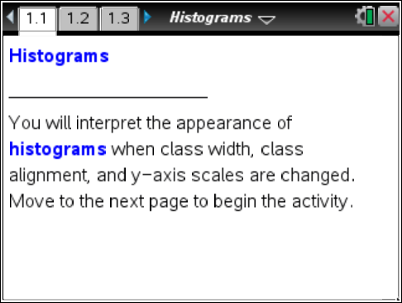

Move to page 1.2.
Twenty-three high school girls were selected at random, and each was asked to report the number of pairs of shoes she owned. The data are given in the following table.

Number of Pairs of Shoes
20 | 12 | 31
21 | 12 | 8
10 | 10 | 5
10 | 51 | 30
5 | 20 | 20
12 | 12 | 20
50 | 15 | 9
30 | 15

Note: The terminology the TI-Nspire uses is different from traditional histogram vocabulary. ‘Bin’ is used instead of ‘class’; therefore, bin width is the same as class width and bin alignment is the same as class alignment.
Move to page 1.3.
Tech Tip: Move your cursor over a bin to display the bin interval and the number of data points contained in the bin.
Tech Tip: Tapping a bin will display the bin interval and the number of data points contained in the bin.
1. Page 1.3 shows a frequency histogram for the shoes data. Use this histogram to describe the shape and center of the distribution. Explain your answer.

2. a. Use the histogram to find the number of girls who have fewer than 13 pairs of shoes. Explain your reasoning.

b. What interval will contain the median number of pairs of shoes? Explain how you determined your answer.

3. a. What is the width of each bin in the histogram? Explain how you know.

b. Make a conjecture about the histogram if the bin width is set to two. Explain your reasoning.

c. Change the bin width to 2 to check your answer. Select Menu > Plot Properties > Histogram Properties > Bin Settings > Equal Bin Width. Enter 2 for the width, and select ·. Does the histogram support your conjecture in part b?

Tech Tip: To change the bin width to 2, select  > Plot Properties > Histogram Properties > Bin Settings > Equal Bin Width. Enter 2 for the width and select OK.
d. The bin width can also be changed by dragging the vertical edge of the bin. Drag the right edge of the left-most bin so that it appears as if the histogram has only one gap. Explain whether this is a good representation for these data.

Move to page 1.4.

4. Two histograms (associated with the shoes data) are displayed in a split screen. The top work area displays a histogram with percent on the vertical scale; the bottom work area displays density on the vertical scale. Analyze the two screens to determine similarities and differences.
a. What is similar about the two distributions?

- What is different about the two distributions?

- If you were to add up the percents in each bin in the top work area, what value should you get? Add the actual percent values to check your conjecture, and explain why the answer makes sense. (Note: On the TI-Nspire handheld, you can select » and add the values using the Scratchpad. Select d to return to the Histogram.tns document.)

- What is the total area of the bins in the density histogram? Explain your reasoning.

Move to page 1.5.

5. Page 1.5 is a split screen displaying two frequency histograms that were created from the same data set. The bin width is 5 for both histograms, but the bin alignment has changed. The bin alignment changes the starting point of the bins, thus it changes the bin intervals.
a. Compare and contrast the histograms.

b. Using either histogram, can you tell if any girl owned 54 pairs of shoes? Explain how you know.

c. Which display would you use if you were a girl arguing that you had to have more shoes because most other girls had a lot of shoes? Which display would you use if you were arguing that most girls did not have that many pairs of shoes? Explain your reasoning in both cases.

6. What are some of the advantages and disadvantages of using a histogram to display data?

