This activity uses the reduced row-echelon form of a matrix to solve systems of three equations with three unknowns. To follow a step-by-step process for row reduction, see the activity: Solving Systems Using Row Operations 1.
1. Open a new document and choose a Calculator page by pressing c > New Document > Add Calculator.

2. Press Menu > Matrix & Vector > Reduced Row-Echelon Form. | 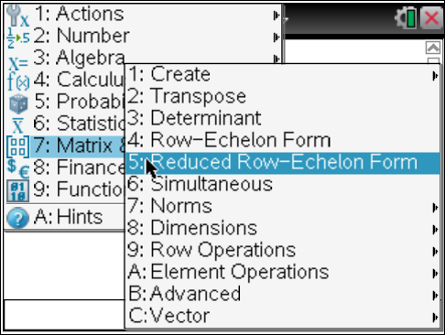
3. Press the t key and choose the 3 X 3 matrix template.  4. Make sure the number of rows is 3. Tab to the number of columns and change it to 4, tab to OK, and press ·. | 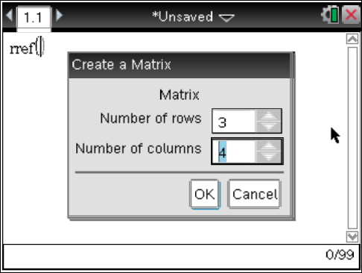
5. Enter the coefficients into the matrix, using the e key to move from element to element. The matrix shown is for the system of equations:  Press ·.  6. The resulting solution matrix will be displayed. | 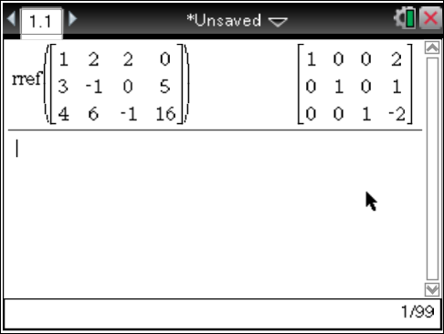
7. To enter another system of equations you may repeat the above Steps 2 through 5 or press £ twice to highlight the command. Press ·. Go to each element and press . to delete the previous value and enter the new value. Use the e key to move from element to element. When completed, press ·.

8. Identify the system as consistent (dependent or independent) or as inconsistent. Give the geometric interpretation of the solution as a point, a line, or having no common intersections.

Given System | Reduced Row-Echelon Form | Type of System | Solution | Geometric  Interpretation

9. How do you know when a matrix is in reduced row-echelon form?

10. What does the last column of the reduced row-echelon matrix represent?

11. Solve the following systems. Identify the system as consistent (dependent or independent) or as inconsistent. Give the geometric interpretation of the solution as a point, a line, or having no common intersections.
Given System | Reduced Row-Echelon Form | Type of System | Solution | Geometric  Interpretation
a.
b.
c.
d.

12. In a reduced row-echelon solution matrix:
a. Why does a last row of 0 0 0 1 indicate no solution?

b. Why does a last row of 0 0 0 0 indicate a dependent system?

c. Explain what types of systems result when the main diagonal does not consist entirely of 1s.

13. For each of the following types of systems, fill in the blank with the appropriate geometric interpretation. When solving a system of three equations with three unknowns,
a. a consistent and independent system results in a/an _____________________.

b. a consistent and dependent system results in a/an _______________________.

c. an inconsistent system results in _________________________________.

