Open the TI-Nspire™ document Standard_Form_of_Quadratic_Functions.tns.  How do the parameters in the standard form of the quadratic equation, , determine the shape of the graph? In this lesson, you will use sliders to investigate this question. | 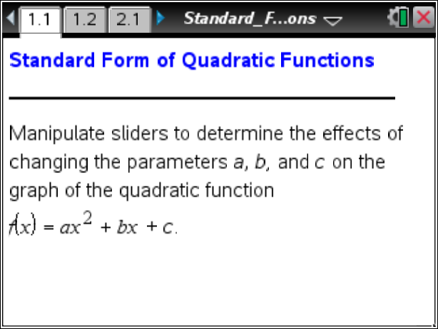

Move to page 1.2.

This page has the graph of a parabola in the standard form with a point P on the graph.

- Set a = 1, b = 0, and c = 0. Note that point P has coordinates (2, 4). Click the slider to increase the value of a. Observe the effect on point P when a > 1. In the table below, list the coordinates of point P for four values of a > 1. Describe what happens to the y-value of point P as the value of a increases.

a =
P-coordinates

- a. Lisa says that when she sees the y-values being vertically stretched away from the x-axis. Describe how it is similar yet different from the behavior of the function when a > 1. Use the slider to verify your answer.

b. Write a sentence to explain the effect that a change in the value of a (for a > 1 or a < –1) has on the graph of the function . Explain why this happens.

- a. Set a = 1, b = 0, and c = 0. Click the slider to examine the effect of values of a when 0 < a < 1. What happens to the y-value of P?

- Set a = –1, b = 0 and c = 0. Click the slider to examine the effect of values of a when –1 < a < 0. What happens to the y-value of P?

- Explain why this is called a vertical shrink or compression.

4. Changing the value of a appears to change all of the points on the parabola except the y-intercept. Adjust each slider one at a time and observe the effect on the y-intercept. How is the location of the y-intercept related to the values of the three sliders?

5. Given the parabola , set a = 1 and b = 0. Adjust the slider to change the value of c. Explain why and how the graph is changing.

Move to page 2.1.

This page has the graph of a parabola in the standard form, , with the coordinates of the vertex given.

6. Set a = 1, b = 0, and c = 0. Click the slider to change the value of variable b. In the table below, fill in the coordinates of the vertex for the given parabolas.
V: (0, 0)  a = 1 b = 0 | V:  a = b = | V:  a = b = | V:  a = b = | V:  a = b =
 | V:  a = b = | V:  a = b = | V:  a = b = | V:  a = b =

7. Using the information from the table above, write a rule to determine the x-coordinate of the vertex. Explain your reasoning.

8. Set a = 2, b = 0, and c = 0. Click the slider to change the value of the variable b. In the table below, fill in the coordinates of the vertex for the given parabolas.

V: (0, 0)  a = 2 b = 0 | V:  a = b = | V:  a = b = | V:  a = b = | V:  a = b =
 | V:  a = b = | V:  a = b = | V:  a = b = | V:  a = b =

9. Based upon the information from the table above, check question 7 to see if the rule you wrote is correct. If not, make the necessary changes and answer the following questions.
- Predict the x-value of the vertex of the parabola . Use the sliders to check your answer.

- Explain how to determine the y-value of the vertex without using the sliders.

10. The axis of symmetry is the line about which a parabola can be reflected without changing its position. Which point does the line of symmetry go through?

11. Write the equations, in standard form, for two parabolas that have the same axis of symmetry but different values of a. Check the work by adjusting the sliders.

12. Describe the difference between a vertical shift and a vertical stretch or compression.

13. What effect does the value of c have on the x-coordinate of the vertex of the parabola ? What effect does the value of c have on the y-coordinate of the vertex? Explain why this is so.

14. a. Write an equation for a parabola that opens up with a vertex of (1, 4).

- Explain how you obtained your answer.

- Why is there more than one possible correct equation?

15 a. Write an equation for a parabola that opens down with a vertex of (1, 4).

b. Explain how you obtained your answer.

- If you knew that the y-intercept was (0, 2), would your answer to part 15a change? Why or why not?

