Capacitors
The charge q on a capacitor’s plate is proportional to the potential difference V across the capacitor. We express this with
where C is a proportionality constant known as the capacitance. C is measured in the unit of the farad, F, (1 farad = 1 coulomb/volt).
If a capacitor of capacitance C (in farads), initially charged to a potential V₀ (volts) is connected across a resistor R (in ohms), a time-dependent current will flow according to Ohm’s law. This situation is shown by the RC (resistor-capacitor) circuit below when the switch is closed.
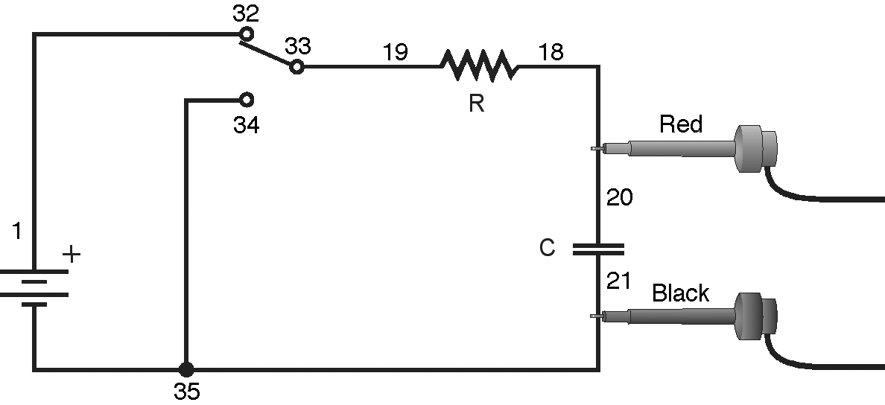
Figure 1
As the current flows, the charge q is depleted, reducing the potential across the capacitor, which in turn reduces the current. This process creates an exponentially decreasing current, modeled by
The rate of the decrease is determined by the product RC, known as the time constant of the circuit. A large time constant means that the capacitor will discharge slowly.

objectives
- Measure an experimental time constant of a resistor-capacitor circuit.
- Compare the time constant to the value predicted from the component values of the resistance and capacitance.
- Measure the potential across a capacitor as a function of time as it discharges.
- Fit an exponential function to the data. One of the fit parameters corresponds to an experimental time constant.
Materials
TI-Nspire handheld or | Vernier Circuit Board or
computer and TI-Nspire software | 10 μF non-polarized capacitor
data-collection interface | 47 kΩ and 100 kΩ resistors
Voltage or Differential Voltage Probe | 2 C- or D-cell batteries with holder
connecting wires | single-pole, double-throw switch

Pre-lab questions
1. Consider a candy jar, initially with 1000 candies. You walk past it once each hour. Since you don’t want anyone to notice that you’re taking candy, each time you take just 10% of the candies remaining in the jar. Sketch a graph of the number of candies remaining as a function of time.
2. How would the graph change if instead of removing 10% of the candies, you removed 20%? Sketch your new graph.

Procedure
1. Connect the circuit as shown in Figure 1 above with the 10 μF capacitor and the 100 kΩ resistor. Record the values of your resistor and capacitor in your data table, as well as any tolerance values marked on them.
2. Connect the clip leads on your voltage probe across the capacitor, with the red (positive lead) to the side of the capacitor connected to the resistor. Connect the black lead to the other side of the capacitor.
3. Connect your voltage probe to the data-collection interface. Connect the interface to the TI-Nspire handheld or computer.
4. Choose New Experiment from the Experiment menu. Choose Collection Setup from the Experiment menu. Enter 20 as the rate (samples/second) and 5 as the experiment duration in seconds. The number of points collected should be 101. Select OK.
5. Set the switch in its other (open) position to allow the capacitor to fully discharge. When the readings have stabilized, choose Setup Sensors ► Zero from the Experiment menu.
6. Set the switch to the closed position illustrated in Figure 1. Wait at least 10 seconds to ensure the capacitor is fully charged.
7. Start data collection (). When data starts to appear in the graph, throw the switch to its open position to discharge the capacitor. After data collection is complete, a graph of voltage vs. time will be displayed.
8. Fit the exponential function y = A*e^ (-Cx) to your data.
- Select the decay region of the data. Be sure to only include values that are positive.
- Choose Curve Fit ► Natural Exponential from the Analyze menu.
- Record the value of the fit parameters in your data table. Notice that the C used in the curve fit is not the same as the C used to stand for capacitance.

9. Print or sketch the graph of voltage vs. time.
10. Click the Store Data button () to save the first run. Modify the circuit to replace the 100 kΩ resistor with a 47 kΩ resistor. Repeat Steps 5–9.

Data
 | Resistor |  | Capacitor | Time constant | Fit Parameters
Trial | R  (Ω) | C  (F) |  | RC  (s) | A | C | 1/C
Discharge 1
Discharge 2

Processing the data
1. In the data table, calculate the time constant of the circuit used; that is, the product of resistance in ohms and capacitance in farads. Note that 1 Ω•F = 1 s.
2. From the fit parameter C, calculate and enter in the data table 1/C for each trial.

Questions
1. Compare the fit equation to the mathematical model for a capacitor discharge proposed in the introduction,
Interpret the fit parameters A and C. What aspects of your experiment do they measure? What are their units?
2. How do the values for 1/C (Processing the Data Step 2) compare to the values of the time constant of your circuit (Processing the Data Step 1).
3. Note that resistor and capacitor are not marked with their exact values, but only approximate values with a tolerance. Ask your instructor the tolerance of the resistors and capacitors you are using. If there is a discrepancy between the two quantities compared in Question 2, can the tolerance values explain the difference?
4. What is the effect of reducing the resistance of the resistor on the way the capacitor discharged?
Extensions
1. Make a plot of ln(V) vs. time for the capacitor discharge. What is the meaning of the slope of this plot? How is it related to the RC constant?
2. What percentage of the initial potential remains after one time constant has passed? After two time constants? Three?
3. Use a Current Probe and Differential Voltage Probe to simultaneously measure the current through the resistor and the potential across the capacitor. How will they be related?
4. Instead of a resistor, use a small flashlight bulb. To light the bulb for a perceptible time, use a large capacitor (approximately 1 F). Collect data. Explain the shape of the graph.
5. Try different value resistors and capacitors and see how the capacitor discharge curves change.
6. Try two 10 μF capacitors in parallel. Predict what will happen to the time constant. Repeat the discharge measurement and determine the time constant of the new circuit using a curve fit.
7. Try two 10 µF capacitors in series. Predict what will happen to the time constant. Repeat the discharge measurement and determine the time constant for the new circuit using a curve fit.

