Open the TI-Nspire document Monopoly_Regression.tns.  Is there any relationship between the distance from Go and the cost of the properties in a standard Monopoly board game? In this activity, you will explore the answer to this question by analyzing the association between the number of spaces from GO and the cost of the corresponding property. | 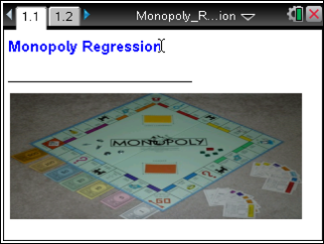

The following data are the number of spaces from GO and the cost of the property for each property on a standard Monopoly board.
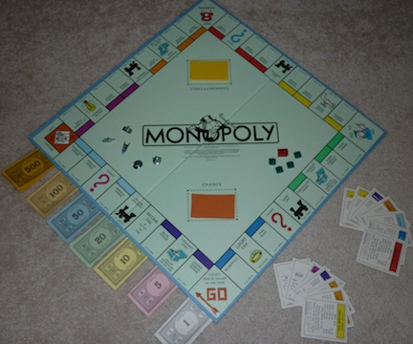
Property | Spaces from GO | Cost
Mediterranean Avenue | 1 | 60
Baltic Avenue | 3 | 60
Reading Railroad | 5 | 200
Oriental Avenue | 6 | 100
Vermont Avenue | 8 | 100
Connecticut Avenue | 9 | 120
St. Charles Place | 11 | 140
Electric Company | 12 | 150
States Avenue | 13 | 140
Virginia Avenue | 14 | 160
Penn Railroad | 15 | 200
St. James Place | 16 | 180
Tennessee Avenue | 18 | 180
New York Avenue | 19 | 200
Kentucky Avenue | 21 | 220
Indiana Avenue | 23 | 220
Illinois Avenue | 24 | 240
B & O Railroad | 25 | 200
Atlantic Avenue | 26 | 260
Ventnor Avenue | 27 | 260
Water Works | 28 | 150
Marvin Gardens | 29 | 280
Pacific Avenue | 31 | 300
North Carolina Avenue | 32 | 300
Pennsylvania Avenue | 34 | 320
Short Line Railroad | 35 | 200
Park Place | 37 | 350
Boardwalk | 39 | 400

Move to page 1.2. | Press / ¢ and / ¡ to navigate through the lesson.
Page 1.2 of the .tns file on the handheld shows a table of the data displayed above.
1. Use the scroll bar at the right to look through the data in the table.
a. Do you notice any trends or any noteworthy data values?

b. Which variable would make sense to be the explanatory variable? The response variable? Explain your reasoning.

2. Insert a new page (1.3) by selecting ~ > Insert > Data & Statistics.
- Create a scatterplot for the data by moving the cursor to the bottom center where it says Click or Enter to add variable.
- Click on the text and select the variable spaces.
- Move the cursor to the center of the left axis, and select cost as the variable0.
3. a. Describe the association between the two variables.

b. Describe any unusual points in your scatterplot.

4. Insert a new page (1.4) by selecting ~ > Insert > Lists & Spreadsheet.
- Move the cursor to the shaded area in the second row of Column A.
- Calculate the least squares regression line for the data by selecting MENU > Statistics > Stat Calculations > Linear Regression (a+bx).
- Press the right arrow for X List:, and choose Spaces.
- Tab to Y List:, and choose Cost.
- Press ·or select OK.
5. a. Write the equation that describes the relationship between the number of spaces from GO and the cost of the properties.

b. Interpret the slope in terms of the context.

c. Interpret the y-intercept. Does it have a meaning in this context? Explain your reasoning.

Move back to page 1.3.

6. On the scatterplot of the data, plot the least-squares regression line on your scatterplot by selecting MENU > Analyze > Regression > Show Linear (a+bx).
7. How well does the line fit the data?

8. Interpret the correlation coefficient.

9. What is the meaning of the coefficient of determination, r²?

10. Insert a new page (1.5) by selecting ~ > Insert > Data and Statistics.
- Create a residual plot by moving the cursor to the lower part of the screen until you see Click or Enter to add variable.
- Select the variable stat.yreg (these are the predicted cost values).
- Move the cursor to the left of the screen until you see Click or Enter to add variable, and select stat.resid.
11. Describe the residual plot. Based only on the residual plot, would you consider your original data to be approximately linear? Explain why or why not.

Move back to page 1.3.

12. In question 6, you displayed the least squares regression line on the scatterplot. If you removed the outliers from the scatterplot, predict how the regression line would change.

Move back to page 1.2.

13. On Page 1.2, delete the following data points for the railroad and utility properties: (5, 200), (12, 150), (15, 200), (25, 200), (28, 150), and (35, 200).
14. Return to Page 1.3, and answer these questions.
a. Was your prediction in question 12 correct? Explain your reasoning.

b. Describe the slope of the new regression line.

Move to page 1.5.

15. Select MENU > Window/Zoom > Zoom-Data, and examine the new residual plot. Does it support a conclusion that the data are more linear? Explain your reasoning.

16. There is one unusual point in the upper right-hand corner. This is the residual for Boardwalk. Explain why it is so large in context of the problem.

