Open the TI-Nspire document Isotopes_Atomic_Mass.tns.  Most elements have two or more stable isotopes (26 elements have a single stable isotope). The atomic mass given in the Periodic Table is an average atomic mass based on the masses and natural abundances of the stable isotopes. A mass spectrometer can be used to determine the masses and abundances of the isotopes. This data is used to determine the average atomic mass of an element. | 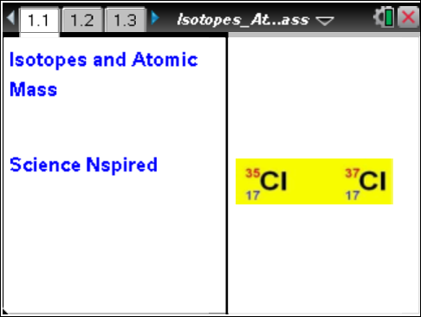

Move to pages 1.2 – 1.4. Answer the following questions here or in the .tns file.
Q1. Most elements have two or more isotopes, like Cl-35 and Cl-37. _________. All of the isotopes of an element have the same number of _________. (More than one response may be correct.)
A. protons | B. neutrons |  | C. electrons
Q2. Isotopes of an element have a different number of _________. (More than one response may be correct.)
A. protons | B. neutrons |  | C. electrons
Q3. Isotopes of an element have the same mass.
A. True |  | B. False
Move to page 1.5.  1. Examine the schematic diagram of a mass spectrometer. |  |  |  | 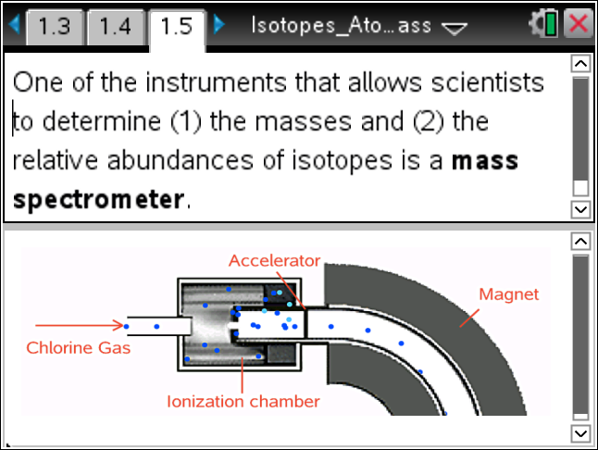
Move to page 1.6. Answer the following question here or in the .tns file.
Q4. In the first stage of the mass spectrometer the atoms in the vaporized gas (chlorine in this
case) _________.
A. are ionized to become +1 ions | B. pass through a magnetic field |  | C. enter into the detector
Move to pages 1.7 and 1.8.  2. Read the instructions on page 1.7 for running the mass spectrometer simulation on page 1.8. After starting the simulation, you can use the up/down arrows to adjust the magnetic field. The counts per second (CPS) will provide data about the abundance of each isotope. |  |  |  | 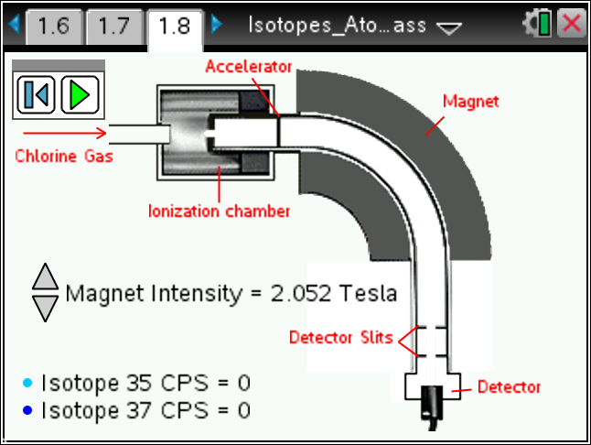
Move to pages 1.9 – 1.21. Answer the following questions below or in the .tns file.
Q5. Based on the data from the mass spectrometer, which Cl isotope has the greatest abundance?
A. Cl-35 |  | B. Cl-37
Q6. To three significant figures, the percent of Cl-35 is _________%.

Q7. If chlorine were 50% Cl-35 and 50% Cl-37, the average atomic mass of Cl (to four significant figures) would be _________ amu.
Data: Cl-35 is 34.97 amu.
Cl-37 is 36.97 amu.
1 amu = 1.66054 x 10^{–27} kg

Q8. The average atomic mass (four significant figures) for Cl is _________ amu.
Data: The abundance of Cl-35 (34.97 amu) is 75.78%.
The abundance of Cl-37 (36.97 amu) is 24.22%.

Q9. 10,000 carbon atoms have a mass of _________ amu.
Data: The abundance of C-12 (12.000 amu) is 98.93%.
The abundance of C-13 (13.003 amu) is 1.07%.
A. 12,000  B. 12,010 |  | C. 13,000  D. 13,003
Q10. The average atomic mass of C is _________ amu.
A. 12.00 | B. 12.01 |  | C. 13.00
Q11. The average atomic mass (four significant figures) for Mg is _________ amu.
Data: The abundance of Mg-24 (23.985 amu) is 78.99%.
The abundance of Mg-25 (24.986 amu) is 10.00%.
The abundance of Mg-256 (25.983 amu) is 11.01%.

Q12. The percentage of Ga-69 found in nature is _________ % (three significant figures).
Data: Ga is 69.723 amu.
Ga-69 is 68.926 amu.
Ga-71 is 70.925 amu.

