Open the TI-Nspire™ document Understanding_Slope.tns  The slope of a line can be determined using two points on the line. Does it matter which two points you choose? This activity introduces the idea of slope with movable points on a line. | 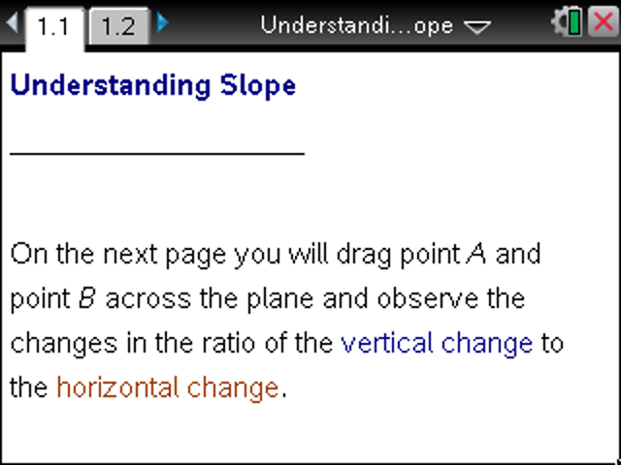

Move to page 1.2.

1. Following the arrows from point A to point B, what is the value of the vertical change?
Of the horizontal change?

2. Move one or both points until the values for both the vertical and horizontal changes are positive. Describe the line.

3. Write your answer to question 2 in the first row of the table below. Move your points to match each pair of remaining conditions. For each case, describe what the line looks like.
Vertical Change | Horizontal Change | Does the line rise or fall from left to right?
Positive | Positive
Positive | Negative
Negative | Positive
Negative | Negative
4. What patterns do you observe in your descriptions in the previous table?

5. Set point A to (–4, 1).
a. Where must you place point B for the line to rise from left to right?

b. Where must you place point B for the line to fall from left to right?

6. Set point A to coordinates of your choice.
a. Where must you place point B for the line to rise from left to right?

b. Where must you place point B for the line to fall from left to right?

7. Ann says that her point B is above and to the right of point A. Elizabeth says that her point B is below and to the left of point A. Jessica says her point B is to the right of point A. Whose line must rise from left to right? Explain.

8. The slope of a line is defined as the ratio of the vertical change to the horizontal change for any two distinct points on the line.
a. What relationships must exist between the vertical and horizontal changes to produce a positive slope?

b. To produce a negative slope?

9. In each question so far, you have been following the arrows from point A to point B. If you started at point B and moved to point A, how would that change your previous answers?

