Part 1 – Plotting Coordinates & Exploring Polar Graphs
The coordinates of a polar curve are given as (θ, r).
1. On page 1.3, grab and drag the head of the arrow r so that it is at (a) (15°, 4), (b) (270°, 5), (c) and (d) . Plot and label these points on the graph below.
2. If r(θ) = cos(θ), what is r?

3. Let r(θ) = 2 – 2cos(θ). Plot points of r(θ) by entering values of r into the spreadsheet on page 1.6. What is the shape of the graph?

4. Use page 2.2 to explore the graph of a polar function. Grab and drag the open point on the circle. Confirm your values for r on page 1.5. Double-click on r1(θ) to change the equation. Explore different equations. Which of the following did you make? Write the equation next to the graph shape.
- circle
- rose with even number of petals
- rose with odd number of petals
- limaçon with an inner loop

Part 2 – Slopes of Polar Graphs
5. How do you find the slope of a line tangent to a polar graph?

6. Recall the polar graph from page 1.3. When r and θ are known, how can you find the corresponding x- and y-coordinates?

7. a. What are the criteria that determine when a horizontal tangent will occur?  b. How many horizontal tangents occur on the polar rose to the right?  c. Find the angle θ of the point where the horizontal tangent is shown to the right? | 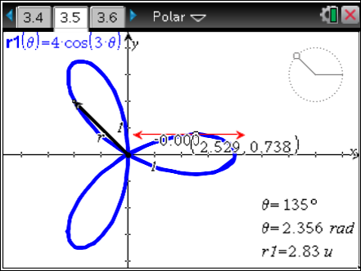
d. Consider how CAS was used on page 3.7 to solve for all θ between 0 and π for the horizontal tangent of r1(θ) = 4cos(3θ). Use this Calculator application to similarly find the angle for the vertical tangents. Show the setup and answers.

8. Find when θ = for r1(θ) = 4cos(3θ). Show you work. Do not use a calculator to solve this problem. (Hint: Use your answer to Problem 6 to help you.)

Part 3 – Area of Polar Graphs
The equation for the area inside a polar curve is where θ₁ and θ₂ are the “first” two times r = 0.
9. What are the limits of integration to find the area of one petal of r1(θ) = 4sin(3θ)?

10. Use CAS to find the area of the first petal of r1(θ) = 4sin(3θ).

