Open the TI-Nspire document Pangaea_Fossil_Puzzle.tns  Are the continents moving? Were all of the continents once joined together in one big “supercontinent”? What evidence do we have to support that idea? These were some of the questions Alfred Wegener, a German meteorologist, tried to answer in the early 1900s. He proposed the theory of continental drift in which the supercontinent, Pangaea, split apart. By visiting various fossil dig sites, you will collect one type of evidence he used to recreate Pangaea. |  | 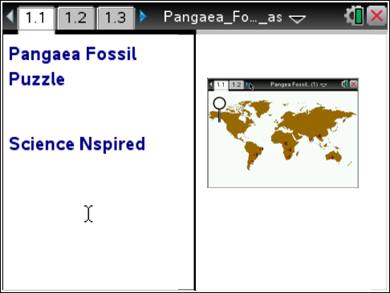
Move to page 1.2. and read the information given.
Alfred Wegener was not the first scientist to propose the idea that the continents were once joined together as a "supercontinent". However, he was the first to use different kinds of evidence, such as fossils, to support this theory of continental drift. A fossil is the remains or imprint of an organism from the past that has been preserved in Earth’s crust. In this activity, you will explore how the locations of fossils around the world support the theory of continental drift.

Move to page 1.3 and answer question 1 below and/or on your device.
Q1. Similar fossils are found on the east coast of South America and the west coast of Africa. Brainstorm a list of explanations for this discovery.

Move to page 1.4 and read the information given. Then move to page 1.5.
Read the directions for the simulation.
1. Select and drag the magnifier to each numbered fossil dig locations on the map. When the question mark appears, select the site to reveal the fossil. | 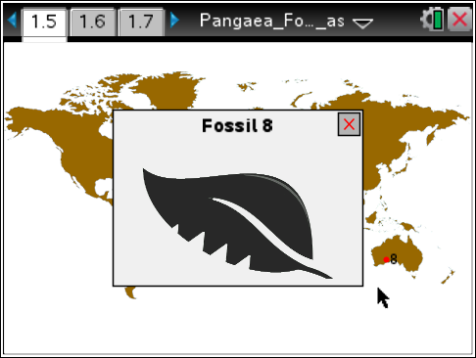
Tech Tip: To access the Directions again, select > Pangaea Fossil Puzzle > Directions.
Tech Tip: To access the Directions again, select b or Document Tools () > Pangaea Fossil Puzzle > Directions.
2. Record the fossil types found at each location on the map below.
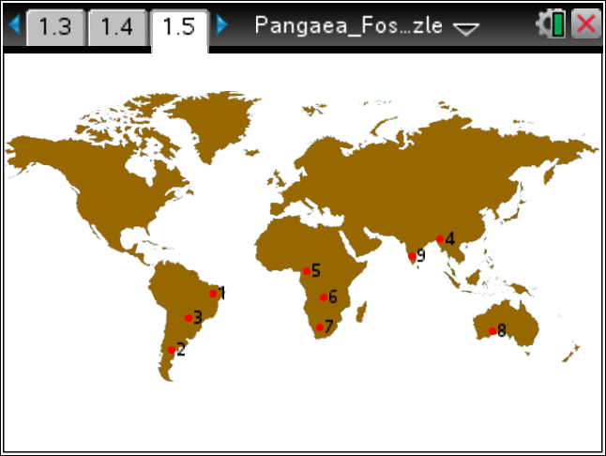

Place the letter corresponding to the fossil types below next to the fossil dig site where it was found on the map.

 A  B

 C  D

Move to pages 1.6 - 1.14.

After examining the evidence in your map above answer questions 2 – 10 below and/or in your .tns file.

Q2. Which two continents have the most matching fossils between them?

South America and Africa
Africa and Eurasia
Africa and Australia
Australia and Eurasia

Q3. What do you notice about the coastlines of South America and Africa?

Q4. India has two fossils in common with: (Circle all that apply)

Africa Eurasia South America Antarctica North America Australia

Q5. Based on the fossil evidence, to which continent was Australia most likely connected?

Africa Eurasia South America Antarctica North America Australia

Q6. What evidence do you have that India was once connected with land masses other than Eurasia?

Q7. Based on your fossil evidence, how would the discovery of fossils on continents separated by miles of ocean support Wegener’s continental drift hypothesis?

Q8. Look at the picture of Fossil A. Does it look like it would be a good swimmer?

Yes or No

Q9. Look at the picture of Fossil B. Does it look like it would be a good swimmer?

Yes or No

Q10. Why would the fossil of an ocean fish found on two different continents NOT be good evidence of continental drift?

