In this activity, you will create a new document with a Graphs application. You will create sliders that can be manipulated to determine the effect of changing the parameters of a quadratic function in vertex form. This activity is written for teachers or students who wish to learn how to incorporate sliders in an activity. The first steps provide a brief introduction to sliders, followed by how to change a slider’s settings. The same steps may be followed to create sliders for parameters a, r, and s for a quadratic function in factored form. The directions provided are for the handheld. If using the computer software, directions may vary slightly.

Steps:  - Select c > New Document >Add Graphs. | 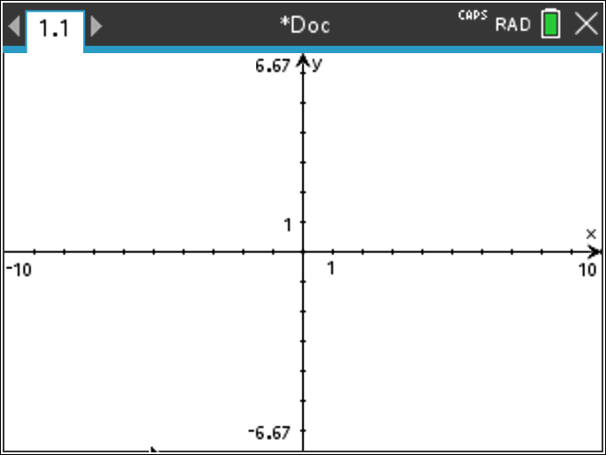
- In the function entry line, enter the equation Notice the multiplication symbol between the a and the parenthesis. | 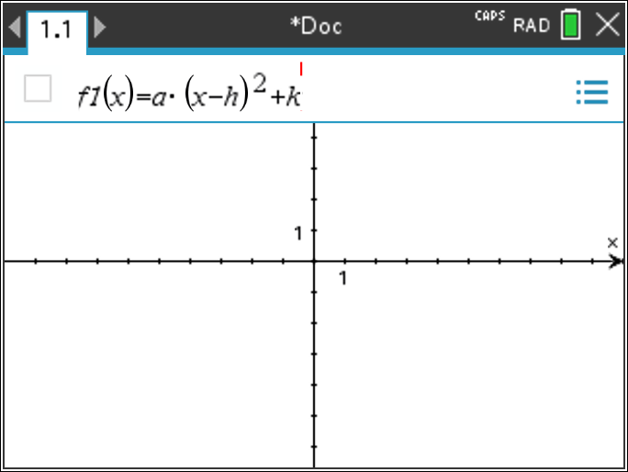
- When you press ·, a popup will appear asking if you would like to create sliders. Unclick the boxes next to h and k and press OK.  - Notice the blue rectangle around your slider. Move your curser over the rectangle and the curser should become a hand. Using the touchpad, move the slider to the bottom left of the screen. | 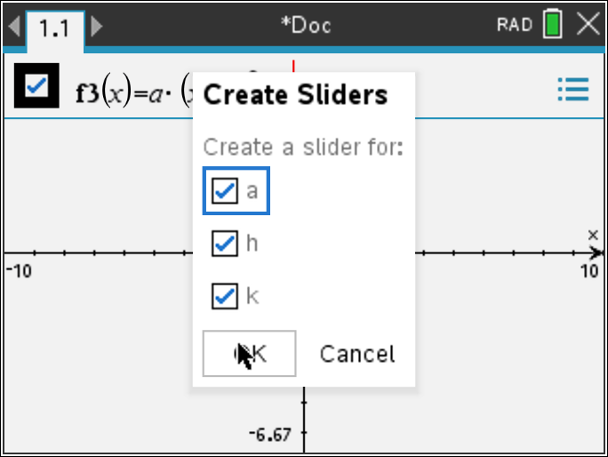  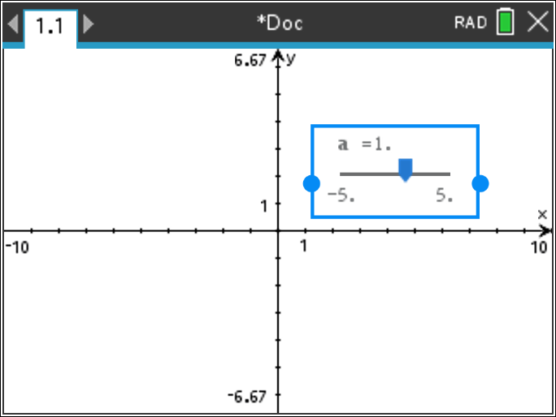
- To save the document, press /» and name the document, and then save it in the folder as directed by your teacher. Press e ¾. As you progress through this activity, remember that /d will undo your previous entry.

- To insert another slider, press b > Actions > Insert Slider. The slider settings box will appear with the variable v1 highlighted. Change v1 to h and press ·.Move this slider next to the first along the bottom of the screen. | 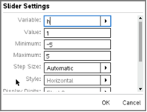
 | 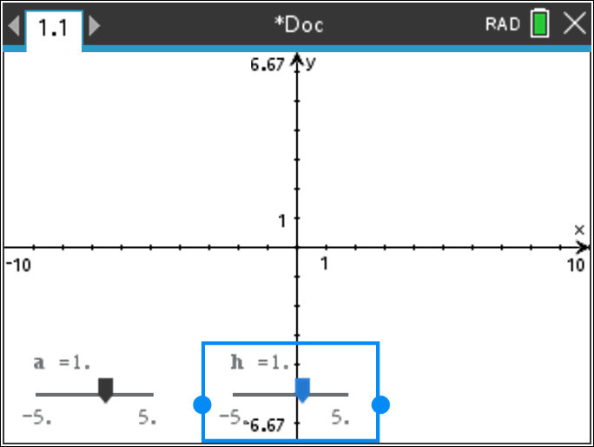
- Repeat the process to insert a third slider, define the third variable as k, and move the slider to the desired location. As soon as the third slider has been added, the parabola f1(x) = 1( x - 1)² + 1 will be graphed. The function label appears near the graph. | 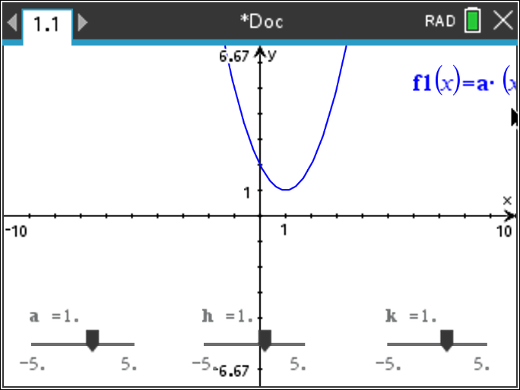
- Move the function label. First, move the cursor to the label, and press / x to grab the label. Use the Touchpad to move the label to the desired location, and press ·. | 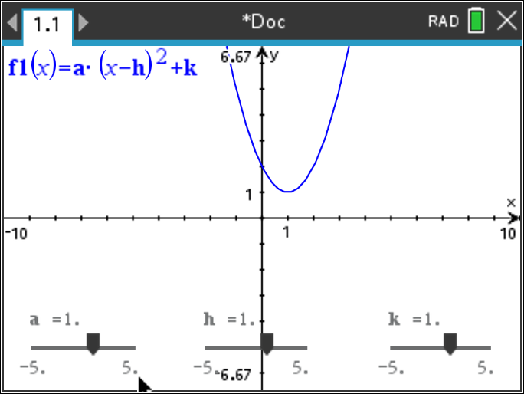
- To change the settings of a slider, move the cursor over the slider and press / b to display the slider menu. Click Settings. Tab through the various settings. For this activity, the settings shown in the screen capture on the right have been chosen for parameter a. | 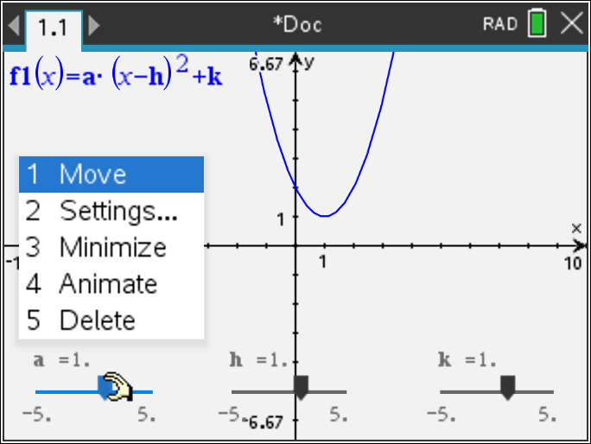
 | 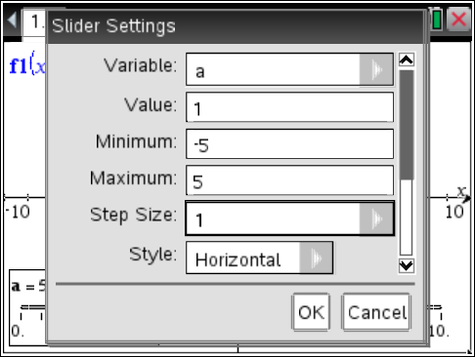
- If Minimized is selected in the Slider Settings or from the menu, the slider can be minimized.  The slider for parameter a has been minimized. Select whichever style you prefer. Note that sliders may be vertical or horizontal.  - Change the slider setting for h and k. Set the value of h = 0 and k = 0, enter minimum and maximum values of –5 and 5, respectively, and enter a step size of 1. Minimize the sliders, if desired. Save the document.  - As you click the arrow keys of a minimized slider to change the slider value, the value of the associated parameter changes, and the graph of the parabola changes.  - Note: When a slider is selected (a solid rectangle is formed around the slider), the value of the parameter can be controlled by the Touchpad arrow keys. To change the slider value for a slider, click on the slider to select it, and use the arrow keys of the Touchpad to change the slider values. Alternatively, you may click the slider controller to change the value of the slide.  Do not forget to save your final document. | 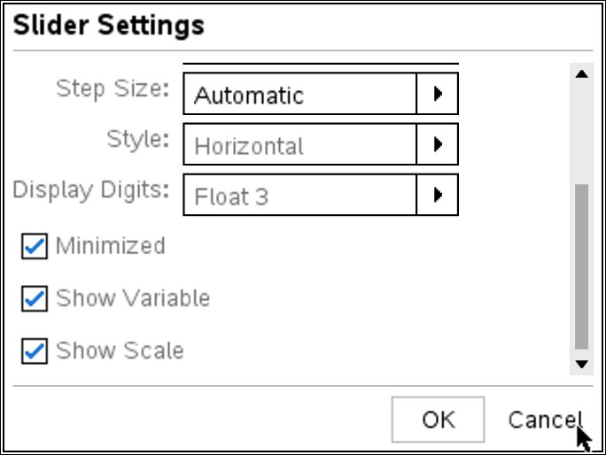  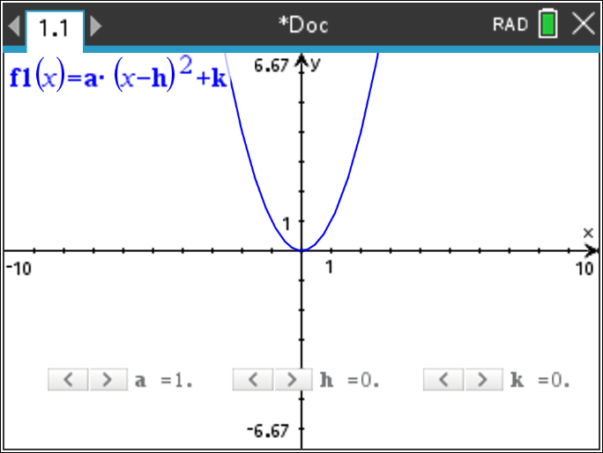  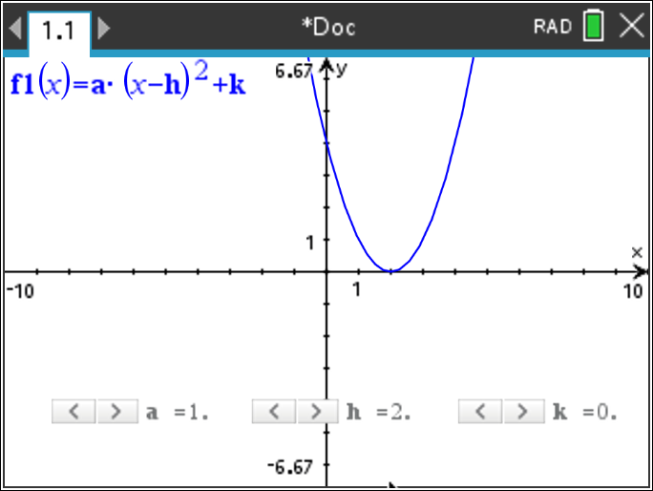  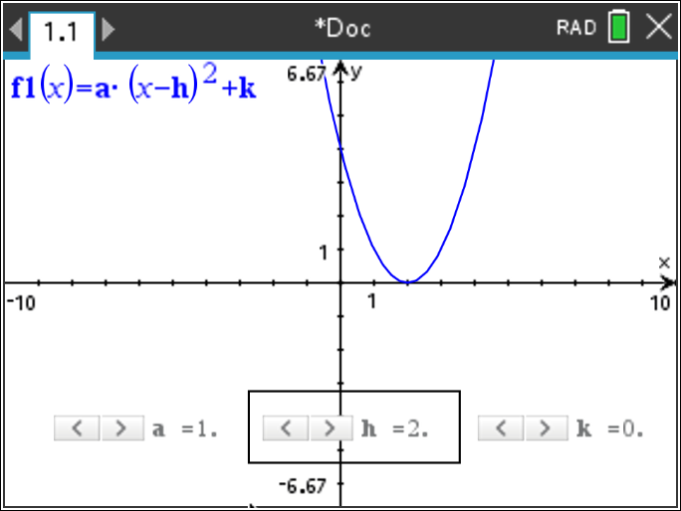
- As you click the arrow keys of a minimized slider to change the slider value, the value of the associated parameter changes, and the graph of the parabola changes.

Note: When a slider is selected (a solid rectangle is formed around the slider), the value of the parameter can be controlled by the Touchpad arrow keys. To change the slider value for a slider that is not minimized, click on the slider to select it, and use the arrow keys of the Touchpad to change the slider values. Alternatively, grab and drag the slider controller to change the value of the slider.

