Open the TI-Nspire document Sea_Floor_Spreading.tns  Scientists estimate that Earth is over 4 billion years old. However, the oldest region of the sea floor is only 200 million years old. How can we explain this? The answer is related to what is happening under the sea at the trenches and ridges in the earth’s crust. In this simulation, you will analyze the motions of the continents and the sea-floor age to determine what is happening. |  | 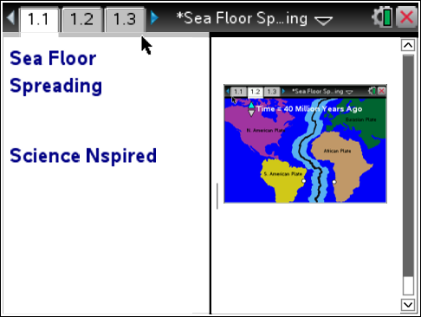
Move to page 1.2 and read the information given.
Earth's crust is divided into 7 major plates that are in continuous motion. Ridges and trenches define the edges of the plates. The Mid-Atlantic Ridge is the underwater mountain range running from Iceland to Antarctica. At the Mid-Atlantic Ridge, plates are moving away from one another. This causes magma from beneath the crust to rise up. When the magma enters the sea floor, it cools and hardens, forming underwater mountains.

Move to page 1.3 and answer question 1 below and/or on your device.
Q1. Which of the following would you most expect to occur at a mid-ocean ridge?

A. volcanic activity
B. strong earthquakes
C. older crust sinking down into the mantle

Move to page 1.4.
Read the directions for the simulation.
- Notice the points on the coasts of South America and Africa. Select the South American point. Then, select the African point. Doing this will collect a distance measurement between the two points.  - Select the up and down arrows (¤ and £) to advance 10 million years towards present time and repeat the distance measurement.  - Continue to collect distance measurements every 10 million years to present day. | 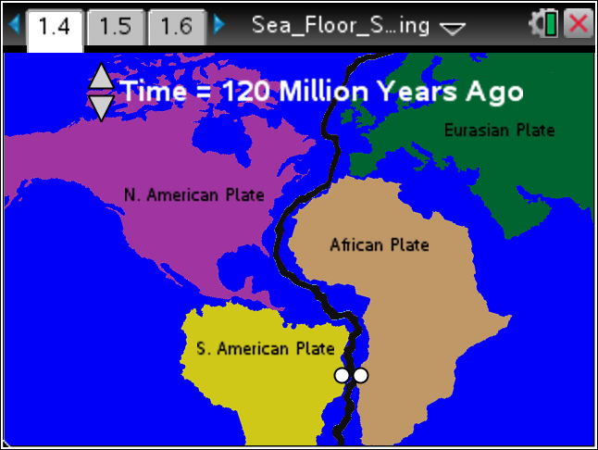
Tech Tip: To access the Directions again, select > Sea Floor Spreading > Directions.

Tech Tip: To access the Directions again, select b or Document Tools () > Sea Floor Spreading > Directions.
Move to pages 1.5 - 1.11
4. On page 1.5 you will find a spreadsheet containing the distance measurements you collected. On page 1.6, you will see a scatterplot of the data. Use this data to answer questions 2 - 6.

Q2. According the graph, as the age of the earth increases, the distance between South America and Africa _______ . (Remember: Present day is 0 years).

A. increases
B. decreases
C. stays the same

Q3. According to this simulation, each plate is moving at a rate of

A. 25 km every million years
B. 33 km every million years
C. 67 km every million years

Q4. If you were to compare a sample of ocean crust next to a mid-ocean ridge with a sample very far from the ridge, what would you notice?

A. The sample near the ridge is much younger.
B. The sample near the ridge is much older.
C. The sample near the ridge is the same age as the sample far from the ridge.

Q5. What evidence from the graph supports the idea that new sea floor is being created?

Q6. If new ocean floor is created at the Mid-Atlantic Ridge, propose an explanation for why the earth’s total crust is not increasing. How could this explain why the age of Earth is 4 billion years old while the oldest region of crust is only 200 million years old?

