Open the TI-Nspire document Addition_by_Division.tns.  Did you know that you are a product of mitosis? Your hair, skin and fingernails are constantly being replaced at a rapid rate; in fact, the outer layer of your skin will all be new in just 3 weeks from now! But this is not true of all of your cells. Your nerve cells, for the most part, stopped reproducing after you were a few months old. The life span of your red blood cells is only about 120 days, while the cells of liver tissues can take up to a year to reproduce! |  | 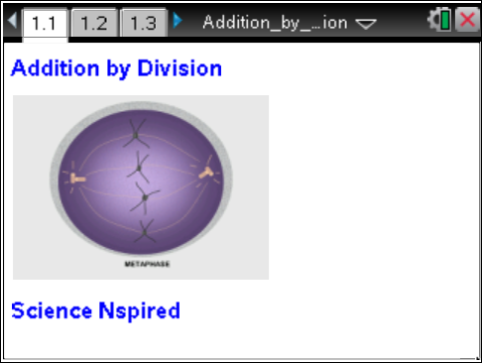
The cell cycle consists of two main segments: interphase and mitosis. Most of the cell's existence is spent in Interphase. Mitosis is the process of cell division, when one cell replicates its DNA and other cell parts, and then divides into 2 identical cells. The process of mitosis takes about the same amount of time regardless of the type of cell. Interphase times vary, as you'll soon see.
In this activity, you will learn how to identify the changes that occur in a cell during its reproduction. You will also correlate these changes to the duration of specific phases within the cell cycle.

Move to pages 1.4 and 1.5. Answer the following questions here. |  | Press / ¢ and / ¡ to navigate through the lesson.
1. Pages 1.4 and 1.5 show pie chart models of the cell cycles of kidney cells and skin cells. Take a couple of minutes to examine both models, keeping in mind that the process of mitosis (which includes prophase, metaphase, anaphase and telophase) takes about the same amount of time in both kidney cells and skin cells. It is the interphase times that vary from cell type to cell type.
Q1. If the mitosis portion of the cell cycle lasts for 24 hours in both kidney cells and skin cells, estimate how long interphase lasts in each cell.
Kidney Cell __________ | Skin Cell __________
Q2. Estimate how long each of the 4 mitotic phases (P,M,A,T) lasts in skin cell mitosis.

Prophase ____  Metaphase ____ | Anaphase ____  Telophase ____
Q3. How long is each of the 4 phases in kidney cell mitosis?

Prophase ____  Metaphase ____ | Anaphase ____  Telophase ____
Q4. Estimate the length of one entire cell cycle in each of the cells that was modeled.

Kidney Cell __________ | Skin Cell __________
Q5. You’re looking in a microscope at a tissue sample of living cells. In which stage of the cell cycle would you expect to find the most cells? In which stage would you expect to find the fewest cells?

Most __________ | Fewest __________
Q6. Which of the two types of cells, kidney or skin, divides more often? How did you determine this? Why do you think this is so?

Q7. When, during a human's lifetime, would you expect to find lots and lots of cells undergoing mitosis? When would you expect to find fewer? Explain both your answers.

Q8. The process of mitosis produces new body cells for you. What are two reasons why your body needs to produce new cells?

Q9. Chemotherapy is a treatment given to cancer patients. Cancer cells typically have a short cell cycle, and chemotherapy often “attacks” non-cancerous cells that also have a short cell cycle. This is called a “side effect.” What are some of the side effects of chemotherapy? Based on what you now know about the cell cycle, what causes these side effects?

Move to page 2.1.
A student looked at an onion root tip under a microscope and counted the cells that she observed in each phase of the cell cycle. She entered those cell numbers into a spreadsheet and then generated a pie chart representing the relative time that an onion root tip cell spent in each phase. Look at page 2.2 to see her results.
2. If possible, and as instructed by your teacher, do the actual cell counts and enter YOUR values in the spreadsheet column named "cells". To do this, simply use your arrow keys to move to the appropriate spreadsheet cell and enter your value for that phase. Continue until you have entered all 5 values for all 5 phases. Watch the pie chart adjust as you enter your numbers.
Q10. The entire cell cycle in an onion root tip cell lasts for about 24 hours. Based on your cell counts, how long does the entire process of mitosis last? How long does each of the 5 phases of the cell cycle last? Explain how you determined your answers.

Move to pages 3.1 and 3.2. Answer the following questions here or in the .tns file.
3. Move to page 3.1 and read the information on that page. Then proceed to page 3.2 for the simulation. After watching the simulation as many times as necessary, answer the following questions. These questions are also found following the simulation on your handheld.
Q11. What evidence can you see that the cell in the simulation is an animal cell?

Q12. During which phase does the nuclear membrane disappear?

A. Prophase  B. Metaphase | C. Anaphase  D. Telophase
Q13. In the cell shown, how many PAIRS of chromosomes are present?

A. 1  B. 2 | C. 3  D. 4
Q14. What is the fibrous network called that is visible in the cell from prophase through anaphase?

A. the nucleus  B. chromatid web | C. centriole fibers  D. spindle apparatus
Q15. During which phase do the chromatids separate from one another?

A. Prophase  B. Metaphase | C. Anaphase  D. Telophase
Q16. At the end of the process shown, how many chromosomes are shown as present in each
“new” cell?

A. 2  B. 4 | C. 6  D. 8
Q17. If you had been watching a simulation of a human cell undergoing mitosis, how many chromosomes would have been present in each new cell?

A. 16  B. 23 | C. 46  D. 92

