Open the TI-Nspire document Pythagorean_Relationships.tns.  This activity lets you move sets of three squares to see what kind of triangles can be formed using one side of each square. | 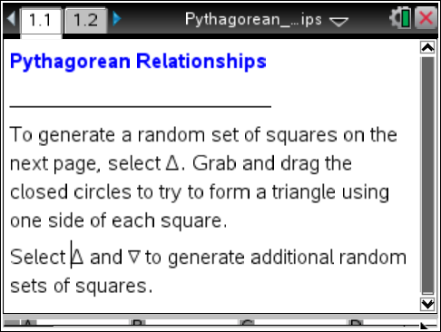

Move to page 1.2.

1. Select the up or down arrows on the screen. Describe the numbers and figures that appear and the connections among them.

2. Drag the closed points to create a triangle so that one side of each square is a side of the triangle.
a. Fill in the table for Trial 1. Record the side lengths and areas and classify the triangle. Enter the smaller side measures in rows A and B and the largest side measure in row C.

b. Select the up or down arrows to do three more trials with a different set of numbers for each trial, and record the results in the table.

 |  | Trial 1 |  |  |  | Trial 2
 |  | Side Length | Area | Classify Δ by Angles |  | Side Length | Area | Classify Δ by Angles
Small | A
Medium | B
Large | C
 |  | Trial 3 |  |  |  | Trial 4
 |  | Side Length | Area | Classify Δ by Angles |  | Side Length | Area | Classify Δ by Angles
Small | A
Medium | B
Large | C

3. Work with the others in your group to organize your results according to the type of triangle by angle.

Acute Triangles |  |  |  | Obtuse Triangles |  |  |  | Right Triangles |  |  |  | No Triangles
a² | b² | c² |  | a² | b² | c² |  | a² | b² | c² |  | a² | b² | c²

Describe the relationship among a², b², and c² that seems to be true for each class of triangles.
a. acute

b. obtuse

c. right

d. no triangle was formed

4. Brianna has five squares with areas 1 in², 2 in², 3 in², 4 in², and 5 in². Which sets of three squares will fit on the sides of a right triangle? Explain your reasoning.

5. If a, b, and c are the lengths of the three sides of a triangle with c the longest side, which of the following will be never true, sometimes true, and always true? Use the work you have done with squares and triangles above to justify your answers.
a. a² + b² = c²

b. a + b = c

c. a + b > c

d. c² – a² = b²

