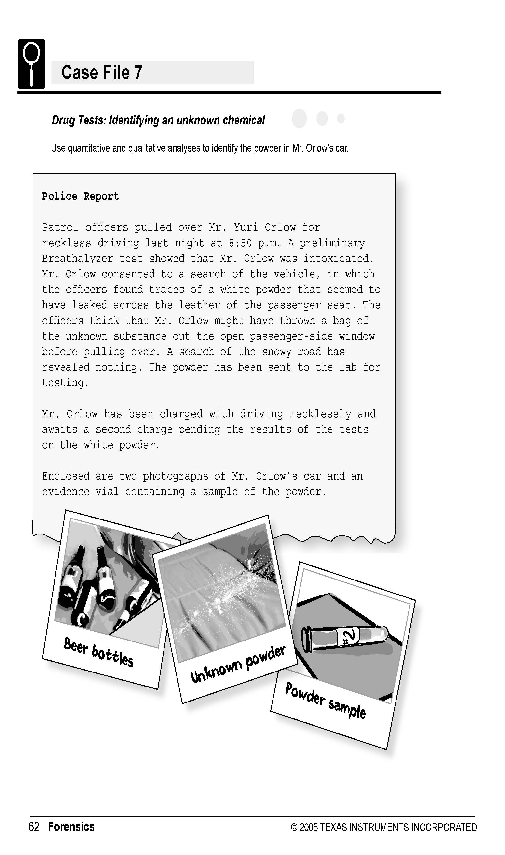

Science Objectives
- Distinguish between physical and chemical properties.
- Distinguish between qualitative and quantitative observation.
- Identify an unknown powder using physical and chemical properties.

Activity Materials
- TI-NspireTM technology  - Case 7 Drug Tests.tns file  - Vernier Easy Link™ or TI-Nspire Lab Cradle  - Vernier pH Sensor  - Vernier Conductivity Probe  - vinegar  - 5 known “drug” samples (5g of each)  - 1 unknown “drug” samples (5g)  - spoons or weighing paper (one per sample) | - distilled water  - stirring rod  - disposable pipettes or droppers  - wash bottle (with distilled water)  - magnifying glass  - balance  - lint-free tissues or lens paper  - goggles (1 pair per student)  - filter paper  - six 50 mL beakers
Procedure
Open the TI-Nspire document Case 7 Drug Tests.tns.  In this data-gathering activity, you will identify an unknown powder using physical and chemical properties. |  | 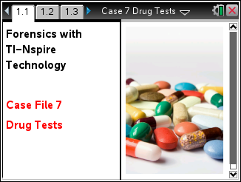
Part 1 – Preparing the Samples and Initial Observations
Move to pages 1.2–1.3.
CAUTION: Obtain and wear goggles during this experiment. Avoid inhaling the powders. Do not taste or smell any of the powders. If you get any powder or liquid on your skin, wash it with water immediately. Tell your teacher right away if any spills or accidents occur.
1. Label five 50 mL beakers with numbers 1 through 5. Label one beaker “Unknown” for the powder taken from Mr. Orlow’s car. Using the balance, measure 2 g of each sample and place it in the proper beaker. To avoid cross-contamination of the other samples, use a different weighing paper or spoon for each sample. Save the spoons or weighing papers for use in Part 5. Note: Your teacher may have already measured the samples for your use.
2. Observe the samples through the magnifying glass, and record your observations in the Evidence Record.

Part 2 – Preparing the Solutions
Move to page 1.4.
3. Prepare powder-and-water mixtures of the six samples.
- Add 20 mL distilled water to each beaker prepared in Step 1. Stir the mixtures thoroughly with the stirring rod. Note: After stirring one sample, rinse the stirring rod with distilled water and dry it with a lint-free tissue before using it to mix another sample.
- Stir each mixture once every 3 minutes for 15 minutes. After the final stir, let the mixtures settle for about 5 minutes.
- Write any observations that you can make about the water mixtures into the Evidence Record. Were the powders very soluble, or not soluble at all?
Part 3 – Testing the pH of the Samples
Move to page 1.5-1.7.
4. On page 1.6, connect the pH Sensor to the TI-Nspire using an EasyLink or Lab Cradle.
Note: For this experiment, your teacher already has the pH Sensor in a pH soaking solution in a beaker. Be careful not to tip over the beaker when you connect the sensor to the interface.
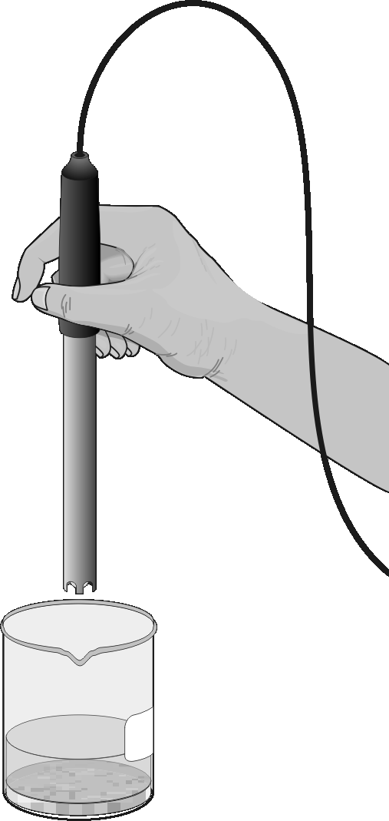
5. Use the pH Sensor to determine the pH of the solution in each sample beaker.
- Rinse the tip of the pH Sensor with distilled water from the wash bottle and place it into the liquid in the beaker containing the first sample.
- Gently swirl the sensor in the solution. Be careful not to let the tip of the sensor touch any solid material at the bottom of the beaker.
- When the pH reading stabilizes, record the pH value in the Evidence Record. and /or on page 4.1 (as directed by your teacher).
- Repeat this process for each of the remaining samples.
6. When you are finished, rinse the pH Sensor with distilled water and return it to its storage container. Disconnect the pH sensor.

Part 4 – Testing the Conductivity of the Samples
Move to pages 2.1–2.3.
7. Set the switch on the probe to the 0–20,000 μS/cm setting. On page 2.2, connect the Conductivity Probe to the interface.
- Select MENU > Experiment > New Experiment to reset defaults for a new sensor.
- Place the sensor in distilled water after rinsing.
- Select MENU > Experiment > Set-Up Sensor > Zero to zero the sensor in water.
8. Collect conductivity data for each sample.
- Place the tip of the probe into the beaker containing sample 1. The hole near the tip of the probe should be completely covered by the liquid. Gently swirl the probe in the solution.
- Once the conductivity reading has stabilized, record the value in your Evidence Record.
- Rinse the Conductivity Probe thoroughly with distilled water from the wash bottle before collecting data for the next sample. Blot the outside of the probe end dry using a tissue. It is not necessary to dry the inside of the hole near the probe end.
- Repeat this process for each of the remaining samples.
Empty the remaining liquid from the beakers as directed by your teacher. Rinse and dry the beakers. Disconnect the conductivity sensor. Record your data in the Evidence Record and/or on page 4.1 (as directed by your teacher).
Part 5 – Reaction of the Samples with Vinegar
Move to page 3.1.
9. In the next test, you will observe the reaction of each of the samples with vinegar, an acid.
- Using the balance, measure 2 g of each sample and put it in the proper beaker. To avoid cross-contamination of the samples, use the measuring papers or spoons that you used in Step 1 or use a new paper or clean spoon for each sample.
- Add 10 mL of vinegar to each sample. Determine whether or not a chemical reaction takes place. Record your observations in the Evidence Record Record your data in the Evidence Record and/or on page 4.1 (as directed by your teacher)..
10. When you have observed and recorded your observations of all of the samples mixed with vinegar, then empty, rinse, and dry the beakers as directed by your teacher.

Evidence Record
Sample | General  Appearance | Observations of Water Mixture | pH | Conductivity  (μS/cm) | Reaction with Vinegar
1
2
3
4
5
Unknown

Case Analysis
Move to page 5.1. Answer the following questions in the .tns file or below on this worksheet if your teacher states he or she will be collecting the worksheet.
Q1. Based on your observations, which known sample do you think was most similar to the unknown powder found in Mr. Orlow’s car? Do you think the unknown was an exact match to that known sample? Explain your answer.

Q2. Explain the difference between physical and chemical properties. Give two examples of physical properties and one example of a chemical property that you measured in the lab.

Q3. Explain the difference between qualitative and quantitative observations. Give one example of a qualitative observation and one example of a quantitative observation that you made in the lab.

Q4. Identify two tests, other than those that you carried out in this investigation, that forensic scientists might use to identify a suspected drug.

