Open the TI-Nspire document vectorarith.tns.  The world around us is in constant motion, so how exactly are scientists able to study and understand motion? Motion is described using different quantitative measurements including distance, speed, velocity, force, acceleration, and momentum. These quantities can be divided into two categories — vectors and scalars. A vector quantity has both magnitude and direction, while scalar quantities only have magnitude. In this lesson, you will construct vectors and perform basic vector operations. You will see vectors displayed graphically in a two-dimensional x-y plane. Then, you will see the results of adding and subtracting vectors. | 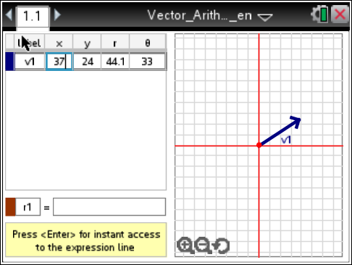

In this tool, you will see a directed line vector. It is drawn starting at an initial point and moving outward, ending in a terminal arrow. The arrow at the end of the vector line represents its direction. The length of the line represents the magnitude of the vector.

- On the left side, the values for v1, x, y, r and θ are displayed. These represent the vector values:
V1 = Vector one
x = the numeric value on the x-axis
y = the numeric value on the y-axis
r = radius of the line from the center
θ = the angle of the line from the x-axis

- To change the x, y, r or θ values of the vector, click in the box, press ., and then enter a number.

- You move a vector in the graph. Click on the vector once, then grab and drag the vector line to the desired location. After releasing the vector, click on the line to update all vector values on the left side, including x, y, r, and θ values.

- To add a new vector line to the graph press Menu > TI-NspireTM Vector Calculator > New Vector. The menu also allows you to delete vector lines already drawn.

1. Add a vector line v2 to the graph with an x-value of –65 and a y-value of 82. Press · to show the remaining vector values.

Q1. How does vector v2 compare to vector v1?

Q2. Choose a positive or negative x-value and y-value for each row in the table below and enter them into the vector tool. Then, record the Quadrant the vector points to. | 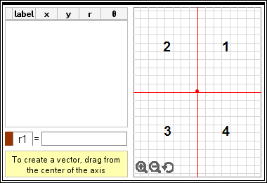
   | x-value | y-value | Quadrant
  v3 | (–) | (+)
  v4 | (+) | (+)
  v5 | (+) | (–)
  v6 | (–) | (–)
2. Delete vectors v3 to v6. Answer the following questions using the Vector Arithmetic tool.

Q3. Add v1 and v2 by entering v1 + v2 into the box next to r1 at the bottom of the screen. Press · to place the vector on the graph. Record values of r1 below.

x = y =

Q4. Open the Scratchpad ». Add the x-values of vectors v1 and v2. Then add the y-values. How do the values compare to the values of vector r1?

3. Add a new vector v3 with x = –8 and y = –23. Then add a new vector v4 with x = 34 and y = –34.

Q5. In the equation box, add all four vectors v1 + v2 + v3 + v4. Press · to place the vector on the graph. Record values of r2 below.

x = y =

Q6. On the Scratchpad add the x-values of vectors v1, v2, v3, and v4. Then add the y-values. How do the values compare to the values of vector r2?

Q7. What x-value and y-value do you think you will get if you subtract the vectors, v1 – v2 – v3 – v4? Use the Scratchpad to make a prediction.

Q8. In the equation box subtract all four vectors v1 – v2 – v3 – v4. Press · to place the vector on the graph. Record values of r3 below.

x = y =

Q9. What statements could be made about adding and subtracting vectors?

