Open the TI-Nspire document Changing_States.tns.
At room temperature, some things are solid, some things are liquid, and some things are a gas. Why is that? Also, water can exist as liquid, as ice, and as steam. What does it take to change water from one form to another? In this simulation, you’ll explore the changing states of matter.

Matter exists in three forms, solid, liquid, and gas. Let’s look at water. At room temperature water is a liquid. If you place the water in a pan and heat it at a high temperature, the water begins to boil and create steam. Steam is a gas.  So, for matter to change from liquid to gas, energy (in the form of heat) needs to be added. Matter is generally considered to exist in three states: solid, liquid, and gas. The particles that make up matter are in continual motion. This motion varies from vibrations in a more or less fixed position (solid), to sliding over one another (liquid), to freely moving in all directions (gas). | 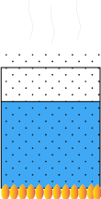
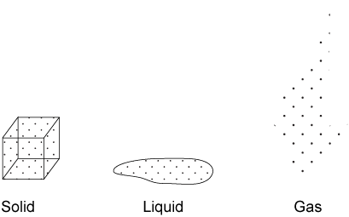

At absolute zero (–273ºC or 0 K), matter has its lowest kinetic energy.

Move to pages 1.2 – 1.4. Answer questions 1 – 3 here and/or in the .tns file.
Q1. Matter is usually considered to exist in one of _________ state(s).
A. one  B. two | C. three  D. five
Q2. All molecular motion is believed to stop at _________.
A. 0°C  B. 0°F | C. 0 K
Q3. The atoms of which state of matter rest in relatively fixed positions?
A. plasma  B. gas | C. liquid  D. solid
So, a transfer of heat changes water to steam. In the simulation you will see the amount of energy needed to change the state of three different substances from solid to liquid to gas.
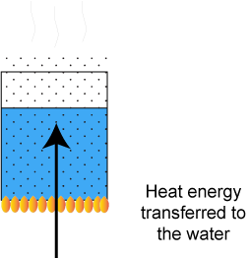

Move to pages 2.1 and 2.2.
Each of the three experiments in this simulation has a different temperature scale. The model shows the general way in which the state of most substances changes with temperature. However, not all substances change from solid to liquid to gas. Some (for example, moth balls) change directly from a solid to a gas, which is called sublimation.
1. Choose Experiment 1 by using the lower up/down arrows until experiment 1 appears (if it is not already chosen).

2. Then, use the upper arrow on the time slider to add heat to the sample. Increasing the time increases the energy added to the substance and shows the related behavior of the particles.
Answer questions 4 – 6 on your activity sheet only.

Q4. What happens to the particles as more energy is added?

Q5. What happens to the temperature of the substance as more heat is added?

Q6. Look at the portions of the graph where the temperature remains constant (where the line is flat), even though heat is still being added. Describe what is happening here.

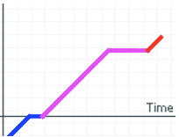

3. Find the melting point (when the matter changes from solid to liquid) and record it in the Data Table below.
4. Find and record the boiling point (when the matter changes from liquid to a gas) and record it in the Data Table below.
5. Complete the table below for Experiment 2 and Experiment 3 following the same steps.
Data Table
Data | Experiment 1  (HOH) | Experiment 2  (C₂H₅OH) | Experiment 3  (Fe)
Melting point
Boiling point

Move to pages 3.1 – 3.6. Answer questions 7 – 12 here and/or in the .tns file.

Q7. The melting point for the substance in Experiment 2 is _________.
A. –114°C  B. 0°C |  | C. 78°C  D. 1535°C
Q8. The boiling point for the substance in Experiment 2 is _________.
A. –114°C  B. 0°C | C. 100°C  D. 78°C |  | E. 1535°C
Q9. When the temperature is –273°C, the particles of a substance _________.

Q10. As temperature increases, the amount of movement of the particles increases.
A. always | B. sometimes |  | C. never
Q11. In the liquid state, most of the movement of the particles is __________.
A. horizontal  B. vertical |  | C. the same in all directions  D. vibratory
Q12. How does the temperature change during any change of state? Explain.

