Open the TI-Nspire document The_Water_Cycle.tns  More commonly known as the water cycle, the hydrologic cycle is the interaction of the atmosphere (air), hydrosphere (water), and lithosphere (land). Water can be stored for long periods in the ground or on the surface, before being recirculated within the earth system to support life on Earth. Throughout the hydrologic cycle, water may exist in any of its three states: solid, liquid, or gas. |  |  |  |  | 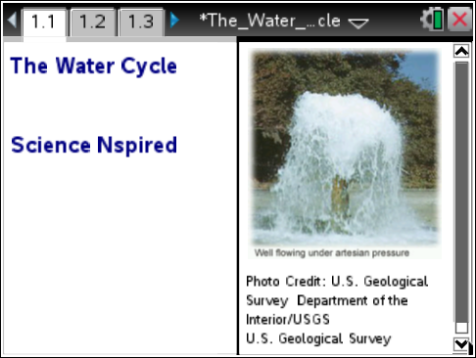
Would an increase in the average global atmospheric temperature have an effect on the hydrologic cycle?

Move to pages 1.2 – 1.4. Answer questions 1 - 3 below and/or on your device.
Q1. Water stored in the ground is part of the hydrologic (water) cycle. True or False?

Q2. Condensation is when air turns into a liquid. True or False?

Q3. There is less water on Earth now than there was 500 years ago. True or False?

Move to page 1.5.  Read the directions for the simulation.  - Use the touchpad or mouse to move the cursor over the picture and find FIVE of the phases of the hydrologic cycle. Watch the movement of the water in its different states. Be sure to read the descriptions and think about in which state(s) water might be present during each phase of the cycle. |  |  |  |  | 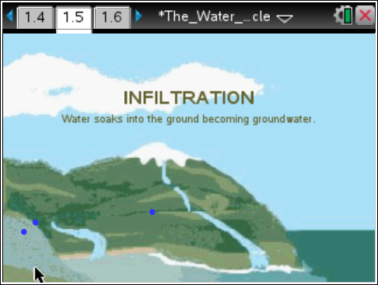
Tech Tip: To observe the five phases of the hydrologic cycle, tap various parts of the screen to reveal the text.
Tech Tip: To access the Directions again, select b or Document Tools () > The Water Cycle > Directions.
Tech Tip: To access the Directions again, select  > Directions.
- NOTE: Transpiration is not represented in this simulation. About 10 percent of the moisture found in the atmosphere is released by plants through transpiration. Transpiration is the process in which water is taken up by the roots of plants and then released as water vapor through small pores on the underside of leaves.

The symbols for the states of water are:
- Blue solid circles = liquid water
- Open circles with white outlines = water vapor
- Open circles with blue outlines = water vapor changing state into tiny water droplets
- Short dashes = water in a liquid and/or solid state

Move to pages 1.6 – 1.11. Answer questions 4 - 9 below and/or on your device.

Q4. In which state or states does water exist during precipitation?

A. solid only | B. liquid only | C. gas only | D. liquid or solid |  |  | E. solid, liquid, and gas
Q5. In which state or states does water exist if it has been condensed?

A. solid only | B. liquid only | C. gas only | D. liquid or solid |  |  | E. solid, liquid, and gas
Q6. Clouds are made of ________.

A. liquid | B. gas | C. condensed air
Q7. Into which state or states is water changing during evaporation?

A. solid only | B. liquid only | C. gas only | D. liquid or solid |  |  | E. solid, liquid, and gas
Q8. In which state or states does water exist during infiltration?

A. solid only | B. liquid only | C. gas only | D. liquid or solid |  |  | E. solid, liquid, and gas
Q9. Can water exist as a solid in the atmosphere? Yes or No?

Move to pages 2.1 – 2.3. Answer questions 10 and 11 below and/or on your device.

Q10. If the average global atmospheric temperature increases, what do you predict will happen to sea level?

A. The sea level will rise.
B. The sea level will fall.
C. No change in sea level will occur.
Q11. Predict what might happen to the severity of storms as the average global atmospheric temperature increases.

A. Storms would become more severe.
B. Storms would become less severe.
C. There would be no change in storm severity.

Move to page 2.4.  Read the directions for the simulation.  The EPA (Environmental Protection Agency) uses climate models to predict future changes in our global average temperatures. This simulation uses the 20th century average of 14.8°C (58.6°F) with a 6°C (11°F) increase over the next 100 years.  2. In this simulation, use the slider to change the average global atmospheric temperature. Observe the changes in the sea level and in the number of heavy precipitation (storm) events as the global average temperature changes. | 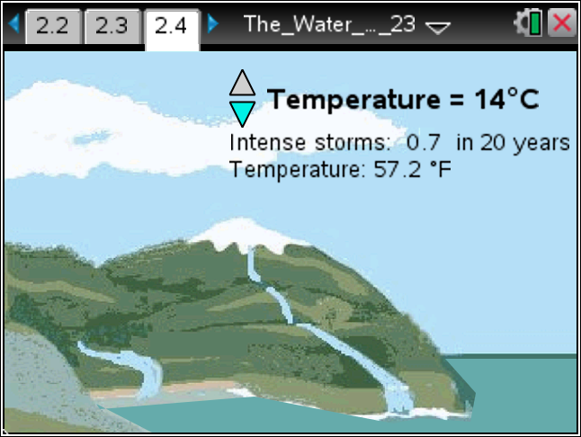
Move to pages 2.5 – 2.9. Answer questions 12 – 16 below and/or on your device.

Q12. What happens to the sea level as the average global atmospheric temperature increases?

Q13. Which of the following is the most plausible hypothesis for the increase in sea level?

A. There is an increase in the amount of precipitation.
B. The ice, snow, and permafrost stored in the hydrologic cycle are melting.
C. Storms are more severe and occur more frequently.

Q14. Based on this simulation, what is predicted to happen to the number of intense storms as the average global atmospheric temperature increases?

A. The number of intense storms will increase.
B. The number of intense storms will decrease.
C. The number of intense storms will stay the same.

Q15. What do you think is happening to the rate of evaporation and condensation as the average global atmospheric temperature increases?

