Open the TI-Nspire document Cell-ebrating_Life!_MG.tns.

There is a great variety among living things, but all living things have common characteristics. The basic unit of life is the same. This allows us to carry out common activities such as growing, responding, reproducing, and using energy. This basic unit of life is cells.
Since cells were discovered by Robert Hooke a few hundred years ago, people have been fascinated by these little structures that have become known as the structural and functional units of life. Every living thing has at least one cell and you have trillions of them. In this activity, you will learn about some of the tiny structures that make up animal and plant cells and what those tiny structures do for the cell.
Part 1: Animal Cell
Move to pages 1.2 and 1.3.
- In the first part of this activity, you will explore the structure of an animal cell. By selecting various tiny cell structures called organelles, you will learn what each does for an animal cell. Read the background information on pages 1.2 and 1.3.
Move to pages 1.4 – 1.8. Answer questions 1 - 5 here and/or in the .tns file.

Q1. A unicellular organism is made of _________________________________________________.

A. one cell that has to do all of the jobs for the organism
B. many cells that stay in one area, but don't work together
C. billions or trillions of cells all working together for the good of the organism

Q2. Which of the following is an example of a unicellular organism?

A. a maple tree
B. a dog
C. a bacterium

Q3. What do you think is meant by the term multicellular organism?

A. an organism that has lots of cells
B. an organism that has one cell
C. an organism that is sometimes an animal and sometimes a plant
Q4. Which cell process is performed by plant cells, but NOT by animal cells?

A. Cell division
B. Protein synthesis
C. Photosynthesis

Q5. Big organisms have big cells and little organisms have little cells.

A. Agree B. Disagree

Move to pages 1.9 and 1.10.  - Read the instructions on page 1.9 about navigating the animal and plant cell diagrams. On page 1.10, there is a picture of an animal cell. Read the directions in the pop-up box. Close the directions box when you’re ready to start exploring the animal cell. | 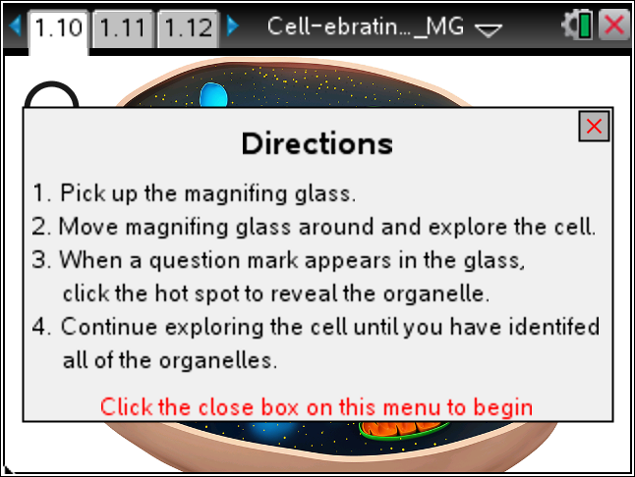
- Select a cell organelle and you will see a name and a description appear. Take notes on the name of the organelle and its function in the space provided below. Continue exploring the cell until you have visited all of the organelles. Some parts of the cell cannot be selected and sometimes there is more than one of the same organelle. When you are ready, move to page 1.11 and answer the questions. Move back to the picture of the cell if you need help answering the questions.

Move to pages 1.11 – 1.17. Answer questions 6 - 12 here and/or in the .tns file.

Q6. Which organelle did you NOT see in the animal cell?

A. Golgi apparatus
B. Chloroplast
C. Mitochondria

Q7. Some cells in your body may have hundreds of mitochondria in them. What is one type of cell that would probably need a lot of mitochondria?

Q8. Name one type of cell that would not need very many mitochondria.

Q9. Some white blood cells (WBCs) are called macrophages, which mean "big eaters"! These cells engulf bacteria and other disease-causing agents and then destroy them with digestive enzymes. Which organelle do you think macrophages have in abundance?

Q10. Other WBCs, called B-lymphocytes, make and secrete proteins called antibodies. What cell organelles do B-lymphocytes have a lot of?

A. Chloroplasts
B. Ribosomes
C. Lysosomes
D. Smooth Endoplasmic Reticulum

Q11. Bacteria cells do not have a nucleus, so they are known as prokaryotes. What other cell organelle would you predict that prokaryotes would NOT have?

A. Plasma membrane
B. Ribosomes
C. Nucleolus

Q12 Some cells in your glands secrete chemicals called hormones, which often have to be packaged up before being sent out of the cell. Which cell organelle would you probably find in great numbers in gland cells?

A. Lysosomes
B. Golgi apparatus
C. Nuclei

Part 2: Plant Cell
Move to page 2.1.  - Now you will take a look at a typical plant cell. Follow the same procedure that you did with the animal cell. Select each cell part and take notes on the name of the organelle and its function in the space provided below. As you work through the plant cell, think about the differences between plant cells and animal cells. | 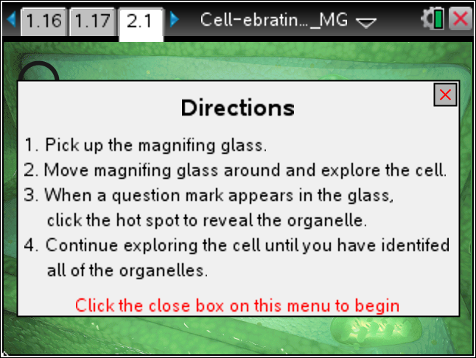
Move to pages 2.2 – 2.7. Answer questions 13 – 18 here and/or in the .tns file.
Q13. Which organelle or organelles can only be found in plant cells?

A. Mitochondria
B. Chloroplasts
C. Nucleus
D. Endoplasmic Reticulum

Q14. Which organelle surrounds all of the others?

A. Cytoplasm
B. Nucleus
C. Cell Wall
D. Vacuole

Q15. Chlorophyll is a green pigment that absorbs sunlight. Most of a cell's chlorophyll can be found inside the ____________.

A. Nucleus
B. Mitochondria
C. Cytoplasm
D. Chloroplasts

Q16. Plants inherit characteristics from their parents just as animals do. Which cell organelle contains the hereditary information?

A. Vacuole
B. Nucleus
C. Golgi apparatus
D. Smooth ER

Q17. Which pair of plant cell organelles deals with energy processing?

A. Smooth ER and Rough ER
B. Golgi apparatus and Smooth ER
C. Chloroplasts and Mitochondria
D. Nucleus and Ribosomes

Q18. In which part of the plant would you likely find cells that have no chloroplasts? Explain.

