Open the TI-Nspire™ document From_Expressions_To_Equations.tns.  Algebraic expressions and equations look quite similar. There are, however, important differences to keep in mind. This activity emphasizes the distinctions between the two. | 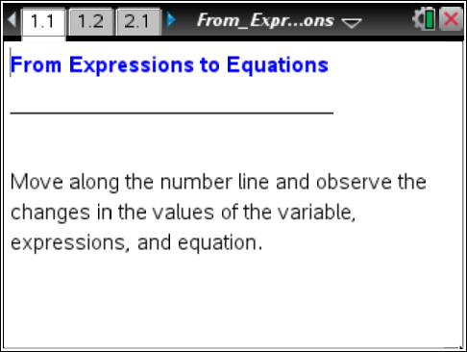

Move to page 1.2.

1. Describe something that changes as you move the point to the right or left on the number line.

2. If the value of the expression is 20, what is the value of x?

3. If the value of the expression is -25, what is the value of x?

Move to page 2.1.

4. What looks the same as the previous page? What looks different?

5. As you move the point, what changes? What stays the same?

6. Find a value of x to make the equation true. Describe the process you used.

7. Is that the only value of x that makes the equation true? Justify your answer.

8. The statement 3(x) + –4 = 11 on page 2.1 is called an equation. The left side of the equation 3(x) + −4 is called an expression.
a. What is the difference between an expression and an equation?

b. Write an example of each.

9. What does it mean to solve an equation?

10. Why can’t an expression be solved?

