The three usual methods of solving a system of equations are graphing, elimination, and substitution. While these methods are excellent, they can be difficult to use when dealing with three or more variables. The row reduction method provides an alternative process. It requires only one matrix and extends the method of elimination.

When solving a system of equations, the system can be written as an augmented matrix. An augmented matrix is a single matrix containing coefficients and a final column for constants.

For example, can be written as .

The row reduction method, also known as the reduced row-echelon form and the Gaussian Method of Elimination, transforms an augmented matrix into a solution matrix.
The solution of this system can be written as an augmented matrix in reduced row-echelon form.
The solution matrix can be written .

1. Why is the goal of the row reduction method to have the solution matrix have only 1s in the diagonal of the first 3 columns and zeros for the rest of the numbers in the first 3 columns? What do the constants in the final column represent?

Matrix Row Operations

To transform augmented matrices into their reduced row-echelon form, a few rules called row operations need to be maintained. When dealing with a matrix, rules allow you to:
- Switch the rows of a matrix
- Multiply a row by a nonzero number
- Multiply a row by a nonzero number and add it to another row

For example, in the matrices listed below, the original matrix becomes the transformed matrix using the row operation 3 · row 1 + row 2.

original matrix transformed matrix
➔

2. Write the correct row operation that transforms the original matrix into its transformed matrix. Both the augmented matrix and the corresponding system of equations are listed to aid in this task.

original matrix transformed matrix original system transformed system

a. ➔ ➔

b. ➔ ➔

c. ➔ ➔

Next, solve the system below by transforming it into reduced row-echelon form by following the following steps.

Entering the Matrix  - Press c > New Document > Add Calculator.  - Press t and select the matrix template.  - Create a matrix with three rows and four columns. Press e, change the number of rows to 3, press e, change the number of columns to 4, press e to select OK and press ·.  - Enter the matrix element values for the system . | 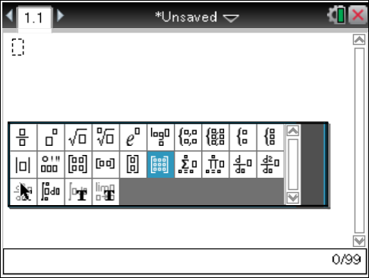  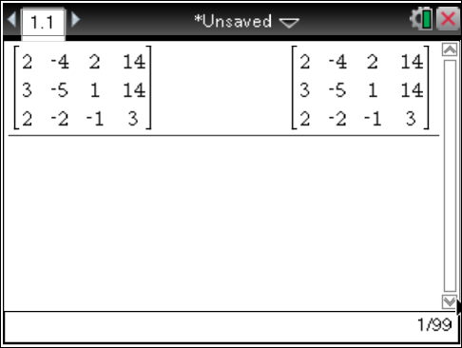

Transforming Column 1

3. To solve the above system, transform the matrix into reduced row-echelon form by establishing 1s on the main diagonal and zeros in every other position. To do this, transform element (1,1) to 1. Then transform the remaining column values to zero.
a. What multiplication needs to be done to row 1 so that the element in the first row, first column, hereafter using the notation (r,c) is 1? Why do you want this element to be a 1?

b. Multiply row 1 by the scalar multiplier identified above. Press Menu > Matrix & Vector > Row Operations > Multiply Row. The correct syntax for the Multiply Row command is mRow(scalar multiplier, matrix, row number). Enter each value as shown. To copy and paste a previous matrix into a row operation command, use the TouchPad or the arrows to select a matrix in a previous entry line and press ·. | 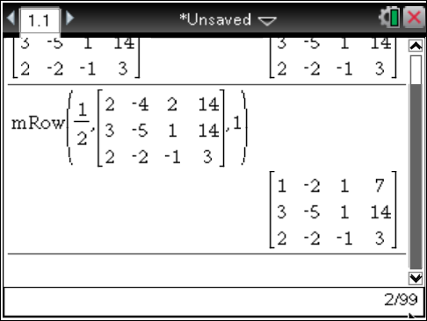

4. After transforming element (1,1) to 1, all other values in the column must be transformed to zero.
a. Once a 1 is established in the column, why must all the other values in the column be zero?

b. What multiplication needs to be done to row 1 so when it is added to row 2, element (2,1) is transformed to zero? Explain why this works.

c. Perform the Multiply Row & Add command by pressing Menu > Matrix & Vector > Row Operations > Multiply Row & Add. The correct syntax after selecting the Multiply Row & Add command is mRowAdd(Scalar multiplier, matrix, row being multiplied, row being added to).

d. What row operation is necessary to transform element (3,1) to zero?

e. Perform the Multiply Row & Add command by pressing Menu > Matrix & Vector > Row Operations > Multiply Row & Add and entering the correct syntax as above.

Transforming Column 2

5. Continue establishing 1s along the main diagonal with zeros in every other position. Since the element (2,2) is already 1, transform the other values in the column to zero. After establishing the 1 in the column, all the other values in the column need to be zeros.
a. Ann says that in order to transform element (1,2) to zero, she needs to multiply row 2 by 2 and add it to row 1. Pat says that in order to transform element (1,2) to zero, he needs to multiply row 3 by 1 and add it to row 1. Who is correct? Explain.

b. Perform the Multiply Row & Add command by pressing Menu > Matrix & Vector > Row Operations > Multiply Row & Add and entering the correct syntax.

c. What row operation is necessary to transform element (3,2) to zero? Explain your choice.

d. Again press Menu > Matrix & Vector > Row Operations > Multiply Row & Add and entering the correct syntax.

Transforming Column 3

6. Continue establishing 1s along the main diagonal with zeros in every other position. Since the element (3,3) is already 1, transform the other values in the column to zero. After establishing the 1 in the column, all the other values in the column need to be zeros.
a. What row operation is necessary to transform element (1,3) to zero?

b. Perform the Multiply Row & Add command by pressing Menu > Matrix & Vector > Row Operations > Multiply Row & Add and entering the correct syntax.

c. What row operation is necessary to transform element (2,3) to zero? Is this the only way?

d. Again press Menu > Matrix & Vector > Row Operations > Multiply Row & Add and entering the correct syntax.

Interpreting the Augmented Matrix

7. Now that the augmented matrix is in its reduced row-echelon form, what is the solution to this system of equations?

8. Verify the solution by substituting your solution into the original system of equations or using the calculator application.

Solving Another System
9. Use row operations to transform the system of equations below to its reduced row-echelon form. State and verify the solution. Give details as to what steps were used.

