Open the TI-Nspire document Law_of_Cosines.tns.  You might know how to find unknown side lengths or angles when you have a right triangle, but what do you do when you can’t use the Pythagorean Theorem? In this activity, you will learn the Law of Cosines, a relationship that you can sometimes use to find unknown side lengths in non-right triangles  . | 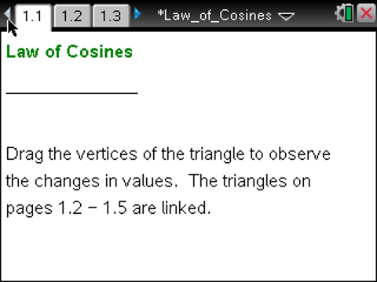

Move to page 1.2. | Press / ¢ and / ¡ to navigate through the lesson.
1. This page shows triangle ABC, with angles A, B, and C, and corresponding sides opposite those angles whose lengths are a, b, and c, respectively. You can drag any of the vertices to change the triangle.
a. Below the triangle, you see the measures of two sides, an angle, the cosine of the angle, and two equations. Describe in words what the expression tells you about the triangle.

b. Drag the vertices and observe the values of the two expressions at the bottom of the screen. What do you observe?

c. Do you think this relationship will hold for the other sides and angles? For example, if you switch side a with side c and angle A with angle C, will the equation be satisfied? Explain your reasoning.

d. Move to page 1.3 and to page 1.4 to test your prediction in part c. Drag the vertices to observe the values of the two equations. Why do you think this relationship might hold?

Move to page 1.3.

2. Adjust the triangle so that the measure of angle C is 90°.
a. What is the cosine of angle C? How do you know?

b. For any triangle with the measure of angle C = 90°, what is ? How do you know?

c. Why must it be true, in this case, that ?

d. What would the equality in part c be if angle A were the right angle? Angle B? Explain.

Move to page 1.5.

3. The equality you just showed in question 2 is called the Law of Cosines. It is true for all triangles, not just right triangles. On Page 1.5, investigate why the Law of Cosines is true.
a. Move a vertex so that angle C is acute. The segment h is called an altitude of the triangle, and it is perpendicular to the side it intersects. Explain why the statement at the bottom of the screen,, is true.

b. Explain why the statement at the bottom of the screen, , is also true.

c. Explain why the statement at the bottom of the screen, , is true.

d. Rewrite the statement in part c using only the sides and angles of the original triangle.

Move to page 2.1.

4. Test your equality in question 3d by multiplying out .
a. Multiply out the expression above in two ways: with the handheld and by hand. Compare the results. Does the handheld differ from your results? If so, how, and why?

b. If you need to, use the handheld to help you reconcile the two results. What important identity is the handheld using in its calculations?

Move back to page 1.5.

5. Move one or more vertices so that angle C is obtuse.
a. What happens to h?

b. You might notice that the statements and still appear on the screen. Show why they are both still true.

c. Is the Law of Cosines true when angle C is obtuse? Explain.

6. Use the Law of Cosines, if possible, to solve for the missing side lengths and angles in each of the following triangles. If it is not possible to use the Law of Cosines, explain why not.
a. a = 5.8, b = 3.4, C = 64º

b. a = 5, b = 8, c = 9

c. a = 8, c = 12, A = 50º

