Open the TI-Nspire document Balancing_Act.tns.  In this simulation, you will observe the forces at work in a teeter-totter. You will find ways of balancing the teeter-totter using the same weight on both sides or different weights distributed in such a way to achieve balance. | 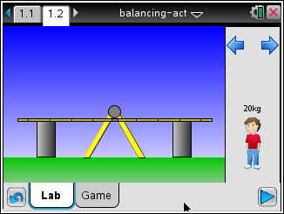
Launch the simulation.
When you start the simulation, the teeter-totter has blocks at either end to keep it from moving up and down. You place people on either side of the teeter-totter. By default there is a 20-kg person. Selecting the blue arrows above the person will bring up other people and object of different masses.
Tech Tip: To view the force on the teeter-totter, select Menu or  > Show Force > Yes. You may need to back-out to the main Tools Menu to see the desired menu option.
Part 1: Exploring Force
- A teeter-totter allows two people, sitting at either end to move up and down. Pushing upward creates an upward force. Place a 20-kilogram person at the farthest end of the teeter-totter, as shown here. Then select the play button .

The downward movement of the person is from the force of gravity. This force is written this way:
The downward force (F) is the weight of the person. The weight is the product of the person’s mass (m) and the acceleration due to gravity. The unit of mass is kilograms (kg) and the value of gravitational acceleration on Earth is 9.8 meters/second².
Q1. Calculate the downward force of the person you placed on the teeter-totter. Make sure to keep track of the units.

The unit of force is expressed as kg-m/s², also referred to as a Newton.

Part 2: Exploring Balance
- Now place another person of the same mass at the far end of the other side of the teeter-totter. |  | 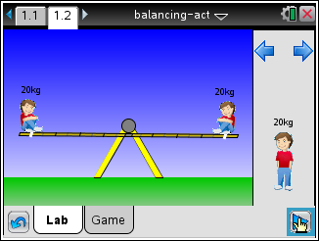
Q2. Describe what happens when you place the second person on the teeter-totter.

A teeter-totter is an example of a simple machine. The horizontal part is called a lever and the point about which the lever rotates is called the fulcrum. When weight is evenly distributed, the lever is horizontal.

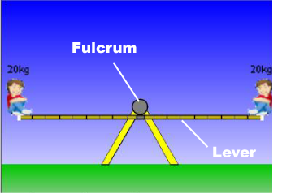
Part 3: Exploring Imbalance
- Now slide the person on the left side of the teeter-totter two spaces to the right toward the fulcrum. Notice the small white indicator that shows where on the lever the person is located. |  | 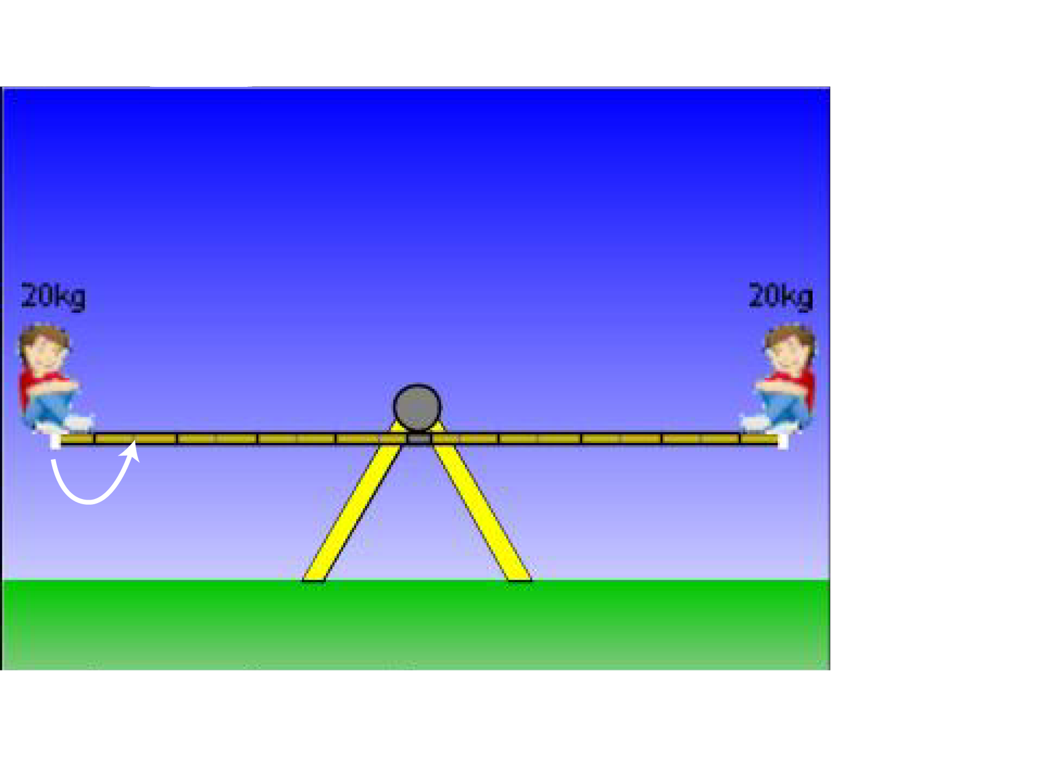
Q3. Describe what happens.

The same amount of weight on either side of the fulcrum doesn’t always lead to a balanced distribution of weight. This is because there is another physical quantity involved: torque.

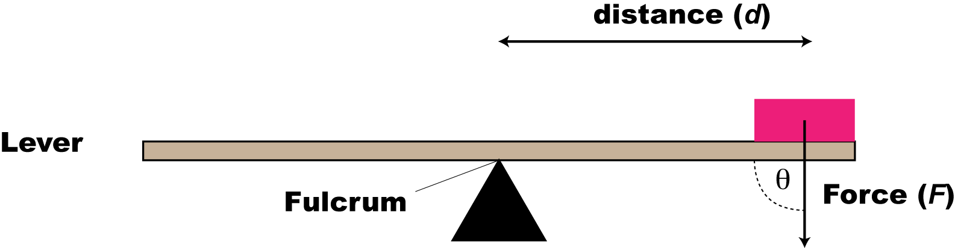

For a lever and fulcrum, torque is defined as the downward force times the distance from the fulcrum.

The unit of force is the Newton-meter, N-m.
Because the angle between the force and lever in a scenario like this is always 90°, the formula for torque simplifies to this:

Q4. Calculate the magnitude of the torque for each person on the teeter-totter. For distance measures use the units shown in the illustration.  Q5. How does torque help explain why having the same weight on either side of the fulcrum doesn’t guarantee balance? | 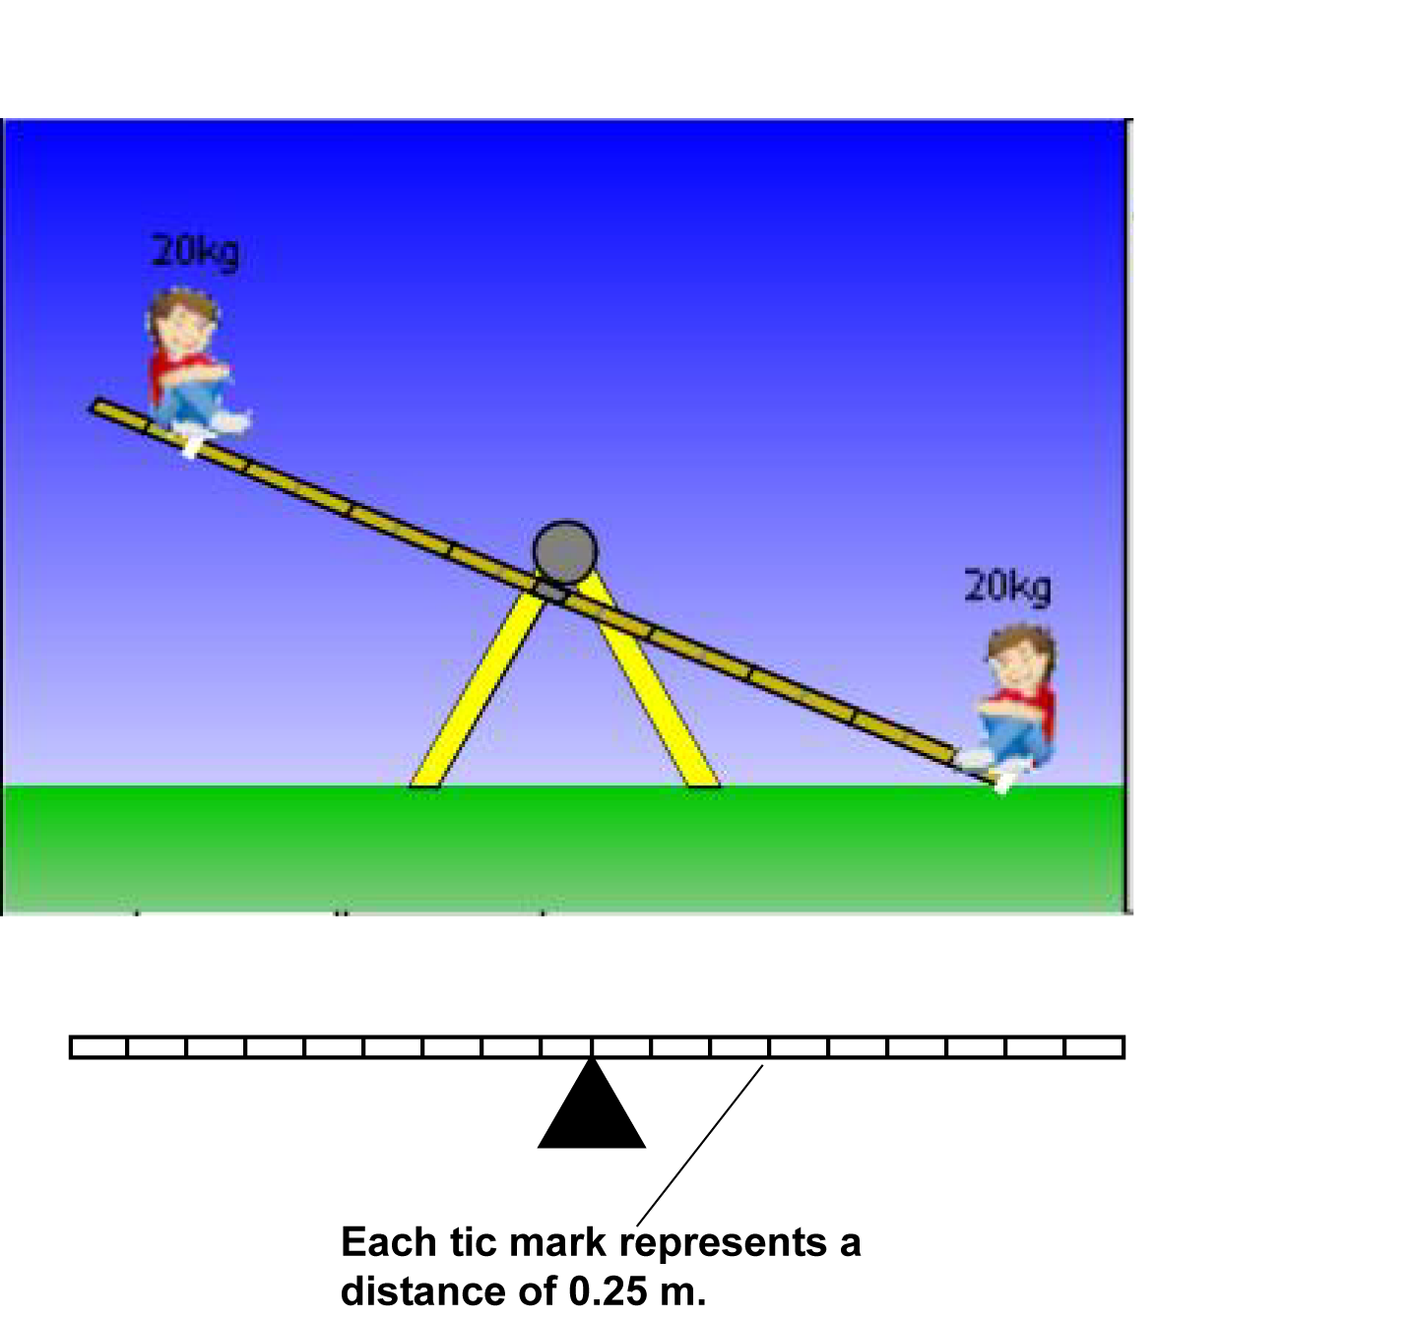
Q6. How far from the fulcrum would you need to place another 20-kg person to have a balanced distribution of weight in question 4? Show how you got your answer.

Part 4: Working with Torque
Suppose there are two different masses (m₁ and m₂) spaced at different distances (d₁ and d₂) from the fulcrum, but the arrangement is such that the lever is balanced.

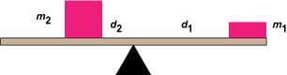

This means an equal amount of torque is being exerted on each side (τ₁ and τ₂).
This is expressed mathematically for the magnitude of the torque:

This relationship can be summarized with this proportion:
- Select the Reset 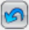 button. Next, place a 20-kg and a 30-kg person on either end of the teeter-totter. Select the blue arrow to access the 30-kg person. Select the play button and you will see the teeter-totter unbalanced in favor of the 30-kg person. | 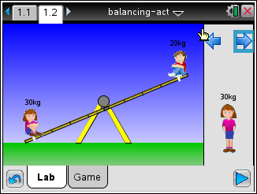
Q7. Use the proportion to calculate where to place the 30-kg person, if the 20-kg person remains in the current position.

Q8. Test the result of the previous question using the simulation. Describe the outcome.

Q9. Select the Reset button. Next, place a 20-kg at farthest end of the teeter-totter and another 20-kg person, 3 units away from the fulcrum. Where would you need to place an 80-kg person to balance the lever? | 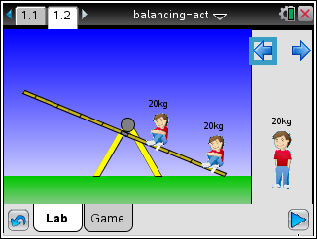
Q10. What is the mass of an object 6 units from the fulcrum that balances a 30-kg person 1 unit from the fulcrum?

