Open the TI-Nspire™ document Parallel_Lines_and_Transversals.tns.  In this activity, you will explore the relationship between angles and parallel lines cut by a transversal by moving points. | 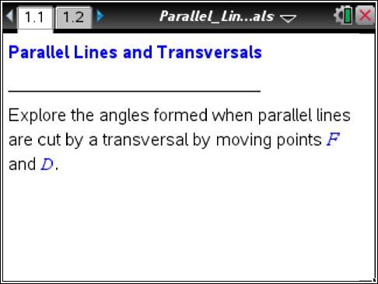

Move to page 1.2.

On page 1.2, students see two parallel lines cut by a transversal.  ∠DAF and ∠DAC form a linear pair.  1. Identify two other linear pairs. | 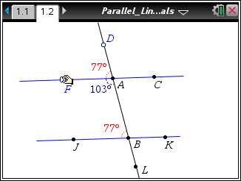
2. Name at least two pairs of supplementary angles that are not linear pairs.

3. Identify two other angles that have the same measure as ∠DAF and explain why they must have the same measure.

Move the cursor to point F. When the cursor becomes a hand, grab the point and move the line. ∠DAF and ∠ABJ and corresponding angles.

4. a. What conjecture can you make about corresponding angles?
How are corresponding angles formed?

b. Identify other corresponding angles.

Grab and move point D to the left and to the right. Students can confirm their answers to questions 2, 3, and 4, by using Menu > Measurement > Angle. Then select the three points that define the angle.

5. After moving point D, list the 8 angles created by cutting the parallel lines with the transversal and record your angle measures.

6. For the following statements, determine if they are always, sometimes or never true. Explain your reasoning using what you have learned in this activity.
  - Supplementary angles form a linear pair.

  - Angles that form a linear pair are supplementary.

  - Corresponding angles are congruent.

