Activity Overview:
In this activity, you will construct a right triangle and then construct an equilateral triangle on each side of the right triangle. You will measure the area of triangles.

Materials
• Technology needed (TI-Nspire™ handheld, computer software)

Step 1 Preparing the document
- Open a new document by clicking on c > New Document > Add Notes.
- Type Area Measures and Right Triangles
Note: To obtain capital letters, press the g key, then the letter.
- Press ~ > File > Save As …
Type Area_Measures_and_Right_Triangles. Tab to ¾ and press · .
Note: To obtain the underscore, press / _.
4. To add a new page, press / ~ > Add Geometry.
5. To hide the scale in the right corner of the screen, go to Menu > View > Hide Scale.
6. To set the number of digits to display the area on the Geometry application, press Menu > Settings. Press ¢ once and then ¤ until Fix 1 appears. Press · ·.
Step 2 Drawing a segment and labeling its endpoints
1. Press Menu > Points & Lines > Segment.
2. Press x to draw the first endpoint of segment and immediately press g C to label the point C.
3. Move to another position on the screen and press x to draw the second endpoint and immediately press g B to label the point B.
4. Press d to exit the Segment tool.

Step 3 Constructing a perpendicular
1. Press Menu > Construction > Perpendicular.
2. Move cursor to the segment until the words segment CB appear. Press x.
3. Then move the cursor until the words point C appear and press x.
4. Press d to exit the Perpendicular tool.
Step 4 Drawing the other leg of the right triangle
1. Press Menu > Points & Lines > Point On.
2. Move to a point on the perpendicular line you just created and press x to make a point and immediately press g A to label this point A.
3. Press d to exit.

Step 5 Drawing right triangle ABC
1. Press Menu > Shapes > Triangle.
2. Move to each of the points A, B, and C, pressing x on each.
3. Press d to exit the Triangle tool.

Step 6 Hiding the perpendicular line  1. Right-click (/ b) on the line and select Hide. |  | 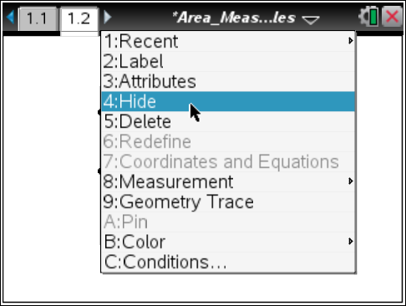
Step 7 Drawing an equilateral triangle on the side of the right triangle with vertices A and C
1. Press Menu > Shapes > Circle.
2. Move to point A. Then press x. Move to point C. Then press x. This makes a circle with center A and radius .
3. Press x on point C (yes again), move to point A, and then press x. This makes a circle with center C and radius .
4. Press d to exit the Circle tool.
5. Press Menu > Points & Lines > Intersection Point(s).
6. Move until one of the circles is highlighted and press x. Move until the other circle is highlighted and press x.
7. Press d to exit.
8. Move to near the point of intersection that is not inside Δ ABC. Press Menu > Actions > Text.
9. Press x, g M, and ·, to label one of the points as M where the two circles intersect. Then press d to exit.
10. Press Menu > Shapes > Triangle and click on points M, A, and C in any order to create triangle MAC.
11. Press d to exit the Triangle tool.
Step 8 Hide the construction circles and other point of intersection
1. Press Menu > Actions > Hide/Show.
2. Move until one of the circles is highlighted and press x. Move until the other circle is highlighted and press x. Move until the second point of intersection for the two circles is highlighted and press x.
3. Press d to exit.
Step 9 Drawing equilateral triangles BNC and APB
1. Repeat Steps 7 and 8 to draw equilateral triangles BNC and APB.
2. If desired, right-click (/ b) on a triangle and select Color > Line Color or Color > Fill Color to add color.
Step 10 Finding the areas of the three equilateral triangles
1. Press Menu > Measurement > Area.
2. Move your cursor to any one of the three triangles until the word triangle appears.
3. Press x. Move the measurement to a good location on the screen and press x to leave the value for the area there. Make a mental note as to which value goes with which triangle.
4. Repeat steps 2 and 3 to find the areas of the other two triangles.
5. Press d to exit the Area tool.
Note: Use the abbreviation aamc for the area of Δ AMC, aapb for the area of Δ APB, and abnc for the area of Δ BNC.
Step 11 Assigning measures to variables
1. Press x on the measure for the area of triangle AMC (aamc).
2. Press h > Store Var, and type aamc (to represent the area of ΔAMC). Press ·.
3. Repeat to assign measures for ΔBNC (abnc) and ΔAPB (aapb).
Note: If you need to grab each of the three area measurements and move them to the left so that you can see them better, do so.
Step 12 Saving the document
1. Press /S.

