Open the TI-Nspire document Clean_Water.tns  What do we mean when we say that water is “clean?” What variables are tested to see if water is clean? The standards for water quality will differ depending on what the water is used for. For example, water for drinking requires different standards than “clean” water for aquatic plants and animals. Knowing how environmental factors affect water quality can help us predict the sources of pollutants in a watershed. In this activity you will collect data from various water samples and use it to determine the location of the sample. |  | 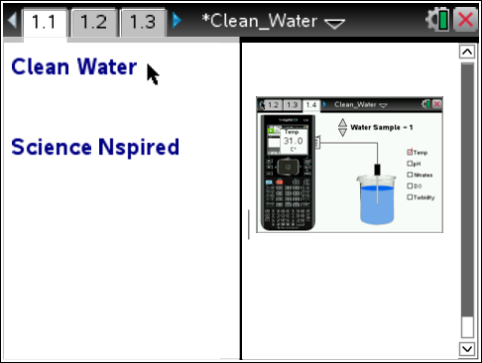
Move to page 1.2. and read the information given. Then, read the background information for this activity shown below.
There are many variables that can affect water quality. In this activity, you will examine five of these variables. These variables are dissolved oxygen, temperature, pH, turbidity, and nitrates. These variables can interact with water in complex ways, so it is best to consider the variables as a group rather than individually. Read through the background material shown below to learn more about these five water quality variables.

Dissolved Oxygen: Dissolved oxygen (DO) is oxygen that is dissolved in water. Aquatic life requires dissolved oxygen to live. Much of the dissolved oxygen in surface water comes from the atmosphere. Moving water becomes aerated more easily, so rivers and streams tend to contain more DO than ponds and lakes. Algae and aquatic plants also deliver oxygen to water through photosynthesis. When there are too many bacteria or aquatic animals in an area, the organisms may overpopulate and use dissolved oxygen in great amounts. Also, cool water can hold more dissolved oxygen than warm water. The normal concentration of DO in freshwater is between 4-7 mg/L.

Temperature: Surface water temperature is affected by air temperature, runoff from the surrounding environment, turbidity, depth, and exposure to sunlight. Water with high turbidity is dark, which means it absorbs more sunlight and increases in temperature. Similarly, shade from trees along the banks and shores can decrease heating from the sun, causing water temperature to drop. Shallow creeks and streams can warm up more quickly than deeper bodies of water. The warmer the water, the less dissolved oxygen the water can carry. The rate of photosynthesis by aquatic plants can also decrease as the temperature of water increases. Some compounds are also more toxic to aquatic life at higher temperatures.

pH: Most fish can tolerate pH values within the range of 5.0 to 9.0. Most rivers, lakes, and streams in the U.S. fall within this range, though acid rain has compromised many bodies of water in our environment. The largest variety of freshwater aquatic organisms prefer a pH range within 6.5 to 8.0

Turbidity: Turbidity is a measure of water clarity. It is an important indicator of suspended sediments in water, and it can indicate the amount of erosion in the surrounding environment. Runoff carrying silt, dirt, and chemicals from urban and agricultural areas can increase the turbidity of surface waters. Usually, turbidity will increase sharply during and after it rains because sediment runs off into the water. Algal blooms can also increase turbidity. High turbidity levels can also raise water temperature, lower dissolved oxygen, and prevent sunlight from reaching aquatic plants, which decreases photosynthesis. The turbidity of surface water is usually between 1 NTU and 50 NTU.

Nitrates: In water, nitrogen is present in many forms, including ammonia, nitrates, and nitrites.
As aquatic plants and animals die, bacteria break them down to form nitrites and nitrates. The waste from aquatic organisms, ducks, geese, farm animals and other organisms contribute to the increase of nitrates in a watershed. Nitrates in water can also result from fertilizer runoff from lawns and agricultural areas. Nitrate levels in freshwater are usually less than 1 mg/L, but manmade sources of nitrate may increase levels to above 4 mg/L.

Move to page 1.3 and answer question 1 below and/or on your device.
Q1. There are many factors that affect water quality. When determining water quality,

A. each factor is considered separately from the others.
B. the factors can affect each other so they are analyzed as a group.
C. only five factors are used to analyze water quality.

Move to page 1.4.
Read the instructions for the simulation.
1. Begin by analyzing Water Sample 1. Start data collection by selecting the GREEN record button on the virtual calculator screen. Select and drag the probe into the beaker. Then, select a on the virtual calculator to collect a data point.  2. Check a new water quality variable and select a on the virtual calculator to record another data point.  3. Continue collecting data points for each of the five variables for Water Sample 1. Then, select the RED stop button on the virtual calculator.  4. Repeat this process for Water Samples 2 and 3. Use the up and down arrows (¤ and £) to select a new water sample. All of the data will be collected in the spreadsheet on page 1.5. | 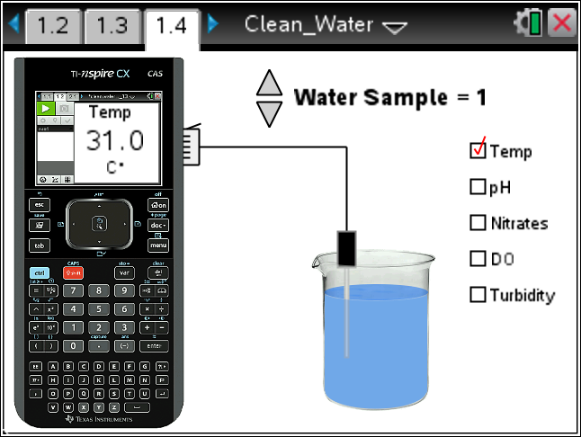
Tech Tip: To access the Directions again, select > Clean Water > Directions.

Tech Tip: To access the Directions again, select b or Document Tools () > Clean Water > Directions.
Move to page 1.5.
5. On page 1.5 you will find a spreadsheet containing the data you collected. Record this data in the table below.

Water Quality Data for Samples

Water Sample | Temperature | pH | Nitrates | Dissolved Oxygen | Turbidity
1
2
3

Move to pages 1.6 - 1.10.
6. The data for each variable and water sample are shown in graphs. Examine these graphs and consider the background information on each variable.

Move to page 1.11
7. Use the background information on each variable to interpret your data and match each water sample with one of the three locations described in questions 2-7.
Q2. Location A: This sample was taken from a large, fast-moving river. The river’s tributaries normally drain both urban and agricultural areas with buffer strips that slow runoff and decrease the amount of sediment entering the river. Which water sample is this?

A. Water Sample 1
B. Water Sample 2
C. Water Sample 3

Q3. What evidence did you use to determine the water sample for Location A?

Q4. Location B: This sample was taken from a farm pond after a heavy rain. There is little vegetation on the banks surrounding this pond. The pond is located in the middle of a bean field that was recently fertilized. Which water sample is this?

A. Water Sample 1
B. Water Sample 2
C. Water Sample 3

Q5. What evidence did you use to determine the water sample for Location B?

Q6. Location C: This sample was taken from a shallow creek near an urban mall area. Runoff from the parking lot drains directly into this creek. Because the creek is shallow, it is very slow-moving and the bottom is easy to see. There are few trees along the banks of this creek. Which water sample is this?

A. Water Sample 1
B. Water Sample 2
C. Water Sample 3

Q7. What evidence did you use to determine the water sample for Location C?

